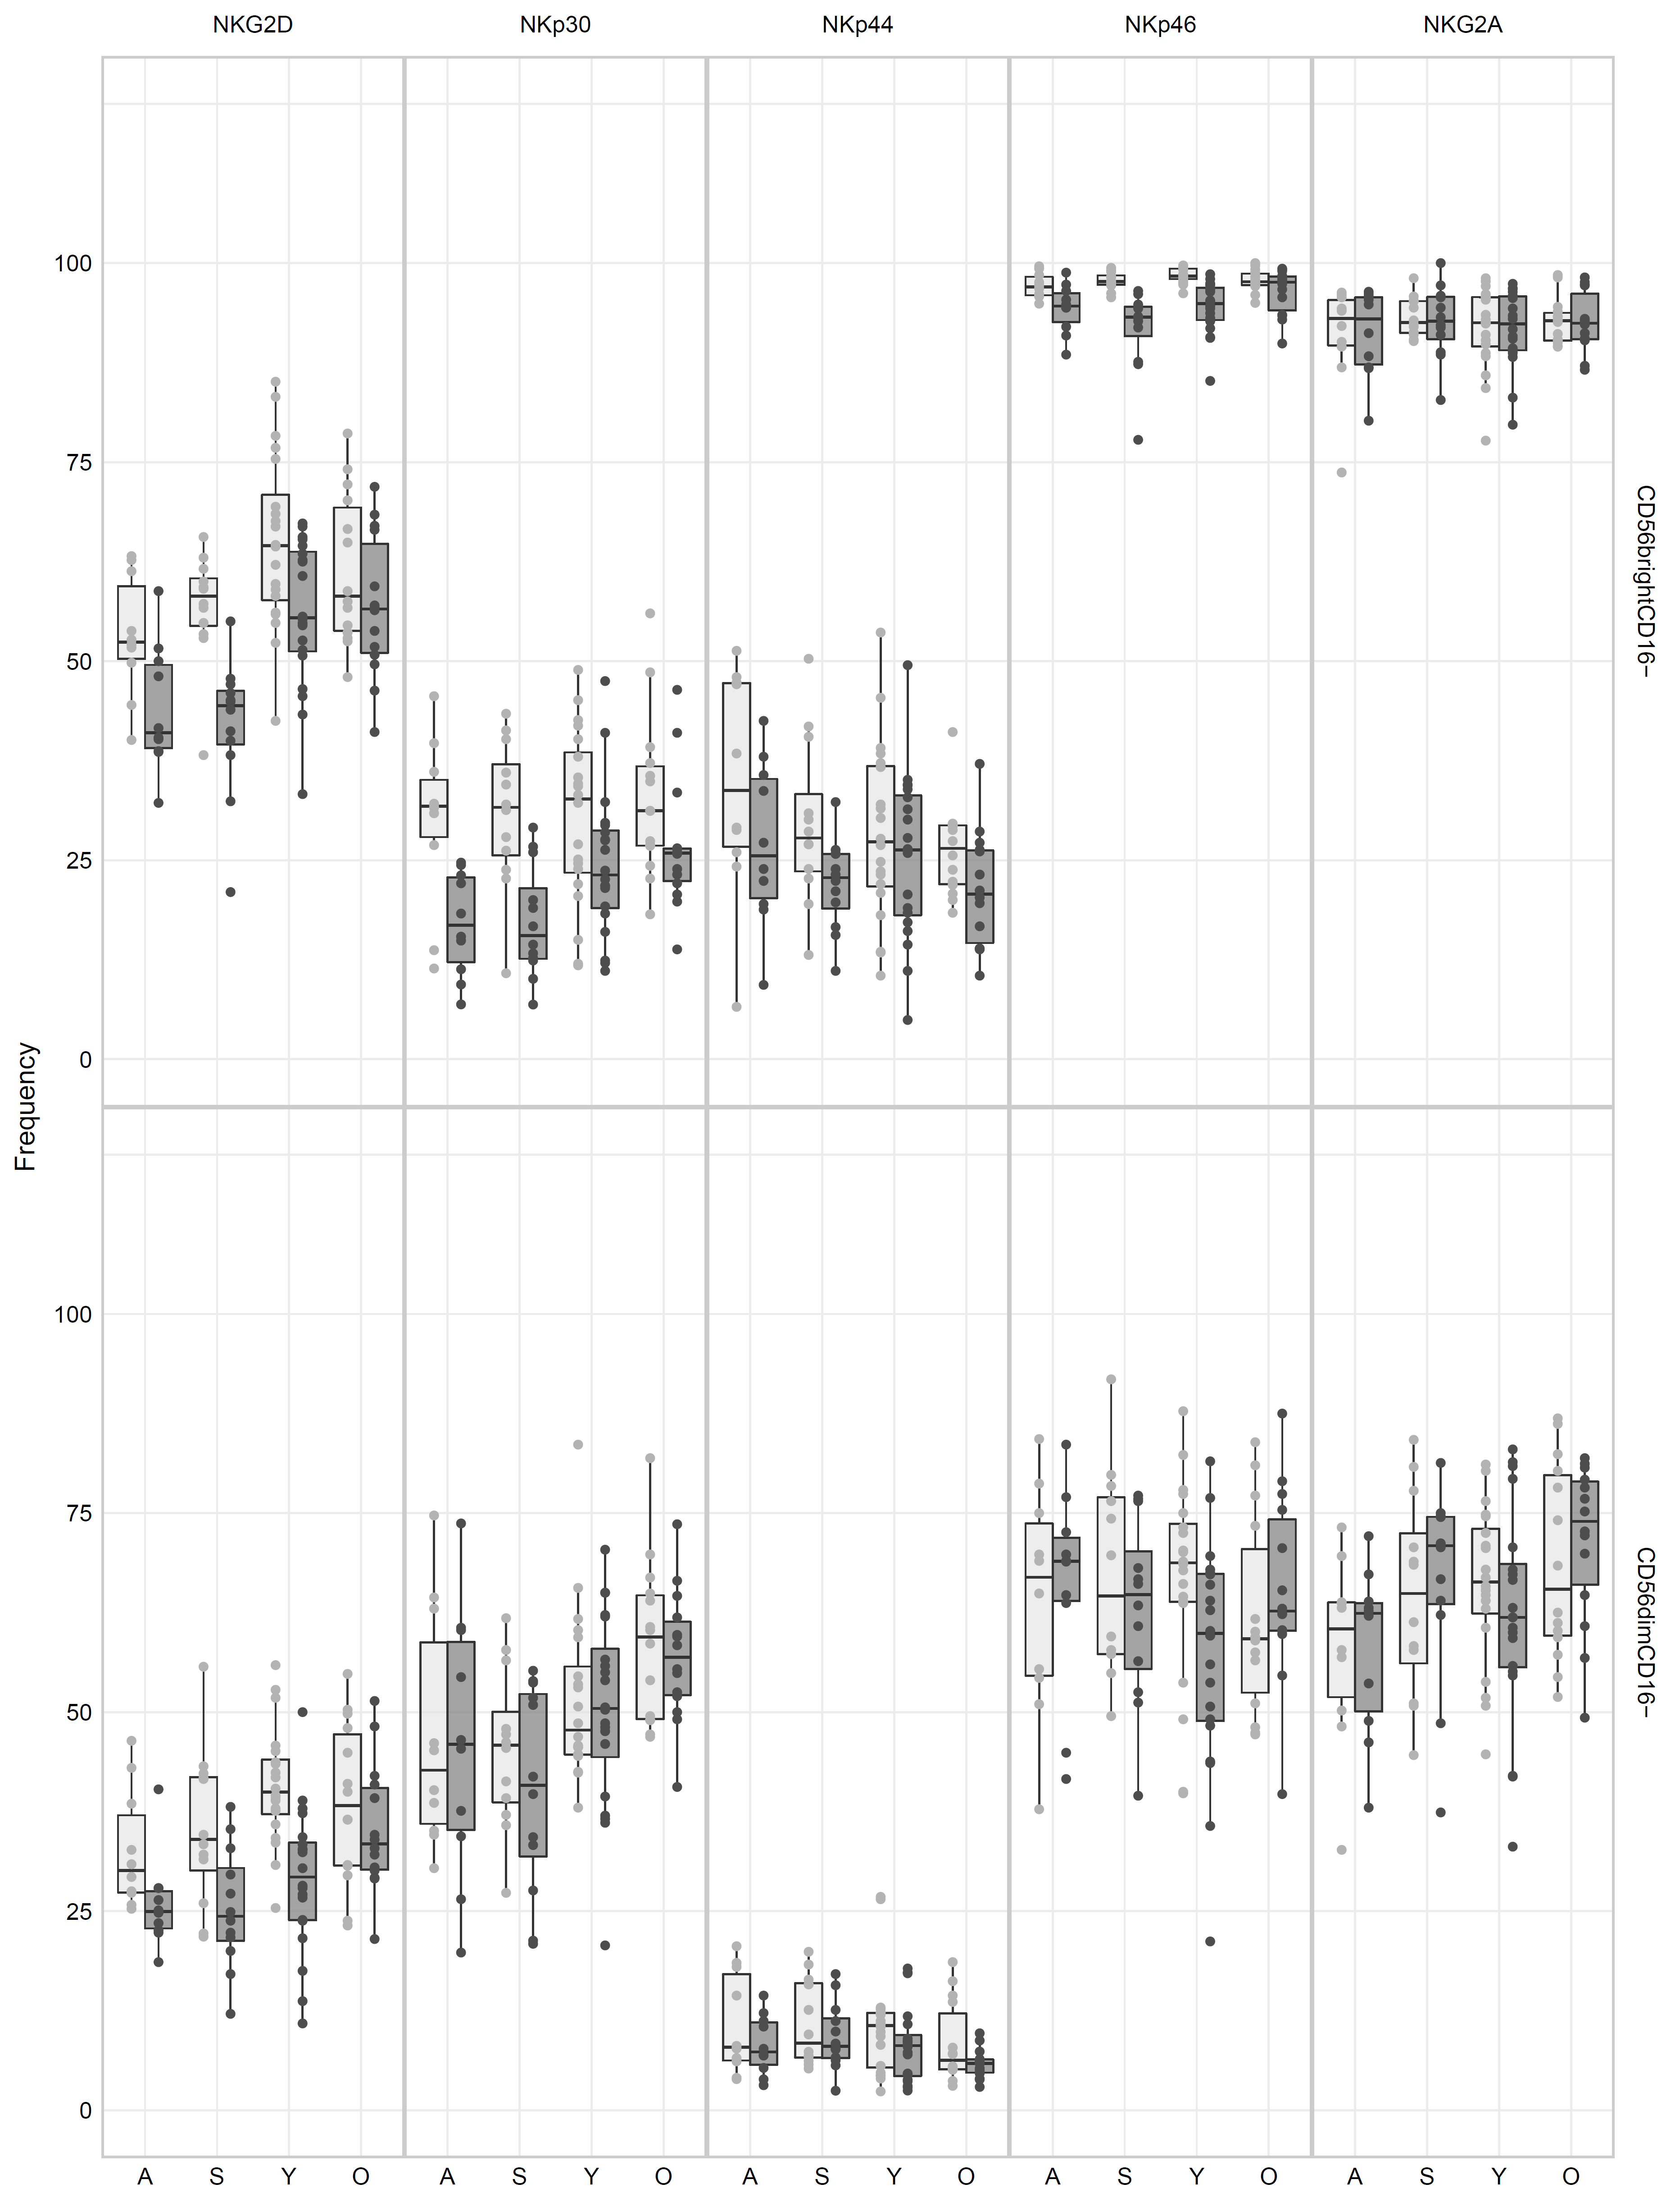

S3 Fig. Downregulation of activating receptors in NK cells in response to WNV infection in subjects with a history of WNV infection.

