S1 Fig. The chromatogram of hydrolytic amino acids (100-fold diluted solution)
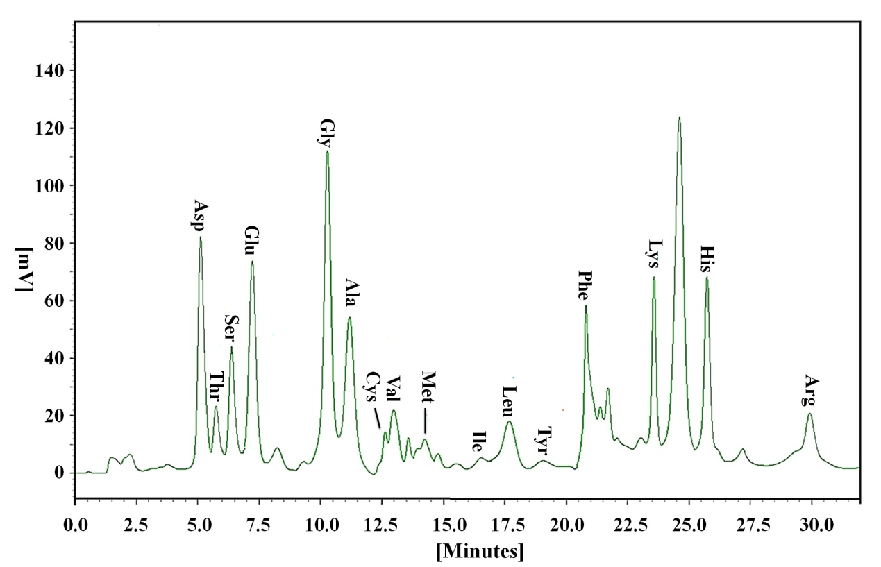
S1 Fig.

