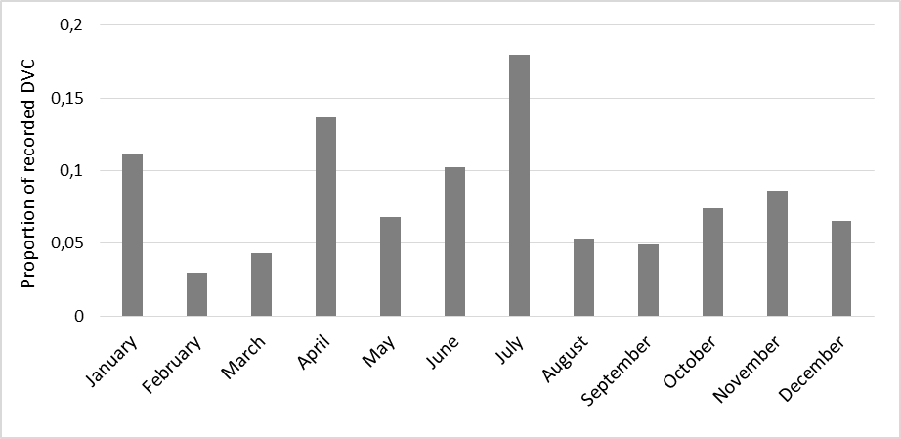
S3 Fig. Pooled roe deer-vehicle collision records by month over the duration of the study. Collision records were available for three out of five road sections used in the study.

