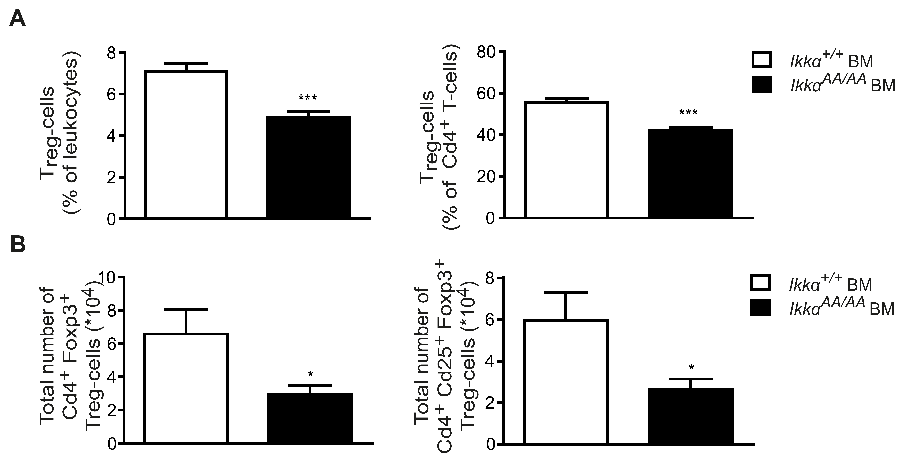
Figure S5. Effect of a bone marrow-specific Ikkα^{AA/AA} knock-in on T_{reg}-cells in a non-atherosclerotic context. Shown is flow cytometric analysis of T_{reg}-cells in lymph nodes from C57BL/6 mice transplanted with Ikkα^{AA/AA} or Ikkα^{+/+} BM. Dead cells were excluded using Sytox Blue. (A) Cd4⁺Foxp3⁺ T_{reg}-cells as percentage of leukocytes (left), and Cd4⁺Cd25⁺Foxp3⁺ T_{reg}-cells as percentage of Cd4⁺ T-cells (right). (B) Total numbers of Cd4⁺Foxp3⁺ T_{reg}-cells (left), and total numbers of Cd4⁺Cd25⁺Foxp3⁺ T_{reg}-cells. Graphs represent the mean ± SEM (n=5), 2-tailed t-test, *P<0.05, **P<0.01, ***P<0.001.

