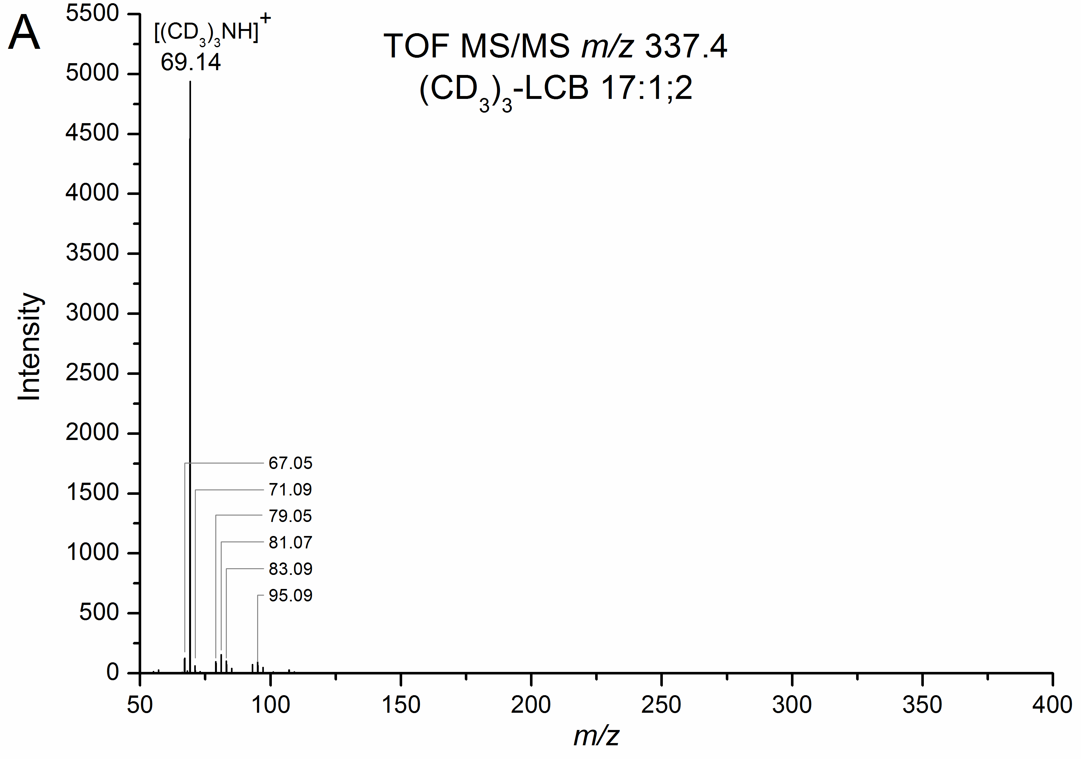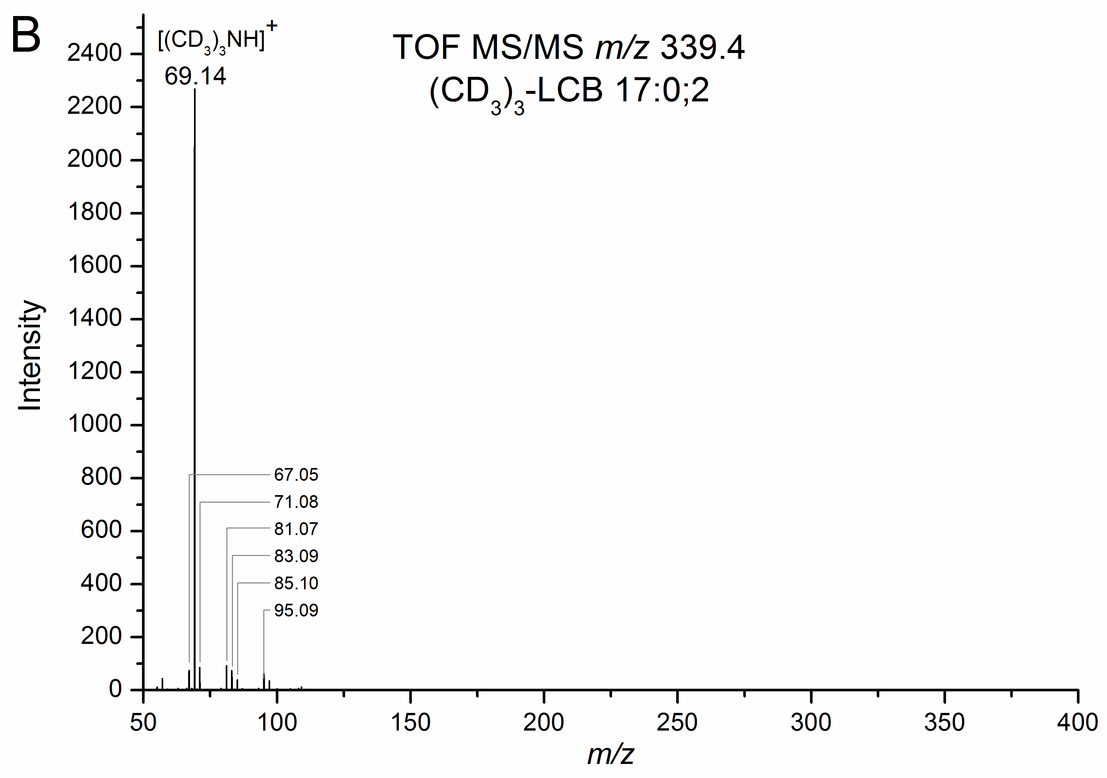

S3 Figure. Structural characterization of CD3I-derivatized LCB species.

