S2 Fig.
Parameters measured during testing of the cross-sectional samples using results from Ethiopia as an example. Figure A - local positive control (QC), Figure B - average between duplicate of the second highest concentration of the standard curve (OD) and Figure C - angular coefficient of the linear part of the curve (Mid-point). The green asymptotes represent the upper accepted range and the red ones the lower. Asymptotes values for OD and mid-point were the same as the ones used at the reference laboratory, the Vaccine Evaluation Unit, Public Health England, Manchester.
Figure A.
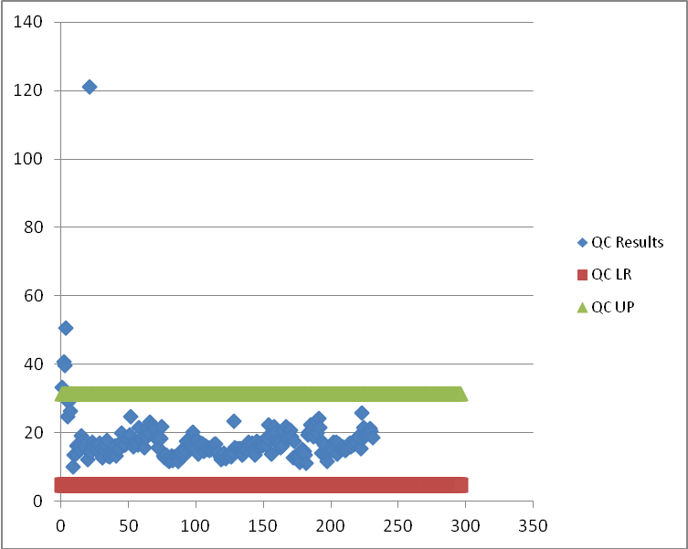

Figure B.
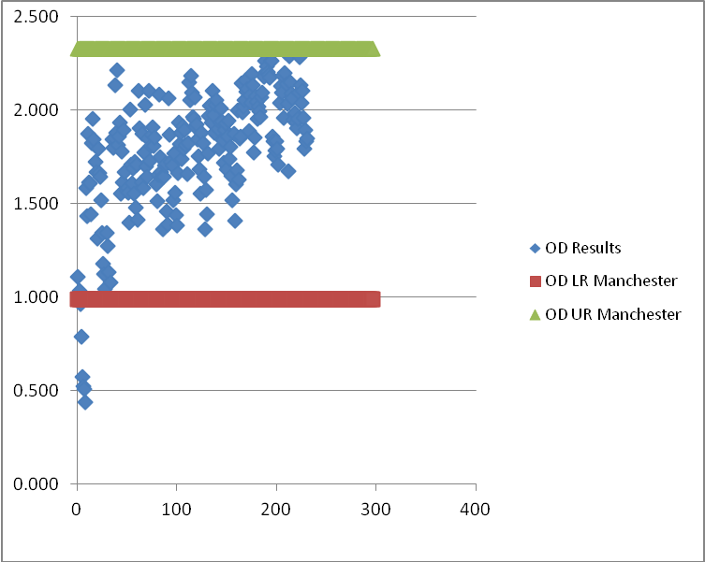
Figure C.
