Appendix: Algorithm predicting the risk of NPC and prognosticating survival, depicting both environmental and genetic variables.
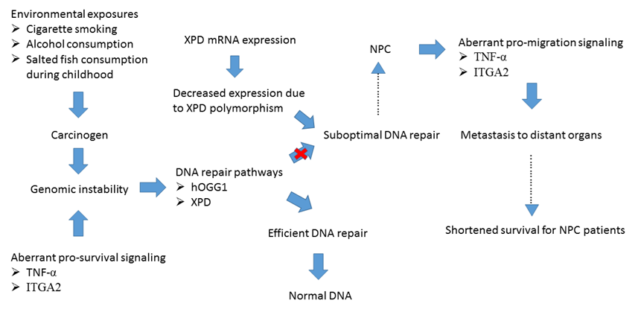

a

ªX – Improper DNA repair

