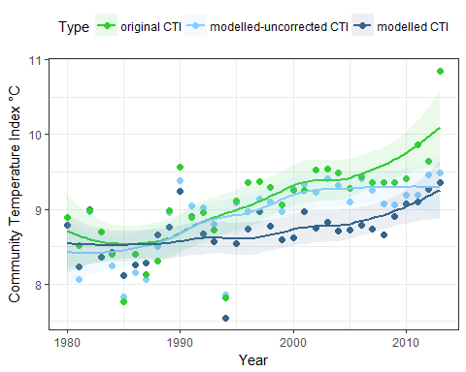

S3 Fig. The effect of including an outlier species (Syngnathus acus) on the results presented in Fig 4.
The original CTI value in the last census year is shown to be strongly influenced by the abundance of this species. However, the general patterns remain the same: the modelled CTI is lower than the original CTI, especially since 1995.

