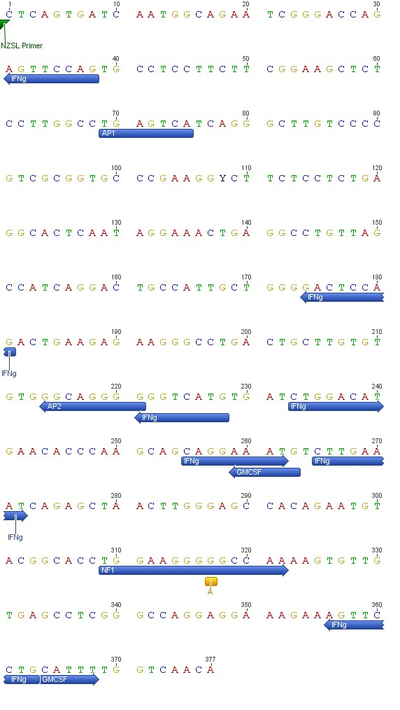
S2 Fig. Transcription factor binding motifs.
Putative transcription factor binding site motifs (AP1, NF-I, IFN-γ, GMCSF) for NZSL SLC11A1 promoter sequence, with SNP (A - G) indicated in gold. Figure output from Geneious with annotations manually added.

