SUPPLEMENTARY FIGURES for the manuscript

Integrated taxonomy and DNA barcoding of Alpine midges (Diptera: Chironomidae)

Matteo Montagna, Valeria Mereghetti, Valeria Lencioni & Bruno Rossaro

Submitted to PLOS ONE as a Research Article

This file includes:

Supplementary Figures A, B, C

Figure A. Histogram of pairwise nucleotide distances. Graph obtained through the web-based interface available at (http://wwwabi.snv.jussieu.fr/public/abgd); model of nucleotide evolution settled to Kimura-2-parameter [40].
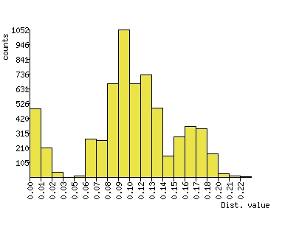

Figure B. Plot of ranked pairwise nucleotide distances. Graph obtained through the web-based interface available at (http://wwwabi.snv.jussieu.fr/public/abgd); model of nucleotide evolution settled to Kimura-2-parameter [40].

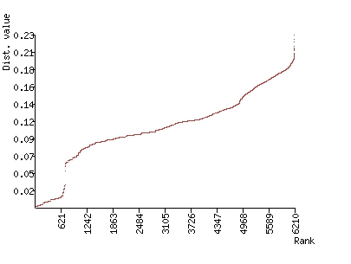

Figure C. Automatic partition of the analyzed data set. Graph obtained through the web-based interface available at (http://wwwabi.snv.jussieu.fr/public/abgd). The number of groups composing the partitions (initial and recursive) are reported as a function of the prior limit between intra- and interspecies divergence.
