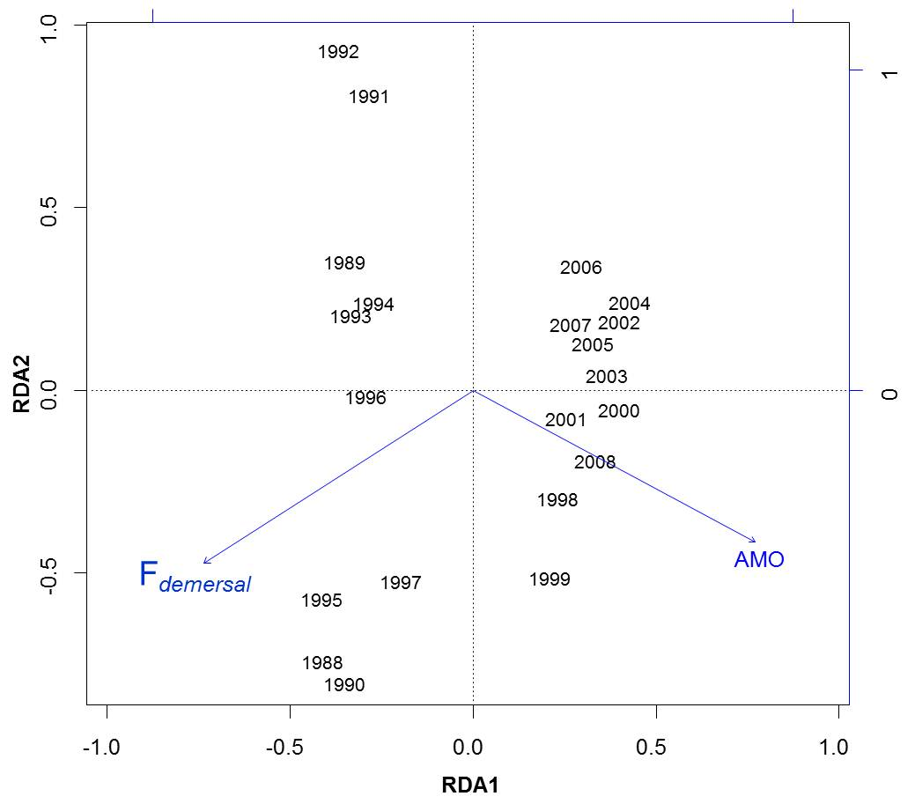

S2 Fig. Relationship between temporal variability in community structure, environmental conditions and fishing pressure. A RDA biplot on the two first axes presents temporal variability in community structure (year labels) and its relationship with the two selected variables (arrows), AMO and F_{demersal}, after stepwise model reduction. The shift in community structure can clearly be seen along axis 1.

