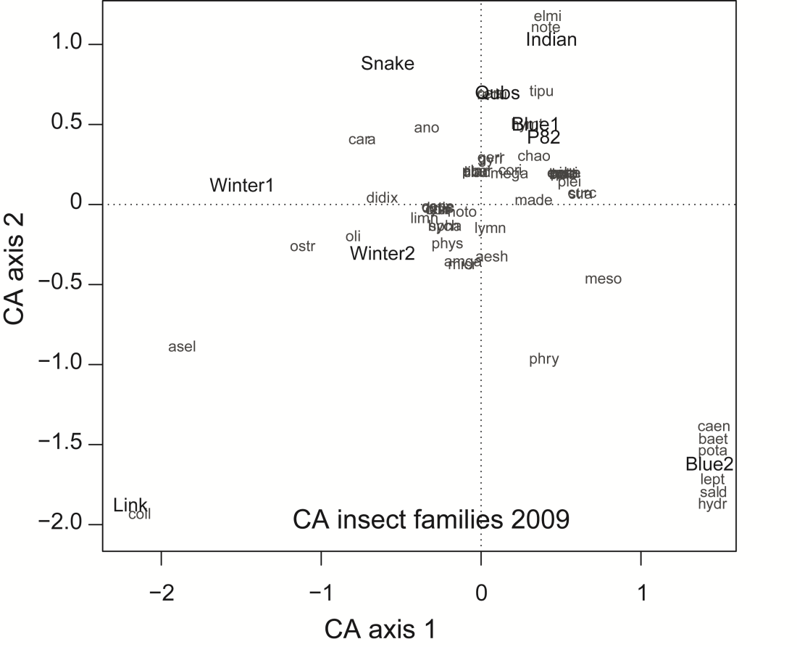
S3 Figure. Correspondence Analysis (CA) comparing invertebrate assemblage structure (presence-absence data) among ponds in 2009. Some species are stacked at the same location in ordination space.

