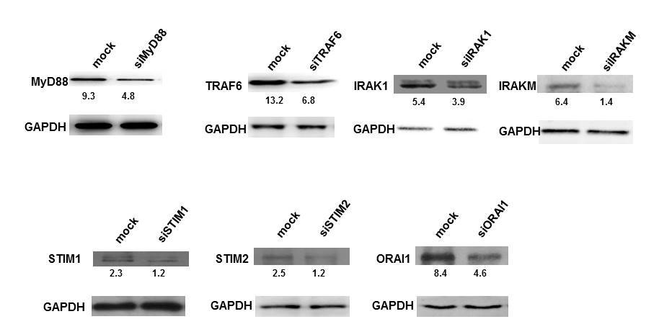

Figure S1. Knockdown efficiency of siRNAs to various molecules. PMA stimulated THP1 cells were transfected with siRNAs to indicated molecules for 36h. Cytoplasmic extracts were prepared and western blotted for indicated molecules. MOCK represents cells transfected with control siRNAs. Numbers below the blots indicate relative intensities of the bands normalized with the housekeeping molecule GAPDH.

