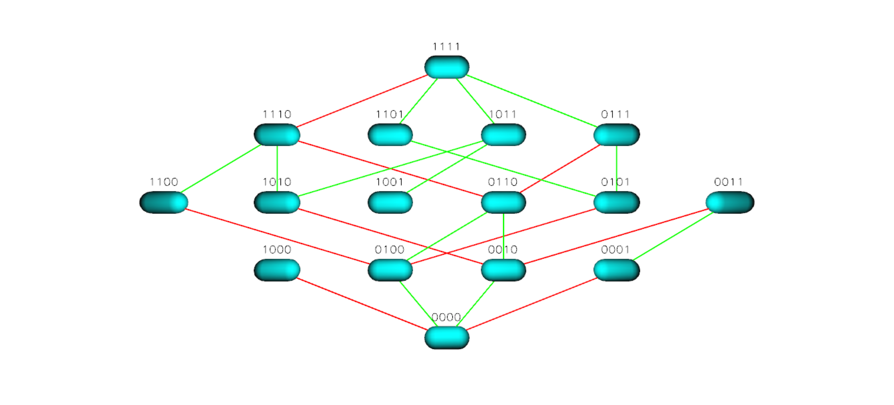
Figure S5 TEM 50 Landscape for Ceftriaxone

