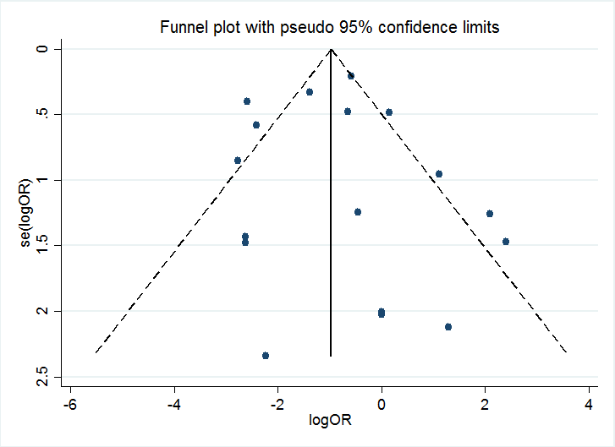

S4 Fig. Egger’s funnel plot for meta-analysis of FIB contamination of PW and tap water sources.

