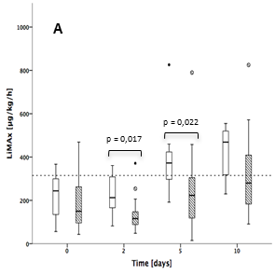

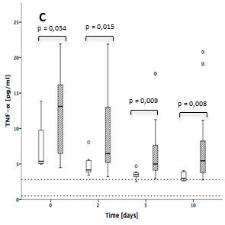
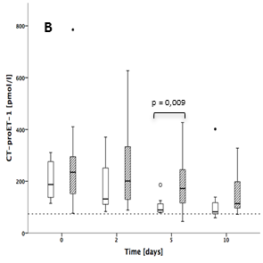

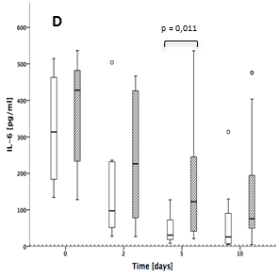

(A) LiMAx, (B) CT-proET-1, (C) TNF-, (D) IL-6. White boxplots: APACHE-II-score <20, shaded boxplots: APACHE-II-score ≥20. Dotted line: normal range

