Reproducibility
For SPARC (R&D Systems Inc., DSP00), 3 samples with low, medium and high [SPARC] were assayed eight (8) times each. According to the 4PL fit, the CV of the low [SPARC] sample was 4%, of the medium 5% and of the high 8%. (Fig. 2A)
For PR3 (Cusabio Biotech CO. LTD, CSB-E13058h), 3 samples of low, medium and high [PR3] were assayed five (5) times each. (Fig.2B) According to the 4PL fit, the CV of the low [PR3] sample was 7%, of the medium [PR3] sample was 24% and of the high [PR3] sample was 21 %. (Fig. 2B)
For SLIT-2 (Cloud-Clone Corp. USCN Life Science Inc., SEA672Hu), 3 urine samples of low, medium and high [SLIT-2] were assayed eight (8) times each. The samples exhibited the following CVs: (18% for the medium [SLIT-2] sample, 18% for the high [SLIT-2] sample and 29% for the low [SLIT-2] sample. The medium and high [SLIT-2] samples had low CVs which were acceptable. The low [SLIT-2] sample had a high CV above the acceptable limit. According to the 4PL fit, the samples exhibited the following CVs: (19% for the medium [SLIT-2] sample, 44% for the high [SLIT-2] sample and 29% for the low [SLIT-2] sample. (Figure A)
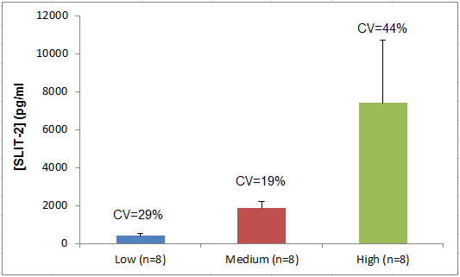
Figure A. Reproducibility study results of SLIT-2.
For H2B (US Biological Life Sciences, 025705), there was no high [H2B] sample available, therefore 2 samples of low [H2B] were assayed six (6) times each. The samples exhibited the following CVs: 42% and 33 % respectively for the 2 low [H2B] samples. Both samples had high CVs above the acceptable limit. According to the 4PL fit, CV could only be calculated for the one low [H2B] sample (56%). (Figure B)
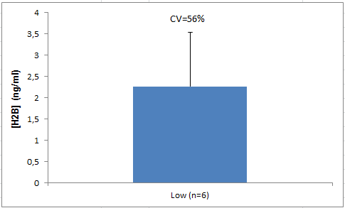
Figure B. Reproducibility study results of H2B.
For H2B (Cloud-Clone Corp. USCN Life Science Inc., SEA356Hu), there was no high [H2B] sample available, therefore 2 samples of low [H2B] were assayed six (6) times each. For the first low [H2B] sample, CV=97% and the second low [H2B] sample gave a negative result therefore CV could not be calculated. According to the 4PL fit, CV could be calculated only for the one low [H2B] sample (88%). (Figure C)
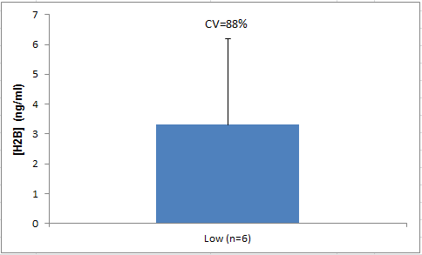
Figure C. Reproducibility study results of H2B.
For Survivin (Enzo Life Sciences, ADI-900-111), two samples of low and high [SURVIVIN]) were assayed twelve (12) times each. The samples exhibited the following CVs: 32% for the low [SURVIVIN] sample and 15% for the high [SURVIVIN] sample. The CV of the high [SURVIVIN] sample is acceptable whereas the CV of the low [SURVIVIN] sample was above the acceptable limit. According to the 4PL fit, CV could be calculated only for the high [SURVIVIN] sample (29%). (Figure D)
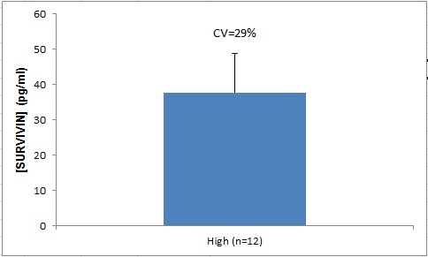
Figure D. Reproducibility study results of SURVIVIN.
For Survivin (R&D Systems Inc., DSV00), there was no high [SURVIVIN] sample available, therefore 2 samples of low [SURVIVIN] were assayed eight (8) times each. The first low [SURVIVIN] sample had CV=19% therefore satisfactory however the second gave a negative result. According to the 4PL fit, the first low [SURVIVIN] sample had CV=13% and the second low [SURVIVIN] sample had CV=6%.(Figure E)
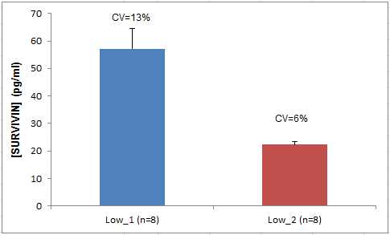
Figure E. Reproducibility study results of SURVIVIN.
For PFN-1 (USCN Life,WUHAN EIAAB SCIENCE CO. LTD, E2122h), 3 samples of low, medium and high [PFN-1] were assayed six (6) times each. The CV of the low concentration sample was not satisfactory (25%). The medium and high [PFN-1] samples exhibited % Recoveries of 17% and 15% respectively that were considered satisfactory.According to the 4PL fit, the CV of the low [PFN-1] sample was 39%, for the medium [PFN-1] sample was 16% and for the high [PFN-1] sample 55%.(Figure F)

Figure F. Reproducibility study results of PFN-1.
For PFN-1 (US Biological Life Sciences, 027613), 3 samples of low, medium and high [PFN-1] were assayed five (5) times each. The CV% was very satisfactory for the high [PFN-1] sample (3%) but out of the limits of acceptance for the medium and low [PFN-1] samples. (23% and 122% respectively)According to the 4PL fit, the 3 samples of low, medium and high [PFN-1] exhibited the same CVs. (Figure G)
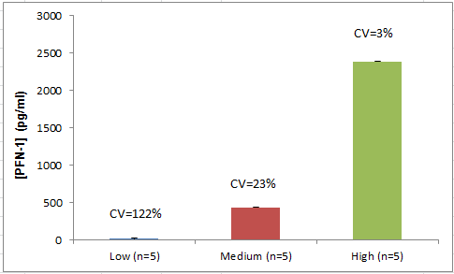
Figure G. Reproducibility study results of PFN-1.

For PFN-1 (Cloud-Clone Corp., USCN Life Science Inc., SEC233Hu), 3 samples of low, medium and high [PFN-1] were assayed six (6) times each. The low and high [PFN-1] samples exhibited satisfactory CVs (12% and 6% respectively), whereas the CV of the medium [PFN-1] sample was above the acceptable limit (23%).According to the 4PL fit, the low [PFN-1] sample had CV=6%, the medium and the high standards had CVs of 28% and 22% respectively). (Figure H)
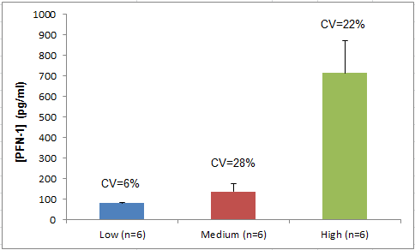
Figure H. Reproducibility study results of PFN-1.
For NIF-1 (CUSABIO Biotech CO. LTD, CSB-EL026683HU), 2 samples of medium and high [NIF-1] were assayed eight (8) times each. The samples exhibited the following CVs: (14% for the medium [NIF-1] sample and 6% for the high [NIF-1] sample). The high and the medium [NIF-1] samples had low CVs which were acceptable. According to the 4PL the medium and high [NIF-1] samples had CVs of 15% and 9% respectively. (Figure I)
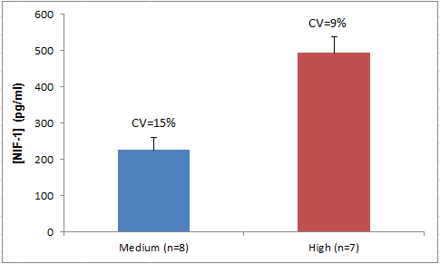
Figure I. Reproducibility study results of NIF-1.
For NIF-1 (USCN Life, WUHAN EIAAB SCIENCE CO., LTD, E1019h), 2 samples of low and medium [NIF-1] were assayed five (5) times each. Both samples exhibited satisfactory CVs. (10% for the low [NIF-1] sample and 11% for the medium [NIF-1] sample). According to the 4PL fit the low and medium [NIF-1] samples had CVs of 9% and 11% respectively. (Figure J)
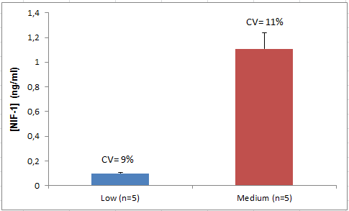
Figure J. Reproducibility study results of NIF-1.

