S5 Fig

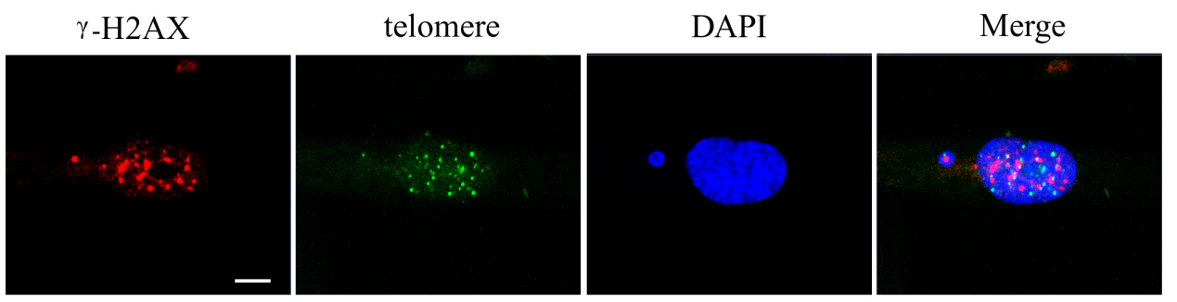

S5 Fig. MN-γ-H2AX (+)-telomere (+) in H2ac depleted cells. Cells with H2ac siRNA were grown on coverslips in 6-well plates before they were processed for telomere FISH and immunofluorescence staining with anti γ–H2AX antibody. Scale bar, 5 μm.

