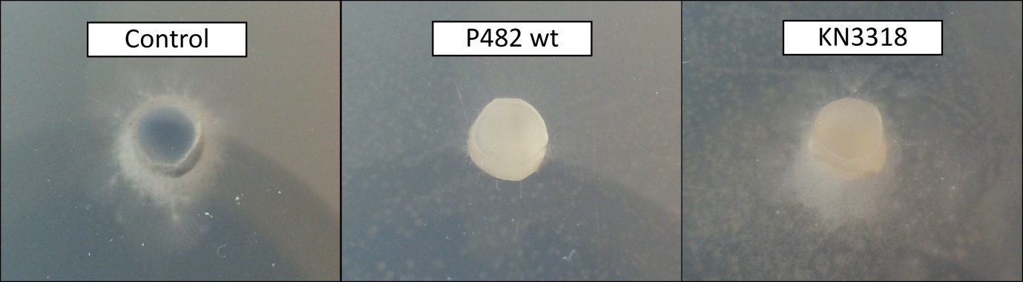
S2 Fig. Photography of the V. dahliae cultures exposed to the Pseudomonas P482 wt volatiles , to the KN3318 mutant volatiles and non-treated control.

