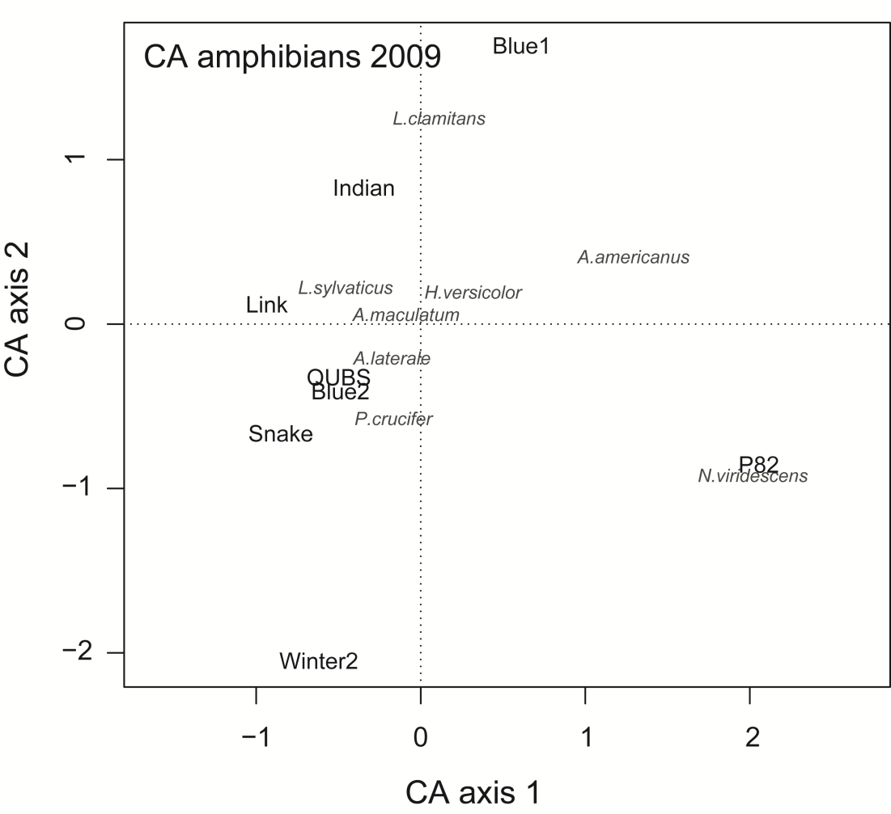
S4 Figure. Correspondence Analysis (CA) of amphibian species assemblage structure (presence-absence data) among ponds in 2009.

