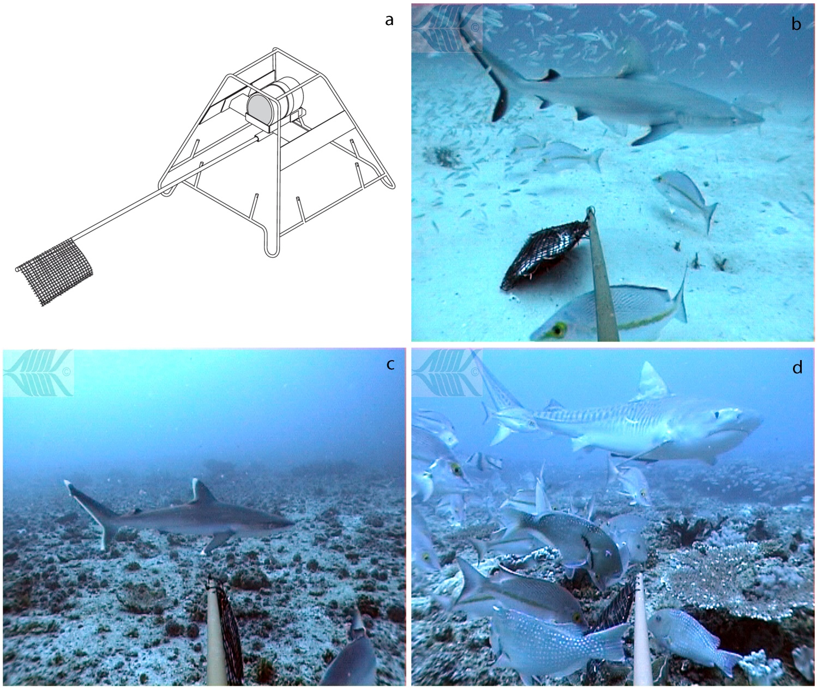
Figure S1 A baited remote underwater video station (BRUVS) showing details of the removable bait arm, plastic camera housing and pegs for placement of ballast on the frame (a). Images of Carcharhinus amblyrhynchos (b), C. albimarginatus (c) and Galeocerdo cuvier (d) in the BRUVS field of view.

