Arbor species
- Rhododendron stamineum (red circle) and Enkianthus serrulatus (blue circle) | - Rhododendron stamineum VS. Enkianthus serrulatus
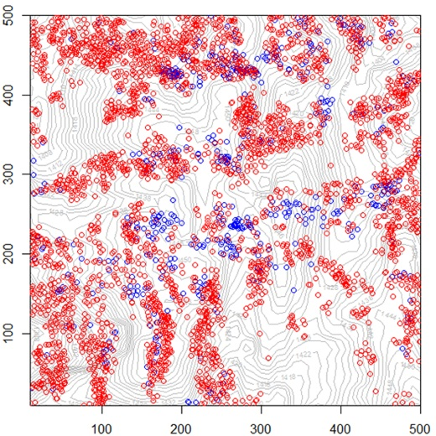
c) Machilus ichangensis (red circle) and Quercus serrate (blue circle) | - Machilus ichangensis VS. Quercus serrate
Shrub species
- Lindera erythrocarpa (red circle) and Photinia beauverdiana (blue circle) | - Lindera erythrocarpa VS. Photinia beauverdiana
g) Neolitsea aurata var. paraciculata (red circle) and Cornus elliptica (blue circle) | (h) Neolitsea aurata var. paraciculata VS. Cornus elliptica

Fig S2. Examples of spatial distributions and bivariate fine-scale species interactions for arbor species (a-d) and shrub species (e-h). Shown are the bivariate g₁₂ pair-correlation function of the data in dependence on scale r (closed circle), the expected g₁₂ function under the heterogeneous Poisson null model (open circle) and the simulation envelopes (gray line) being the fifth-lowest and the fifth-highest values of the Monte Carlo simulations of the null modes. The horizontal lines give the expected g₁₂ function for independent patterns.

