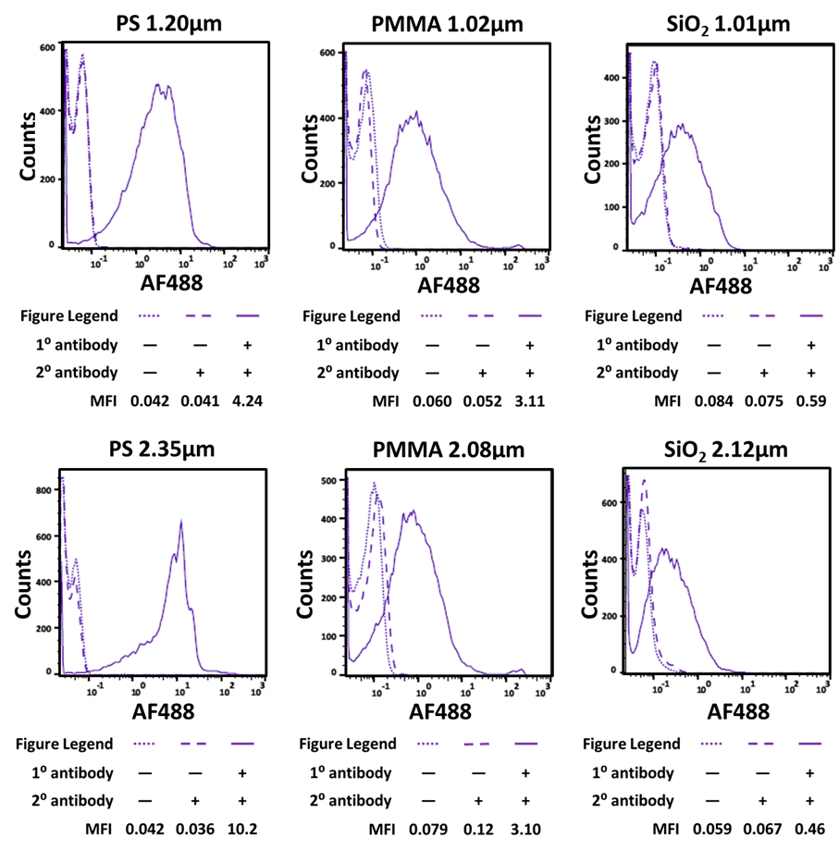
S1 Fig. Determination of antibody immobilization efficiency of commercially available carboxylated beads: Murine monoclonal BBM.1 antibody (1° antibody) was added to protein A-coated PS, PMMA, and SiO₂ beads. The BBM.1 antibody was then detected by goat anti-mouse secondary antibody coupled to Alexa Fluor 488. Fluorescence of the beads was measured by flow cytometry.

