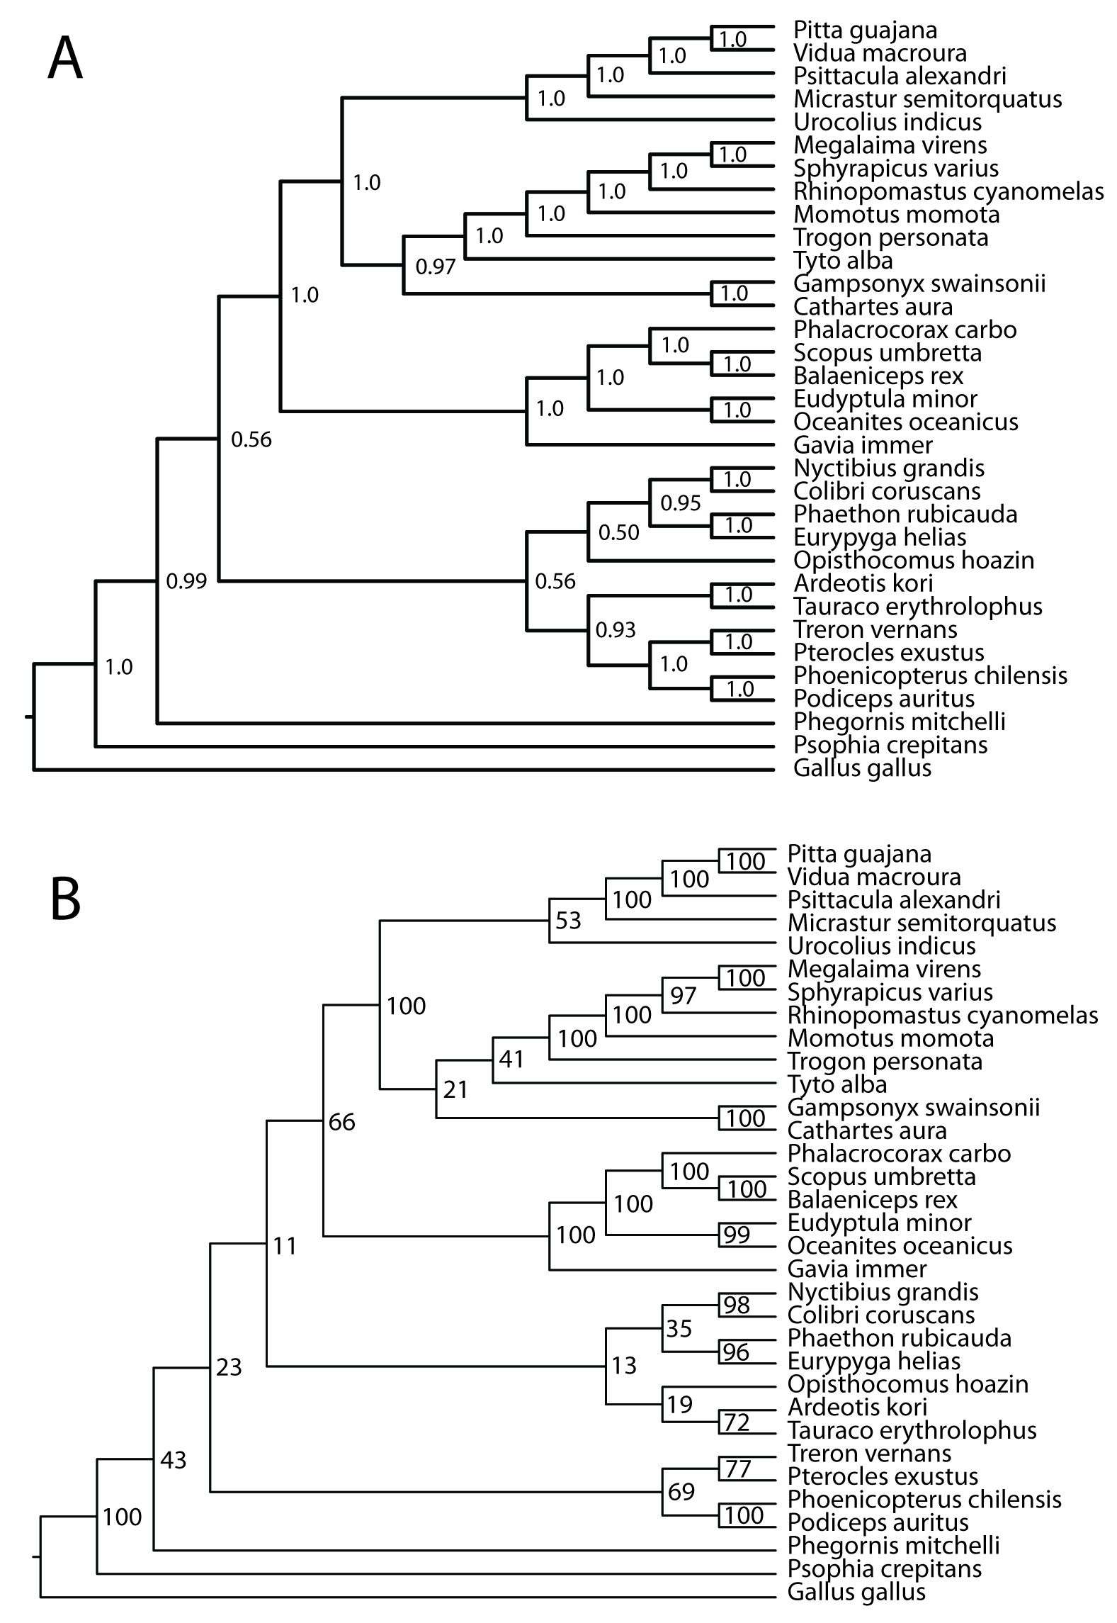
Figure S1. Fully resolved trees from the 1,541 locus analysis with support values. A. Bayesian tree. B. maximum-likelihood tree.

