S2 Appendix. Description of traps used in the mark-release-recapture experiments.
Traps used in this study were custom-made four-vane black panel traps, suspended from 1.6m steel posts baited with a single 150 mL of 95% alpha-pinene-filled and a single 150 mL 98% ethanol-filled sealed 150 μm thick polyethylene dispenser (Fig A).

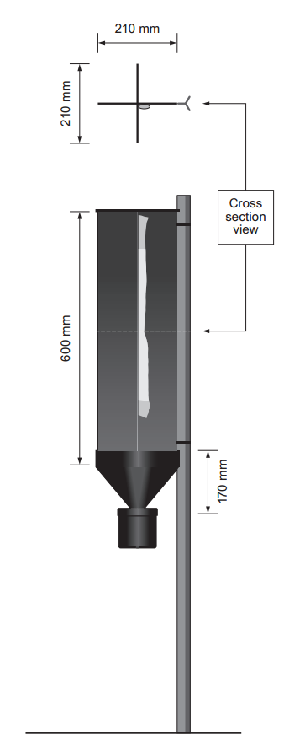
Fig A. Flight intercept panel trap used for mark-release-recapture experiments.

