African perceptions of female attractiveness.
Vinet Coetzee*, Stella J. Faerber, Jaco M. Greeff, Carmen E. Lefevre, Daniel E. Re, David I. Perrett
* Correspondence: vcoetzee@tuks.co.za

Supplementary Text S2: Instructions for post-inflammatory hyper pigmentation ratings
You will be asked to rate faces regarding post-inflammatory hyperpigmentation. Post-inflammatory hyperpigmentation is an acquired hypermelanosis occurring after cutaneous inflammation or injury that can arise in all skin types [1]. Please rate the kind of hyperpigmentation following inflammation due to acne. You will now see a view images showing post-inflammatory hyperpigmentation due to acne.

Stimulus example:
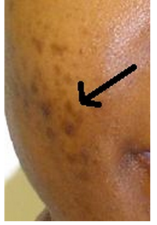
Four stimulus examples were shown for 4 seconds each.

References
1. Davis EC, Callender VD (2010) Postinflammatory hyperpigmentation: a review of the epidemiology, clinical features, and treatment options in skin of color. J Clin Aesthetic Dermatol 3: 20–31.

