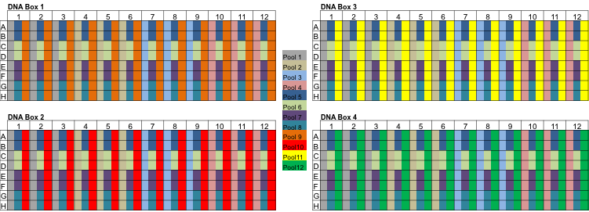

Figure S2. Schematic representation of the pooling design employed for amplicon generation in a target gene, BnSAD.
A total of 384 lines were used for PCR amplification with products from 96 being pooled and used for Illumina library construction with a unique barcoded adapter. A total of 12 row, column and plate pools were generated such that each line was amplified in three different pools to enable the identification of a mutation in a set of six lines. The different pools are represented by different colours in each well of the four 96 well plates containing the 384 different lines.

