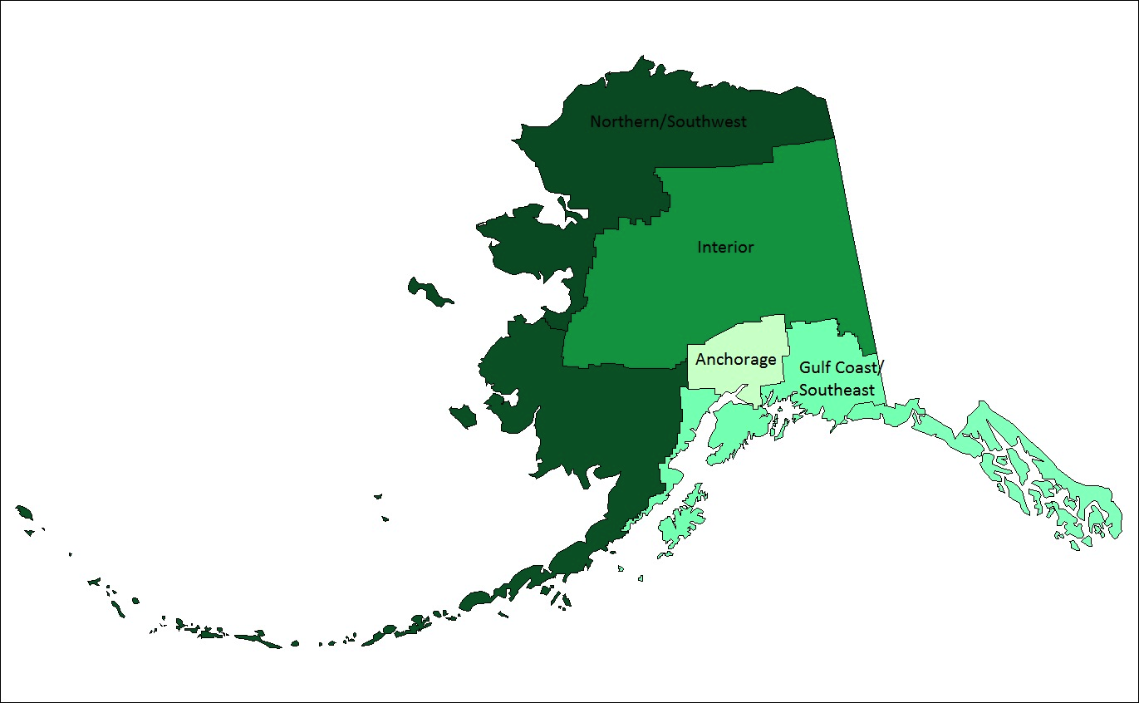

Figure S1: Regions of Alaska

