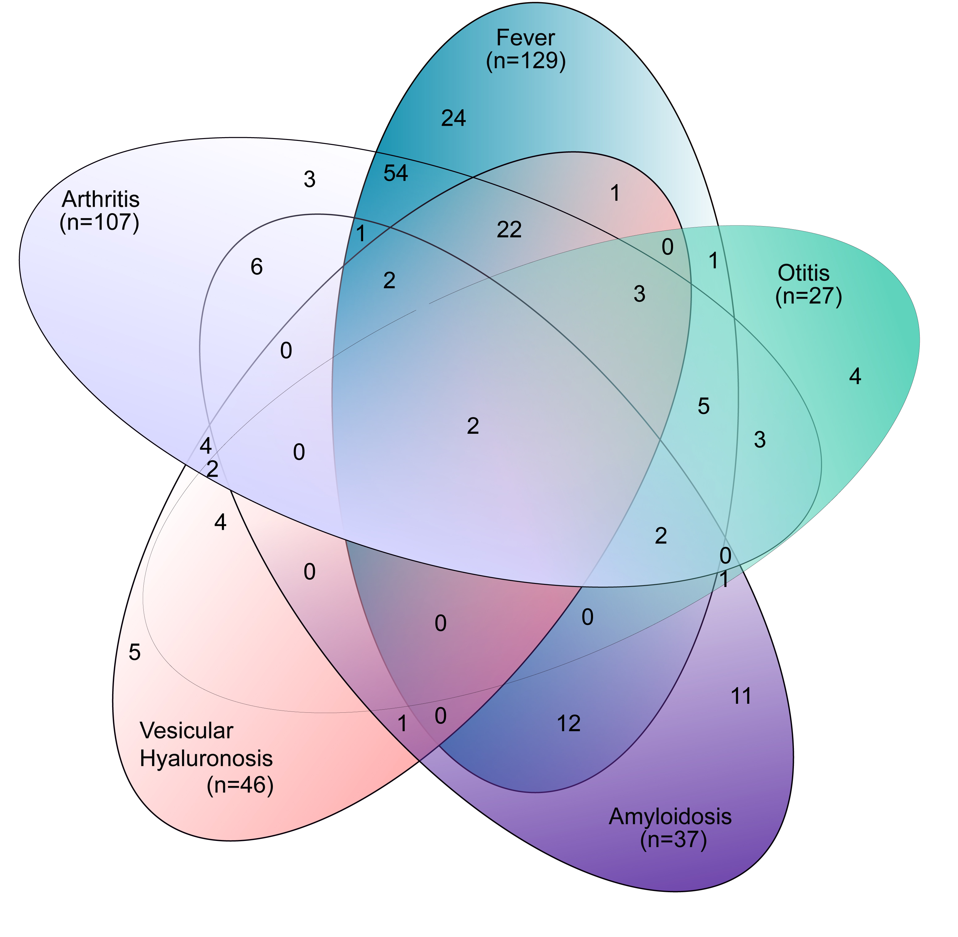
Figure S2. Overlapping membership of individuals to each of the five symptoms of Shar-Pei Autoinflammatory Disease (SPAID). The majority of individuals belong to two or more groups with only two individuals diagnosed to suffer from all symptoms.

