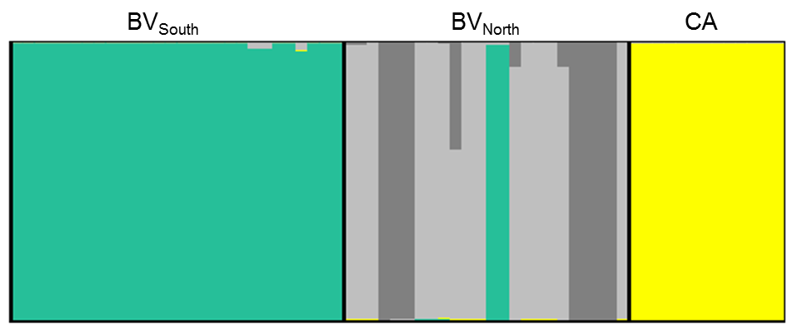
Figure S2 Genetic structure within the three study sites as inferred from the Geneland analysis. Study sites comprise the southern area of Buenaventura (BV_{South}), the northern area of Buenaventura (BV_{North}) and Cerro Azul (CA). Each bar corresponds to an individual´s probability of belonging to a specific genetic cluster. Each of the four genetic clusters is presented in a different colour. Displayed are the results of Bayesian clustering analysis for the reduced data set (n = 65).

