CHST15 mRNA
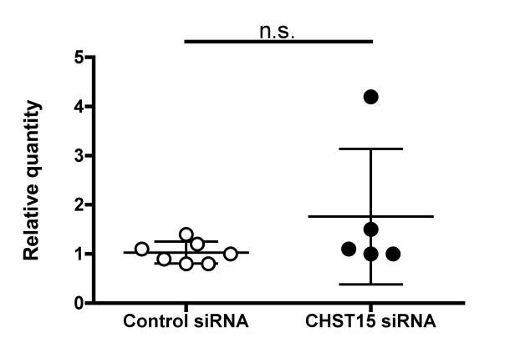

Supporting Information 1.

Gene-suppressive effect of CHST15 siRNA on day-9 tumor in a xenograft model. Relative quantities of CHST15 mRNA in control siRNA treated and CHST15 siRNA treated xenografts at day 9. Data were expressed as mean±SD (Control siRNA: n=7, CHST15 siRNA; n=5).

