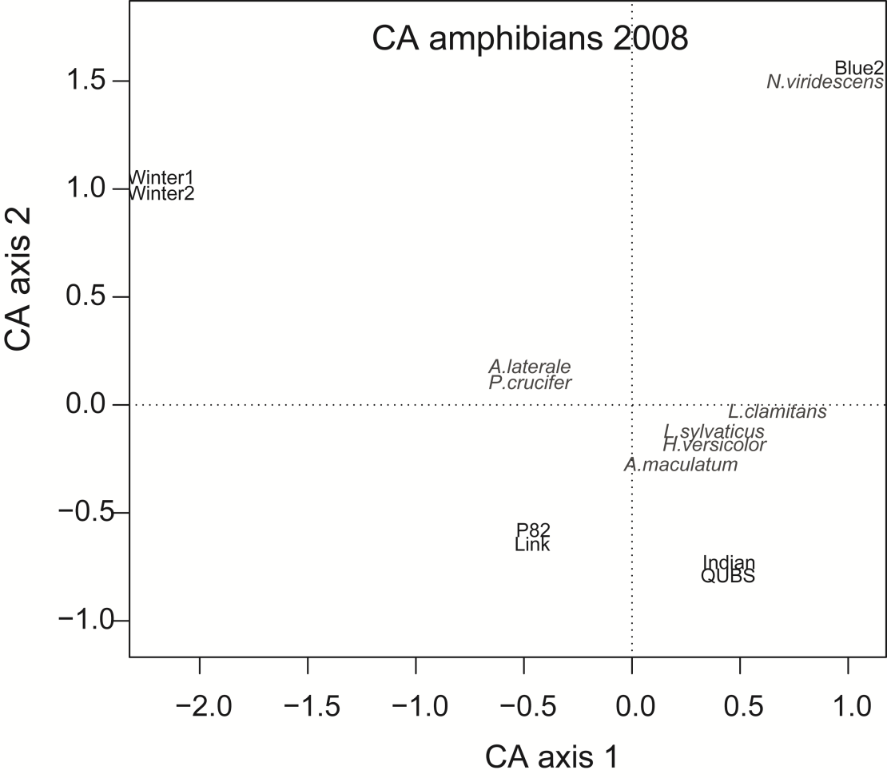
S2 Figure. Correspondence Analysis (CA) comparing amphibian species assemblage structure (presence-absence data) among ponds in 2008.

