S2 Appendix
A. Fig A.
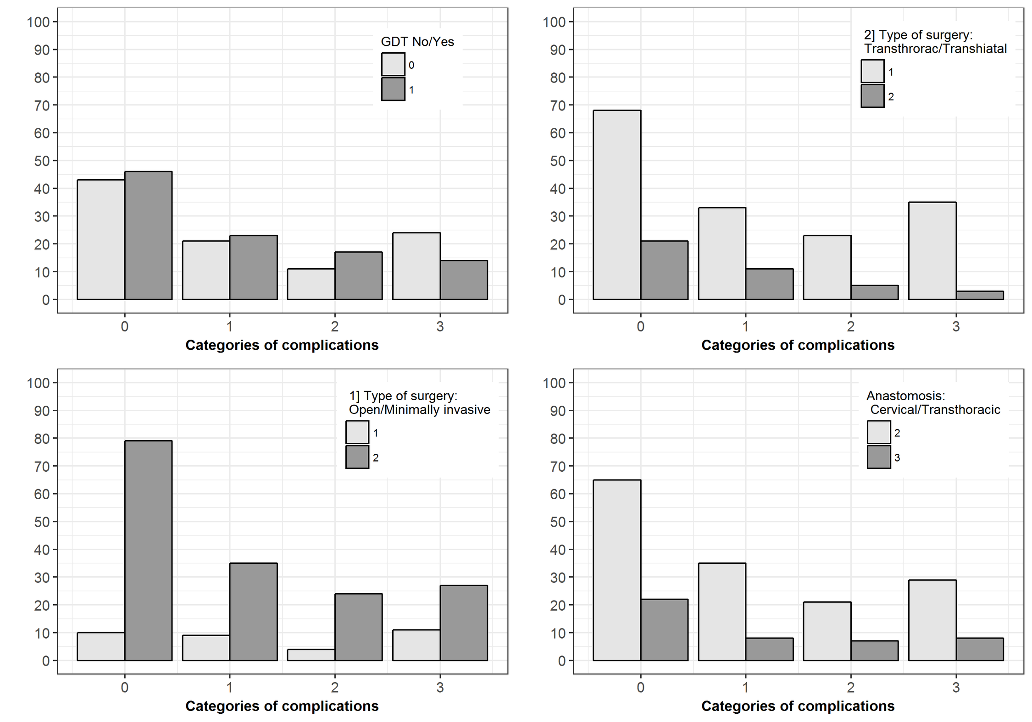

B. Linear regression analysis
Model 1) Included all the potential predictors beside the primary determinant (GDT) for Intraoperative fluid balance. Predictors with a p-value >.10 were excluded from model 2.
 |  | 95% CI
 | Bèta | Lower | Upper | p value
GDT_yes_no | -701,544 | -962,358 | -440,729 | 0.00
Open_minimally invasive | 31,755 | -321,461 | 384,972 | 0.859
Thocr_Ttocr | -313,853 | -642,514 | 14,807 | 0.061
Epidural yes_no | -161,852 | -567,215 | 243,512 | 0.432

Model 2) The same as model 1 but without open_minimally invasive and epidural variables
 |  | 95% CI
 | Bèta | Lower | Upper | p value
GDT_yes_no | -719,516 | -972,425 | -466,607 | .000
thocr_ttocr | -319,992 | -635,532 | -4,453 | .047

Model 1) Included all the potential predictors beside the primary determinant (GDT) for cumulative postoperative fluid balance. Predictors with a p-value >.1 were excluded.
 |  | 95% CI
 | Bèta | Lower | Upper | p value
GDT_yes_no | -894,201 | -1739,169 | -49,232 | .038
Open_scopic surgery | -1644,818 | -2789,144 | -500,492 | .005
thocr_ttocr | -620,149 | -1684,921 | 444,623 | .252
Epidural yes_no | -333,166 | -1646,433 | 980,102 | .617

Model 2) The same as model 1 but without thocr_ttocr and epidural variable
 |  | 95% CI
 | Bèta | Lower | Upper | p value
GDT_yes_no | -927,811 | -1755,656 | -99,966 | .028
Open_scopic | -1481,926 | -2581,654 | -382,199 | .009

A multivariate linear regression model was constructed for intraoperative and cumulative fluid balance by group allocation (standard vs. goal directed therapy (GDT ))–corrected for potential confounders. Potential confounders for which an adjustment was made were: presence of epidural analgesia and type of surgery (open vs. minimally invasive surgery, transhiatal vs. transthoracic surgery). GDT was an independent predictor for fluid balance at the end of the operation. Patients treated with GDT had received a mean of 720 ml less fluids than the standard group (p< .001). GDT was also a predictor for the cumulative amount of fluids received at the time of discharge to the ward

References

1. Software and datasets to support 'Modern Applied Statistics with S', fourth edition, by W. N. Venables and B. D. Ripley. Springer, 2002, ISBN 0-387-95457-0.
2. R Core Team (2016). R: A language and environment for statistical computing. R Foundation for
Statistical Computing, Vienna, Austria. URL https://www.R-project.org/.

