S1 File. Quality assessment of included studies
Table1. Quality assessment of included observational studies based on Newcastle-Ottawa scale
Author, Year | Selection  (4 points) | Comparability  (2 points) | Exposure  (3 points) | Total  (9 points)
Rush,2015 | 3 | 2 | 3 | 8
Anijeet,2010 | 3 | 0 | 2 | 5
Rudnisky,2014 | 3 | 0 | 3 | 6
Shorstein,2013 | 3 | 0 | 3 | 6
Haripriya,2016 | 3 | 1 | 3 | 7
Matsuura,2013 | 3 | 0 | 3 | 6
Friling,2013 | 3 | 1 | 3 | 7
Galvis,2014 | 3 | 0 | 2 | 5
Colleaux,2000 | 3 | 0 | 2 | 5
Jabbarvand,2016 | 3 | 0 | 3 | 6
Christopher,2008 | 4 | 1 | 3 | 8
Jason,2008 | 4 | 1 | 3 | 8
Yu-Wai,2008 | 3 | 0 | 3 | 6
Tan,2012 | 3 | 0 | 3 | 6
Asencio,2015 | 3 | 1 | 3 | 7
Note: We considered the value of total point from 1 to 3, 4 to 6, and ≥ 7 to indicate the quality of the study was low, moderate and high. Comparing with RCTs, the number of participants included in the observational studies was large (≥1000), we obeyed the above rules. On the contrary, if the number was less than 1000, we would make the final decision on Table1 to a lower level.
Fig. 1 Risk of bias summary: review authors' judgements about each risk of bias item for randomized controlled trials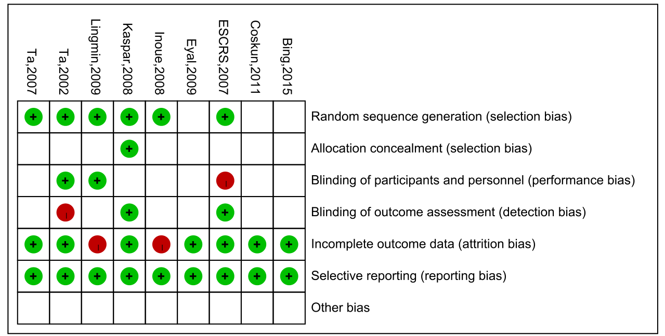

Table2. Quality appraisal of studies included in the meta-analysis.
Study | Random  allocation | Concealment  schemes | Blinding | Withdrawals and Drop-out |  | Jadad scale
ESCRS,2007 | 2 | 1 | 1 | 1 | 5
Coskun,2011 | 1 | 1 | 1 | 1 | 4
Eyal,2009 | 1 | 1 | 1 | 1 | 4
Kaspar,2008 | 2 | 2 | 1 | 1 | 6
Bing,2015 | 1 | 1 | 1 | 1 | 4
Inoue,2008 | 2 | 1 | 1 | 0 | 4
Lingmin,2009 | 2 | 1 | 1 | 0 | 4
Ta,2002 | 2 | 1 | 1 | 1 | 5
Ta,2007 | 2 | 1 | 1 | 1 | 5
Note:
We used Jadad scale to assess the included studies. Points were determined as follows,
- Random allocation: computer-generated random numbers, 2 points; not described, 1 point; inappropriate method, 0 point.
- Allocation concealment: central randomization, sealed envelopes or similar, 2 points; not described, 1 point; inappropriate or unused, 0 point.
- Blindness: identical placebo tablets or similar, 2 point; inadequate or not described, 1 point; inappropriate or no double blinding, 0 point.
- Withdrawals and drop-outs: numbers and reasons are described, 1 point; not described, 0 point.
The Jadad scale score ranges from 1 to 7; higher score indicates better RCT quality. If a study had a modified Jadad score >4 points, it was considered to be of high quality; if the score was 3-4 points, it was moderate quality; and if the score was <3 points, it was low quality.

