Combined Supporting Information File S1

Table S1: Saccharomyces cerevisiae strains

Strain | Genotype | Source
BY4741 | MATa his3∆1 leu2∆0 met15∆0 ura3∆0 | SGD Consortium
BY4741 trp1∆ | BY4741 with trp1∆::Kan^{R} | SGD Consortium
BY4741 rev3∆ | BY4741 with rev3∆::Kan^{R} | SGD Consortium
BY4741 xrs2∆ | BY4741 with xrs2∆::Kan^{R} | SGD Consortium
BY4741 mre11∆ | BY4741 with mre11∆::Kan^{R} | SGD Consortium
BY4741 mms2∆ | BY4741 with mms2∆::Kan^{R} | SGD Consortium
BY4741 rad50∆ | BY4741 with rad50∆::Kan^{R} | SGD Consortium
BY4741 rad51∆ | BY4741 with rad51∆::Kan^{R} | SGD Consortium
BY4741 rad52∆ | BY4741 with rad52∆::Kan^{R} | SGD Consortium
BY4741 rad54∆ | BY4741 with rad54∆::Kan^{R} | SGD Consortium
BY4741 rad55∆ | BY4741 with rad55∆::Kan^{R} | SGD Consortium
BY4741 rad57∆ | BY4741 with rad57∆::Kan^{R} | SGD Consortium
BY4741 exo1∆ | BY4741 with exo1∆::Kan^{R} | SGD Consortium
BY4741 sae2∆ | BY4741 with sae2∆::Kan^{R} | SGD Consortium
WXY2469 | BY4741 with mms2∆::Kan^{R} rad51∆LEU2 | This Study
WXY2950 | BY4741 with sae2∆::Kan^{R} exo1∆LEU2 | This Study
WXY2547 | BY4741 with sae2∆::Kan^{R} mms2∆LEU2 | This Study
WXY2546 | BY4741 with sae2∆::Kan^{R} rev3∆LEU2 | This Study
WXY2949 | BY4741 with mms2∆::Kan^{R} exo1∆LEU2 | This Study
WXY2551 | BY4741 with rev3∆::Kan^{R} exo1∆::LEU2 | This Study
WXY2536 | BY4741 with rev3∆::Kan^{R} mms2∆::URA3 | Lab Stock
WXY2528 | BY4741 with mre11∆::Kan^{R} rev∆∆::nat^{R} mms2∆::LEU2 | This Study
Y5565 | MAT can1∆::MFA1pr-HIS3 mfa1∆::MF1pr-LEU2 lyp1∆  | Lab Stock
 | his3∆1 leu2∆0 ura3∆0 met15∆0
Y8621 | Y5565 with rev3∆::nat^{R} lys2∆+ | Lab Stock
Y9897 | Y5565 with mms2∆::nat^{R} lys2∆+ | Lab Stock
DMA (deletion mutant array) | BY4741 MATa can1∆::MFA1pr-HIS3 lyp1∆
WXY2491 | DMA with rev3∆::nat^{R} mre11∆😐an^{R} | This Study
WXY2493 | DMA with mms2∆::nat^{R} mre11∆😐an^{R} | This Study
WXY2460 | DMA with rev3∆::nat^{R} rad50∆😐an^{R} | This Study
WXY2462 | DMA with mms2∆::nat^{R} rad50∆😐an^{R} | This Study
WXY2219 | DMA with rev3∆::nat^{R} rad51∆😐an^{R} | This Study
WXY2416 | DMA with mms2∆::nat^{R} rad52∆😐an^{R} | This Study
WXY2032 | DMA with rev3∆::nat^{R} rad52∆😐an^{R} | This Study
WXY2417 | DMA with mms2∆::nat^{R} rad54∆😐an^{R} | This Study
WXY2555 | DMA with rev3∆::nat^{R} rad54∆😐an^{R} | This Study
WXY2419 | DMA with mms2∆::nat^{R} rad55∆😐an^{R} | This Study
WXY2020 | DMA with rev3∆::nat^{R} rad55∆😐an^{R} | This Study
WXY2420 | DMA with mms2∆::nat^{R} rad57∆😐an^{R} | This Study
WXY2421 | DMA with rev3∆::nat^{R} rad57∆😐an^{R} | This Study
WXY2477 | DMA with rev3∆::nat^{R} xrs2∆😐an^{R} | This Study
WXY2479 | DMA with mms2∆::nat^{R} xrs2∆😐an^{R} | This Study
DBY747 | MATa his3-∆1 leu2-3,112 trp1-289 ura3-52 | D. Botstein
WXY2379 | DBY747 with mre11∆::HIS3 | This Study
WXY2384 | DBY747 with pol30-K164R | This Study
WXY2389 | DBY747 with mre11∆::HIS3 pol30-K164R | This Study
WXY2390 | DBY747 with mre11∆::HIS3 rev3∆::LEU2 | This Study
WXY667 | DBY747 with rev3∆::hisG-URA3-hisG | This Study
WXY2917 | DBY747 with exo1∆::LEU2 | This Study
WXY644 | DBY747 with mms2∆::URA3 | Lab Stock
WXY2394 | DBY747 with sae2∆::LEU2 | This Study
WXY2379 | DBY747 with mre11∆::HIS3 | This Study
WXY2918 | DBY747 with mms2∆::URA3 exo1∆::LEU2 | This Study
WXY2991 | DBY747 with exo1∆::LEU2 rev3∆::hisG-URA3-hisG | This Study
HK578-10A | MATa ade2-1 can1-100 his3-11,15 leu2-3,112 trp1-1 ura3-1 | H. Klein
HK578-10D | MAT ade2-1 can1-100 his3-11,15 leu2-3,112 trp1-1 ura3-1 | H. Klein
WXY994 | 10A pol30-K164R | Lab Stock
WXY930 | 10D rad18∆::LEU2 | Lab Stock
WXY919 | 10A ade2-1 ade3∆::hisG mre11∆::HIS3 | Lab Stock
WXY989 | 10D pol30∆::HIS3/YCpL-Pol30/pGBT-RAD18/YEpRAD6 | This Study
WXY990 | 10D pol30∆::HIS3/YCpL-pol30-K164R/pGBT-RAD18/YEpRAD6 | This Study
WXY2959 | 10A siz1∆::HIS3 | This Study
WXY2995 | 10A mre11∆::HIS3 siz1∆::LEU2 | This Study
WXY2994 | 10A siz1∆::HIS3 rad51∆::LEU2 | This Study
WXY2962 | 10A siz1∆::HIS3 sae2∆::LEU2 | This Study
WXY2963 | 10A siz1∆::HIS3 exo1∆::URA3 | This Study
WXY2960 | 10A mms2∆::URA3 siz1∆::HIS3 | This Study
WXY2975 | 10A sae2∆::LEU2 | This Study
WXY3007 | 10A pol30-K164R sae2∆::LEU2 | This Study
WXY3008 | 10D rad18∆::TRP1 sae2∆::LEU2 | This Study
JC437 | W303 Mre11-Myc::KanMX | Lab stock
JC2604 | W303 Rad18-HA::TRP1 | This Study
JC2605 | W303 Rad18-HA::TRP1, Mre11-MYC::KanMX | This Study

Figure S1. Gradient plate assay showing that the nuclease activity of Sae2 plays a role in PRR. Single and double mutants were transformed with plasmids carrying wild type, the nuclease/helicase-dead mutations or the vector alone. Overnight cell cultures were imprinted on YPD or YPD + MMS at desired concentrations and incubated at 30°C for 2 days before being photographed. Strains used were isogenic to BY4741.

Figure S2. Control experimental data to confirm anti-PCNA antibody and detection of PCNA ubiquitination. Overnight cultures were subcultured and allowed to grow to a cell count of approximately 1x10⁷ cells/ml before being treated with 0.05% MMS (as indicated) for 90 minutes. Total cell extracts were obtained under denaturing conditions and analyzed by SDS-PAGE and western blot. (A) Monoubiquitinated PCNA is detected in wild-type yeast whole cell extracts without the need for His_{n}-affinity purification. The PCNA ubiquitination band is slightly shifted up in the strain containing the Pol30-His₇ allele compared to the native Pol30 allele (cf. lanes 5 and 6) further confirms that this band is PCNA modification. (B) Overexpression of Rad6 and/or Rad18 enhances detection of PCNA monoubiquitination; however, it is not required for the detection of monoubiquitination (cf. lanes 5 and 6). (C) A null mutation of rad18 abolishes monoubiquitinated PCNA. Strains used were HK578-10A (wild-type) and its isogenic derivatives WXY994 (pol30-K164R) and WXY930 (rad18∆).

Figure S3. Control experiments to confirm di-ubiquitination of PCNA. (A) SUMOylated PCNA is observed in the absence of MMS treatment (lanes 1 and 3), but it is dependent on the Pol30-K164 residue (lanes 2 and 4), as well as SIZ1 (lane 5). (B) Upon MMS treatment, the two prominent bands marked as Ub₁ and Ub₂ are deemed to be PCNA mono- and diubiquitinations, respectively, as they were shifted in the lane containing the Pol30-His₇ cell extract (cf. lanes 1 and 3), and were abolished in the pol30-K164R mutations (lanes 2 and 4). As expected, they were not affected by deletion of SIZ1 (lane 5) and only the diubiquitinated PCNA was abolished by the mms2 null mutation (lane 6). Strains used were HK578-10A (wild-type) and its isogenic derivatives WXY994 (pol30-K164R), WXY2959 (siz1∆) and WXY2960 (mms2∆ siz1∆).

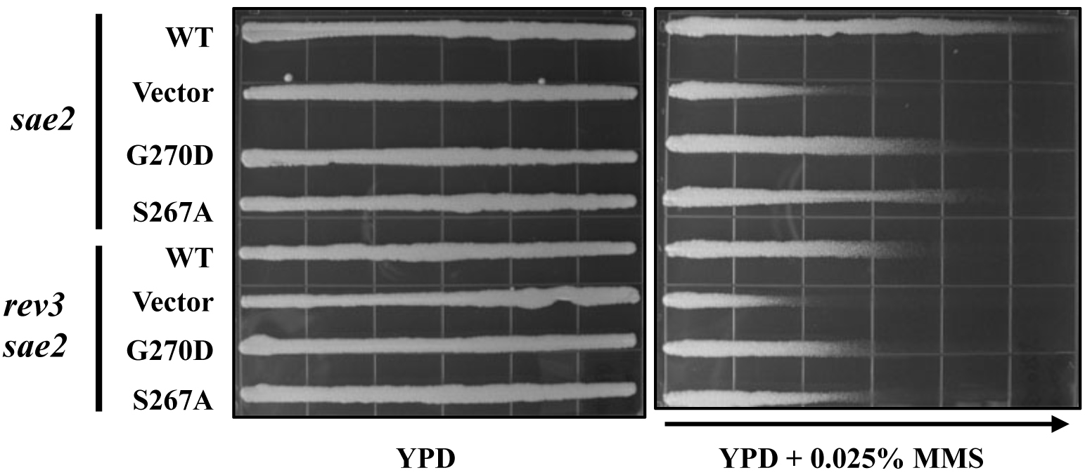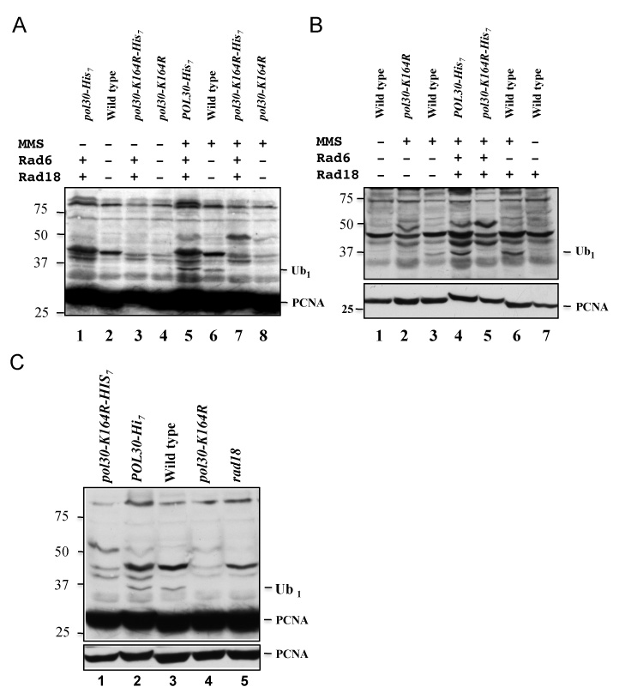
Figure S1

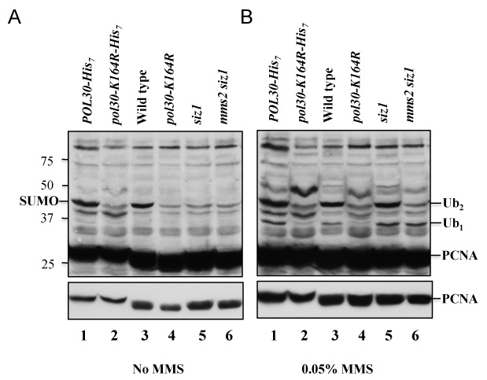
Figure S2

Figure S3

