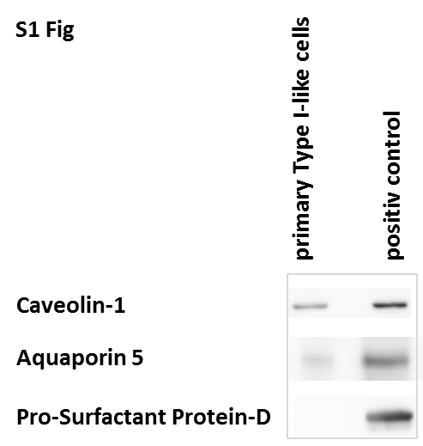

S1 Fig - Expression of alveolar type I (caveolin-1 and aquaporin-5) and II markers (pro-surfactant protein-D) in primary alveolar epithelial cells after 5 days of culture in our laboratory. Measurements were obtained by immunoblots using specific antibodies. A protein extract from rat lung tissue served as positive control.

