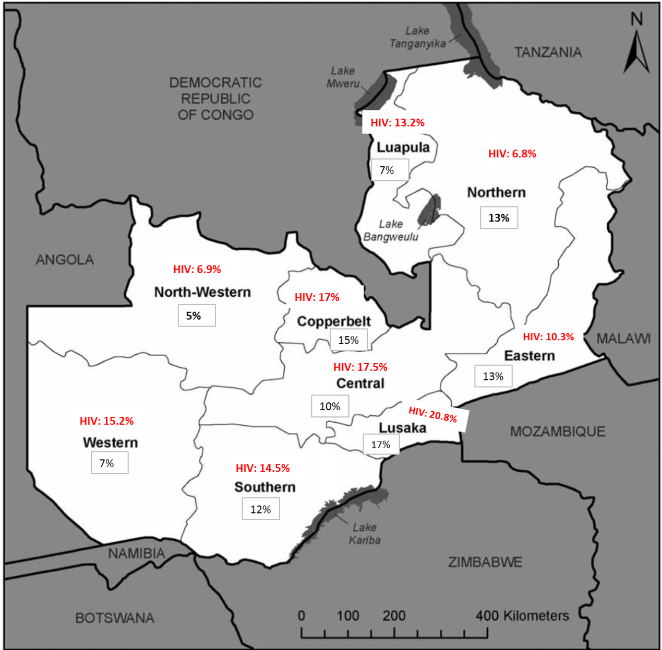
Fig. S2. Map of Zambia showing HIV prevalence* and the proportion of the country’s total population in each province#
Sources: *2007 Demographic and Health Survey (DHS) [1] #2010 Census of Population and Housing [2]

References
1. Zambia Demographic and Health Survey 2007. Available: http://dhsprogram.com/pubs/pdf/FR211/FR211%5Brevised-05-12-2009%5D.pdf [Internet]. CSO and Macro International Inc. 2009.
2. Central Statistical Office, Republic of Zambia. Zambia 2010 Census of Population and Housing. Available: http://unstats.un.org/unsd/demographic/sources/census/2010_phc/Zambia/PreliminaryReport.pdf 2010.

