Figure S1A
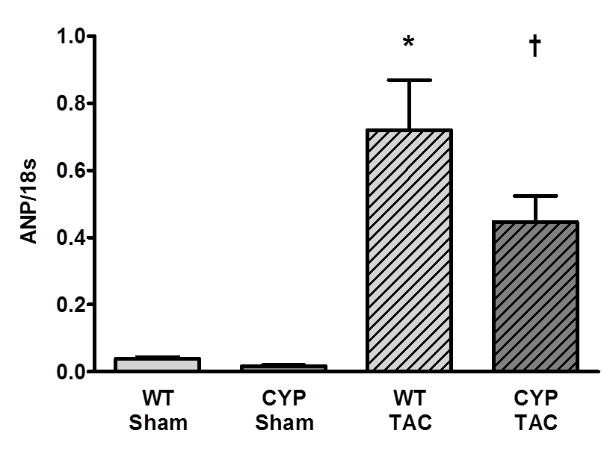

Figure S1B
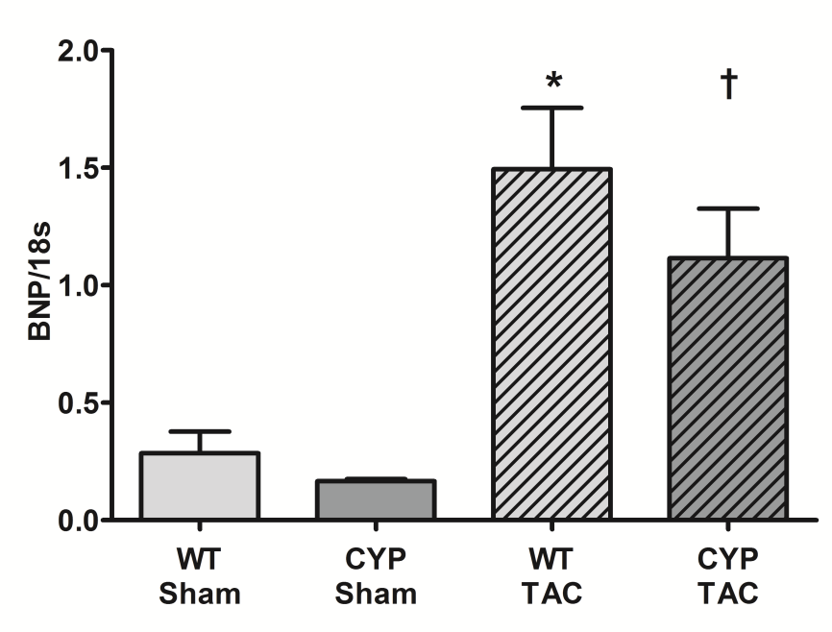

Figure S1C:
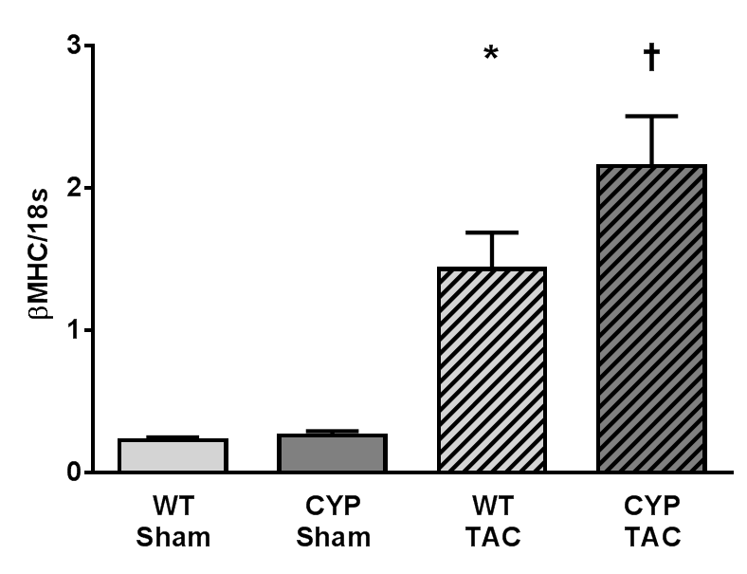
Figure S1D
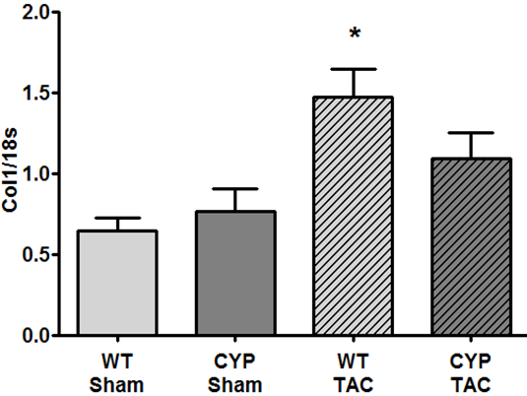

Figure S1E
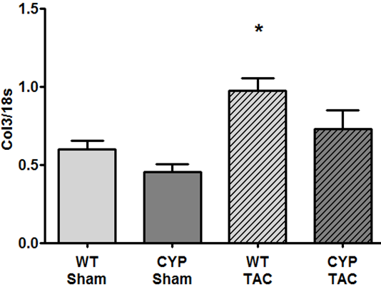

Figure S1: Effect of chronic pressure overload on the expression of markers of hypertrophy and fibrosis in WT and CYP2J2-TG mice. RNA isolated from left ventricular tissue 8 weeks after sham or TAC operation was reverse transcribed and analyzed by quantitative Taqman- or SYBR-PCR for the expression of ANP (A), BNP (B), βMHC (C) as well as Col1 (D) and Col3 (E). WT+Sham: n=13; CYP+Sham: n=7; WT+TAC: n=11; CYP+TAC: n=8. ANOVA, Post-Hoc Tukey; *p<0.05 vs. WT+Sham; †p<0.05 vs. CYP+Sham.

