SUPPORT MATERIAL

S1 Fig. Chromatogram obtained by CG of essential A. suaveolens oil.
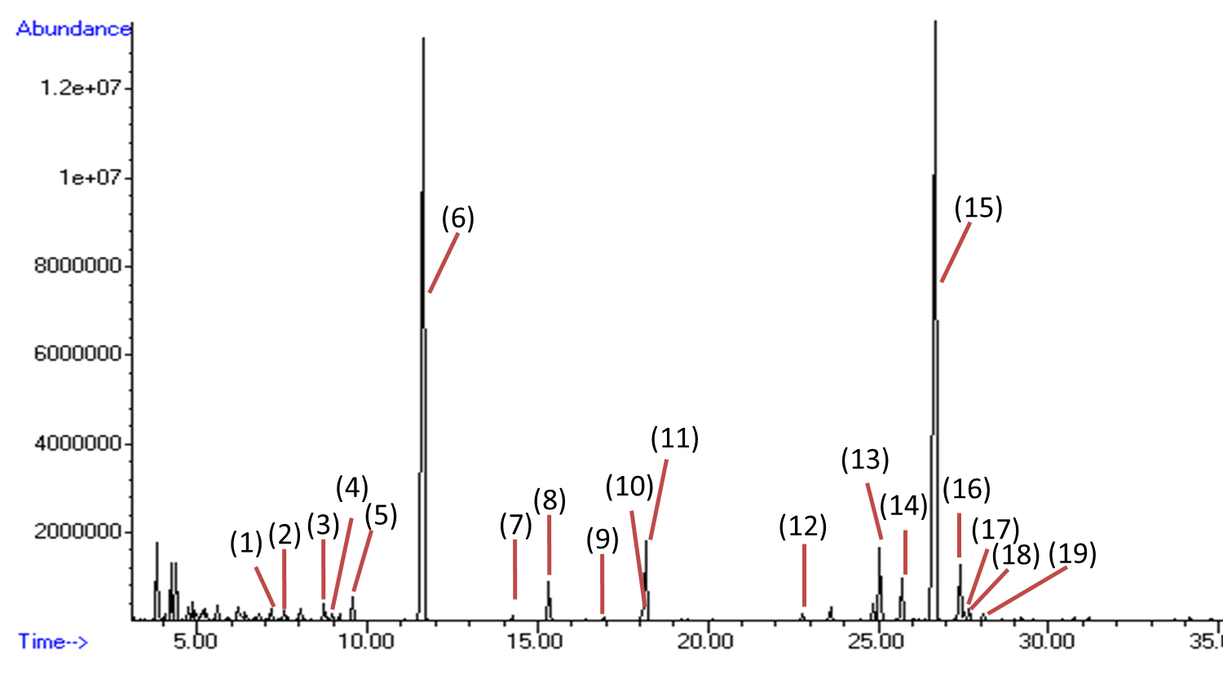
Conditions: Drag gas: Helium (He); initial temperature 60 ° C; initial time 1.0 min .; the column temperature increased 3 ° C / min. to 240 ° C, kept at this temperature for 30.0 min.

