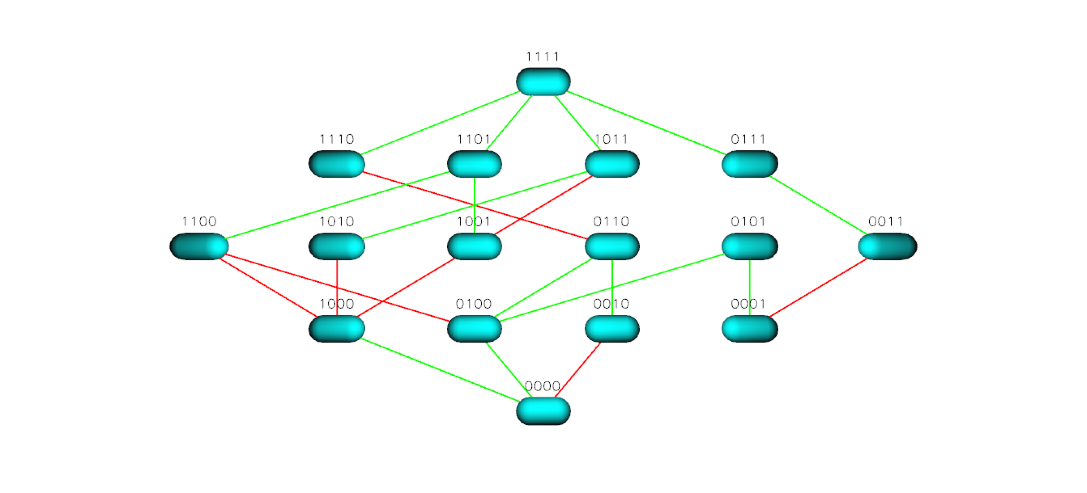
Figure S25 TEM 85 Landscape for Cefepime

