Supplementary Material
S1 Fig A.
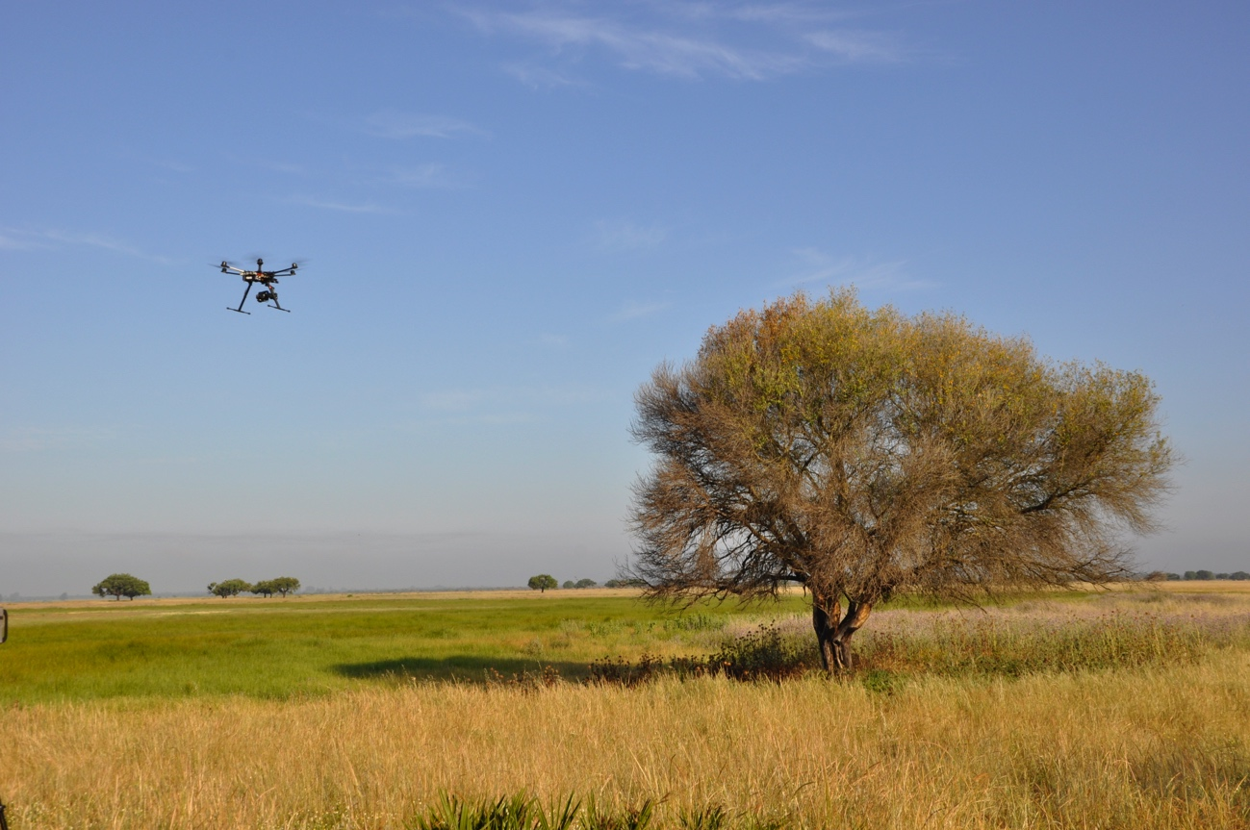
Nest

S1 Table A.
A | Estimate | Std. Error | z value | P
Intercept | -1.189 | 0.228 | -5.19 | <0.001
Treatment (decorated) | 3.437 | 0.298 | 11.53 | <0.001
B | Estimate | Std. Error | t value | P
Intercept | 1.554 | 0.047 | 32.71 | <0.001
Treatment (decorated) | -0.295 | 0.04 | -7.29 | <0.001

