The ARRIVE Guidelines Checklist
Animal Research: Reporting In Vivo Experiments
Carol Kilkenny¹, William J Browne², Innes C Cuthill³, Michael Emerson⁴ and Douglas G Altman⁵
¹The National Centre for the Replacement, Refinement and Reduction of Animals in Research, London, UK, ²School of Veterinary Science, University of Bristol, Bristol, UK, ³School of Biological Sciences, University of Bristol, Bristol, UK, ⁴National Heart and Lung Institute, Imperial College London, UK, ⁵Centre for Statistics in Medicine, University of Oxford, Oxford, UK.

 |  | ITEM | RECOMMENDATION | Section/  Paragraph
 |  |  |  | Page 1
 |  |  |  | Page 3
 | INTRODUCTION
 | 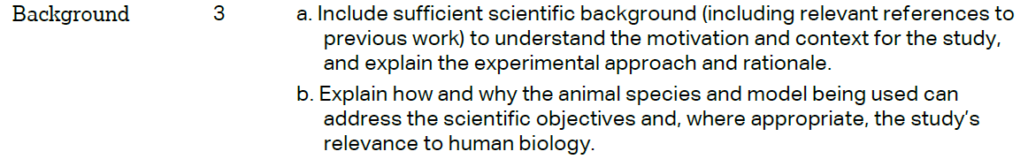 |  |  | Pages 4-5
 |  |  |  | Page 5, paragraph 3
 | METHODS
 |  |  |  | Page 6, paragraph 2
 | 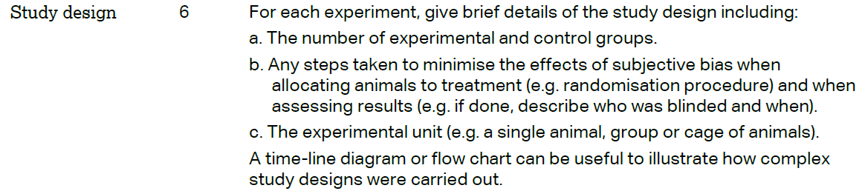 |  |  | Page 6, paragraph 3, Figure Legends (pages 22-24) and Supplementary Materials (Pages 1-2)
 | 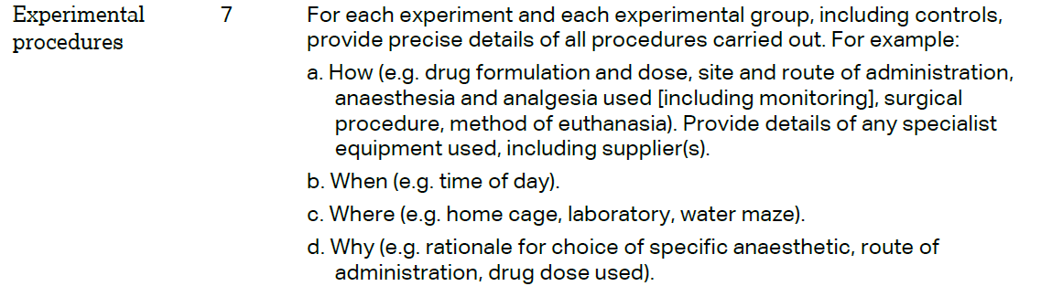 |  |  | Page 6, paragraph 3 and Supplementary Materials (Pages 1-2)
 | 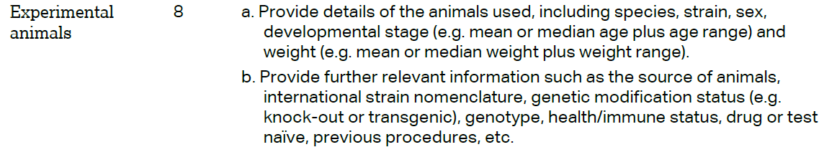 |  |  | Page 6, paragraph 3 and Supplementary Materials (Pages 1-2)
The ARRIVE guidelines. Originally published in PLoS Biology, June 2010¹
 | 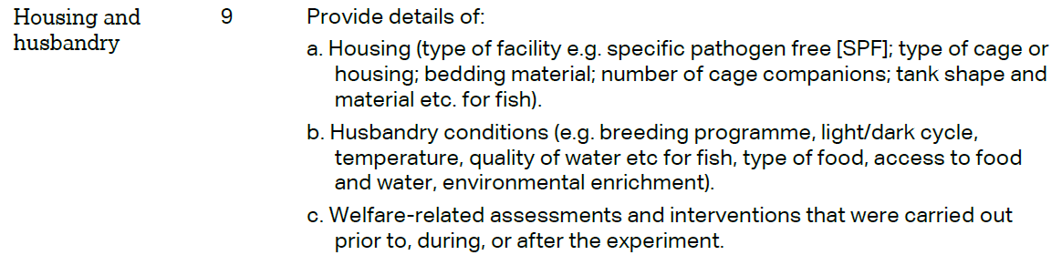 | Page 6, paragraph 3, and Supplementary Material (Pages 1-2)
 | 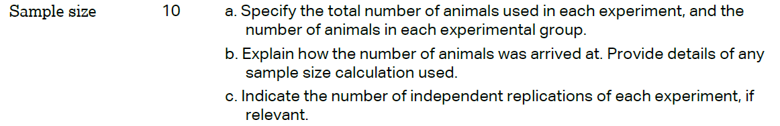 | Figure Legends 1-4 (Pages 22-23)
 | 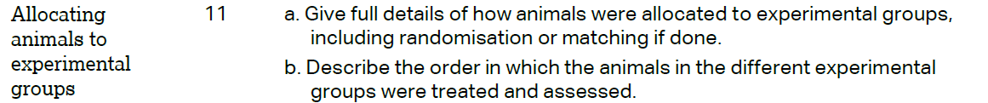 | Figure Legends 1-4 (Pages 22-23)
 |  | Figure Legends 1-4 (Pages 22-23) and Supplementary Material (Pages 1-2)
 | 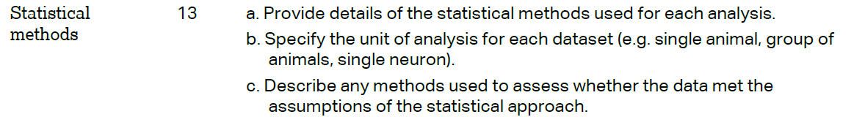 | Page 7
 | RESULTS
 |  | Pages 8-11
 |  | Pages 8-11 and Figure Legends 1-4 (Pages 22-23)
 |  | Pages 8-11
 |  | Pages 8-11
 | DISCUSSION
 | 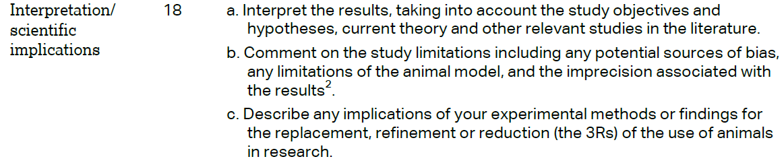 | Pages 13-16
 |  | Pages 13-16
 |  | Online Submission
