Supplementary Material:
Mixed Signals? Morphological and Molecular Evidence Suggest a Color Polymorphism in some the Neotropical Polythore Damselflies
Sánchez Herrera, M., Kuhn, W.R., Lorenzo-Carballa, M.O., Harding, K.M., Ankrom, N., Sherratt, T.N., Hoffmann, J. , Van Gossum, H., Ware, J.L., Cordero-Rivera, A. & Beatty, C.D.

List of Supplementary Table and Figures:
Table A. Localities and GenBank accession numbers for specimens used in this study.
Listed are: voucher/specimen ID; species to which each specimen was initially assigned; sex; collection locality (abbreviation), coordinates, and elevation; GenBank accession number; and reference. Symbols next to specimen ID denote analyses in which that specimen was used: landmark and comparative morphological analyses (†), phylogenetic analysis from morphology (‡), and phylogenetic analysis from COI (*).
Table B. F_{ST} and p-values among Polythore populations.
Values correspond to those represented graphically in Fig. 7. See Fig. 7 legend and methods text for further explanation.
Figure A. Example image of each wingform with landmarks present.
50 landmarks were placed on each of the fore- and hindwings. See Methods and Figs. 2 and 4 for more explanation of landmark placement.
Figure B. Example standardized square image.
Specimen scans were standardized using a custom script in order to make them comparable to one another for the chromaticity and GWT analyses. In this process, wings were first extracted from the original scan and masked, then rotated so that the proximal margin was horizontal, rescaled to 512 px-wide, and arranged with fore- and hindwings on the upper and lower halves of the image, respectively.
Figure C. Depiction of image sub-sampling in the chromaticity analysis.
Sub-images are shown here on a standardized square image of a P. ornata male, which has been transformed to chromaticity coordinates and only the ‘r’ channel taken. Images were samples at 4 scales: (A) full square, (B) each wing separately, (C) thirds of each wing, and (D) sixths of each wing. See Methods for a more detailed explanation.
Figure D. Depiction of Gabor wavelets and GWT image sub-sampling scheme.
(A) Density plots of real and imaginary Gabor wavelets at the 3 angles used in this study; white pixels represent high values and black pixels, low values. (B) Placement of the circular Gabor wavelets (circles) over a square image (dashed); 4 scales of wavelets were used in the GWT analysis (full square, and 1/4, 1/16, and 1/64 of square). See Methods for a more detailed explanation.
Figure E. Relative contributions (loadings) of coefficients in the first two DAPC axes for morphological analyses.
(A) Landmarking, (B) Chromaticity, and (C) GWT analyses. The top 5 contributing coefficients are highlighted in red and correspond to the wing locations highlighted in Fig. 5D–F and S1 F.C.
Figure F. Discriminant analysis of combined morphological analyses.
(A) DAPC plot, (B) relative contributions, and (C) areas of the wings corresponding to the 5 most discriminating coefficients for DAPC axes 1 and 2 for the combined morphological dataset (landmarking, chromaticity, and GWT analyses). See Fig. 5 and Results text for explanation of C. Note: the top contributing coefficients (C) were all from the GWT analysis. Note: in B, coefficients 1–200 are from the landmarking analysis, 201–263 are from the chromaticity analysis and the remaining coefficients are from the GWT analysis.
Figure G. Phylogenetic reconstruction based on morphological dataset.
Reconstruction was performed using parsimony and bootstrapping (with 500 pseudoreplicates) in TNT and is shown here as a proportional phylogram. Values above branches are bootstrap support values; only values >50% are shown.
File S2. Polythore polymorphism.zip (as a separate file).
Compressed folder containing everything needed to run the analyses presented in this paper, including images, data, and a Mathematica notebook.

Table A
Specimen ID | Species | Sex | Locality | Coordinates | Elev. (m) | GenBank Acc. No. | Ref.
ANDESE/MSH231 * | P. gigantea | ? | Colombia, Antioquia, Caldas, Quebrada |  |  | KP738303 | Sánchez Herrera et al., 2010
ANDESE/LCG010 * | P. gigantea | ? | Colombia, Antioquia, Copacabana |  |  | KP738303 | Sánchez Herrera et al., 2010
ANDESE/MSH206 * | P. gigantea | ? | Colombia, Antioquia, Quebrada La Doctora |  |  | KP738302 | Sánchez Herrera et al., 2010
ANDESE/MSH212 * | P. gigantea | ? | Colombia, Antioquia, Quebrada La Doctora |  |  | KP738301 | Sánchez Herrera et al., 2010
ANDESE/MSH220 * | P. gigantea | ? | Colombia, Antioquia, Quebrada La Miel |  |  | KP738304 | Sánchez Herrera et al., 2010
ANDESE/MSH183 * | P. procera | ? | Colombia, Cundinamarca, Cementerio |  |  | FJ514980 | Sánchez Herrera et al., 2010
ANDESE/MSH185 * | P. procera | ? | Colombia, Cundinamarca, Cementerio |  |  | FJ514982 | Sánchez Herrera et al., 2010
ANDESE/MSH187 * | P. procera | ? | Colombia, Cundinamarca, Cementerio |  |  | FJ514984 | Sánchez Herrera et al., 2010
ANDESE/MSH189 * | P. procera | ? | Colombia, Cundinamarca, Cementerio |  |  | FJ514986 | Sánchez Herrera et al., 2010
ANDESE/MSH130 * | P. procera | ? | Colombia, Cundinamarca, Quebrada La Catira |  |  | FJ514944 | Sánchez Herrera et al., 2010
ANDESE/MSH132 * | P. procera | ? | Colombia, Cundinamarca, Quebrada La Catira |  |  | FJ514946 | Sánchez Herrera et al., 2010
ANDESE/MSH134 * | P. procera | ? | Colombia, Cundinamarca, Quebrada La Catira |  |  | FJ514948 | Sánchez Herrera et al., 2010
ANDESE/MSH138 * | P. procera | ? | Colombia, Cundinamarca, Quebrada La Catira |  |  | FJ514950 | Sánchez Herrera et al., 2010
ANDESE/MSH140 * | P. procera | ? | Colombia, Cundinamarca, Quebrada La Catira |  |  | FJ514952 | Sánchez Herrera et al., 2010
ANDESE/MSH170 * | P. procera | ? | Colombia, Cundinamarca, Quebrada La Catira |  |  | FJ514968 | Sánchez Herrera et al., 2010
ANDESE/MSH162 * | Euthore fasciata | ? | Colombia, Cundinamarca, Vereda Virgen de Chirajara |  |  | n.a. | Sánchez Herrera et al., 2010
ANDESE/MSH149 * | Polythore sp. | ? | Colombia, Cundinamarca, Vereda Virgen de Chirajara |  |  | FJ514960 | Sánchez Herrera et al., 2010
ANDESE/MSH154 * | Polythore sp. | ? | Colombia, Cundinamarca, Vereda Virgen de Chirajara |  |  | FJ514964 | Sánchez Herrera et al., 2010
ANDESE/MSH158 * | Polythore sp. | ? | Colombia, Cundinamarca, Vereda Virgen de Chirajara |  |  | FJ514966 | Sánchez Herrera et al., 2010
ANDESE/MSH200 * | Polythore sp. | ? | Colombia, Cundinamarca, Vereda Virgen de Chirajara |  |  | FJ514996 | Sánchez Herrera et al., 2010
ANDESE/MSH176 * | P. procera | ? | Colombia, Villavicencio, Bosque Bavaria |  |  | FJ514974 | Sánchez Herrera et al., 2010
ANDESE/MSH191 * | P. procera | ? | Colombia, Villavicencio, Bosque Bavaria |  |  | FJ514988 | Sánchez Herrera et al., 2010
ANDESE/MSH193 * | P. procera | ? | Colombia, Villavicencio, Bosque Bavaria |  |  | FJ514990 | Sánchez Herrera et al., 2010
ANDESE/MSH195 * | P. procera | ? | Colombia, Villavicencio, Bosque Bavaria |  |  | FJ514992 | Sánchez Herrera et al., 2010
ANDESE/MSH197 * | P. procera | ? | Colombia, Villavicencio, Bosque Bavaria |  |  | FJ514994 | Sánchez Herrera et al., 2010
P-88 †‡ | P. aurora | M | Peru (northern), Iquitos (IQT) | S 3º 47.4' W 73º 20.4' | 90 | n.a. | This study
P-89 †‡ | P. aurora | M | Peru (northern), Iquitos (IQT) | S 3º 47.4' W 73º 20.4' | 90 | n.a. | This study
Pa05 †‡* | P. aurora | M | Peru (northern), Iquitos (IQT) | S 3º 47.4' W 73º 20.4' | 90 | KP738289 | This study
Pa87 †‡* | P. aurora | M | Peru (northern), Iquitos (IQT) | S 3º 47.4' W 73º 20.4' | 90 | KP738290 | This study
Pl10 †‡* | P. neopicta | M | Peru, Oxapampa (OX) | S 10º 48.6' W 75º 19.8' | 879 | KP738291 | This study
Pl39 †‡* | P. neopicta | M | Peru, Oxapampa (OX) | S 10º 48.6' W 75º 19.8' | 879 | KP738295 | This study
Po42 †‡* | P. ornata | M | Peru, Oxapampa (OX) | S 10º 48.6' W 75º 19.8' | 879 | KP738307 | This study
P-24a †‡ | P. ornata | M | Peru, Pampa Hermosa (PMH) | S 11º 4.8' W 75º 27.6' | 1342 | n.a. | This study
P-24b † | P. ornata | F | Peru, Pampa Hermosa (PMH) | S 11º 4.8' W 75º 27.6' | 1342 | n.a. | This study
P-25a †‡ | P. ornata | M | Peru, Pampa Hermosa (PMH) | S 11º 4.8' W 75º 27.6' | 1342 | n.a. | This study
P-25b †‡ | P. ornata | M | Peru, Pampa Hermosa (PMH) | S 11º 4.8' W 75º 27.6' | 1342 | n.a. | This study
P-25c †‡ | P. ornata | M | Peru, Pampa Hermosa (PMH) | S 11º 4.8' W 75º 27.6' | 1342 | n.a. | This study
P-26a † | P. ornata | F | Peru, Pampa Hermosa (PMH) | S 11º 4.8' W 75º 27.6' | 1342 | n.a. | This study
P-26b † | P. ornata | F | Peru, Pampa Hermosa (PMH) | S 11º 4.8' W 75º 27.6' | 1342 | n.a. | This study
P-26c † | P. ornata | F | Peru, Pampa Hermosa (PMH) | S 11º 4.8' W 75º 27.6' | 1342 | n.a. | This study
P-32a †‡ | P. ornata | M | Peru, Pampa Hermosa (PMH) | S 11º 4.8' W 75º 27.6' | 1342 | n.a. | This study
P-32b †‡ | P. ornata | M | Peru, Pampa Hermosa (PMH) | S 11º 4.8' W 75º 27.6' | 1342 | n.a. | This study
Po20a †‡* | P. ornata | M | Peru, Pampa Hermosa (PMH) | S 11º 4.8' W 75º 27.6' | 1357 | KP738297 | This study
Po20b †‡* | P. ornata | M | Peru, Pampa Hermosa (PMH) | S 11º 4.8' W 75º 27.6' | 1357 | KP738298 | This study
Po20c †‡* | P. ornata | M | Peru, Pampa Hermosa (PMH) | S 11º 4.8' W 75º 27.6' | 1357 | KP738299 | This study
Po30a †‡ | P. ornata | M | Peru, Pampa Hermosa (PMH) | S 11º 4.8' W 75º 27.6' | 1342 | n.a. | This study
Po30a †‡* | P. ornata | M | Peru, Pampa Hermosa (PMH) | S 11º 4.8' W 75º 27.6' | 1342 | KP738300 | This study
Po30c †‡* | P. ornata | M | Peru, Pampa Hermosa (PMH) | S 11º 4.8' W 75º 27.6' | 1342 | KP738306 | This study
Po43 †‡* | P. ornata | M | Peru, Pampa Hermosa (PMH) | S 11º 4.8' W 75º 27.6' | 1348 | KP738308 | This study
Po45 †‡* | P. ornata | M | Peru, Pampa Hermosa (PMH) | S 11º 4.8' W 75º 27.6' | 1342 | KP738309 | This study
Po47a †‡* | P. ornata | M | Peru, Pampa Hermosa (PMH) | S 11º 4.8' W 75º 27.6' | 1357 | KP738310 | This study
Po47b †‡* | P. ornata | M | Peru, Pampa Hermosa (PMH) | S 11º 4.8' W 75º 27.6' | 1357 | KP738311 | This study
Po49 * | P. ornata | M | Peru, Pampa Hermosa (PMH) | S 11º 4.8' W 75º 27.6' | 1357 | KP738312 | This study
P-43 †‡ | P. spaeteri | M | Peru, Panguana (PAN) | S 9º 37.2' W 74º 55.8' | 261 | n.a. | This study
P-44 † | P. spaeteri | F | Peru, Panguana (PAN) | S 9º 37.2' W 74º 55.8' | 261 | n.a. | This study
P-49 †‡ | P. spaeteri | M | Peru, Panguana (PAN) | S 9º 37.2' W 74º 55.8' | 261 | n.a. | This study
P-50 † | P. spaeteri | F | Peru, Panguana (PAN) | S 9º 37.2' W 74º 55.8' | 261 | n.a. | This study
P-94 †‡ | P. spaeteri | M | Peru, Panguana (PAN) | S 9º 37.2' W 74º 55.8' | 261 | n.a. | This study
Ps06 †‡* | P. spaeteri | M | Peru, Panguana (PAN) | S 9º 37.2' W 74º 55.8' | 261 | KP738327 | This study
Ps07 †‡* | P. spaeteri | M | Peru, Panguana (PAN) | S 9º 37.2' W 74º 55.8' | 261 | KP738328 | This study
Ps08 †‡* | P. spaeteri | M | Peru, Panguana (PAN) | S 9º 37.2' W 74º 55.8' | 261 | KP738329 | This study
Ps09 †‡* | P. spaeteri | M | Peru, Panguana (PAN) | S 9º 37.2' W 74º 55.8' | 270 | KP738330 | This study
Ps54 †‡* | P. spaeteri | M | Peru, Panguana (PAN) | S 9º 37.2' W 74º 55.8' | 269 | KP738331 | This study
Ps57 †‡* | P. spaeteri | M | Peru, Panguana (PAN) | S 9º 37.2' W 74º 55.8' | 270 | KP738332 | This study
Ps58 * | P. spaeteri | F | Peru, Panguana (PAN) | S 9º 37.2' W 74º 55.8' | 263 | KP738333 | This study
Ps90 †‡* | P. spaeteri | M | Peru, Panguana (PAN) | S 9º 37.2' W 74º 55.8' | 227 | KP738334 | This study
PsAM180640 * | P. spaeteri | ? | Peru, Panguana (PAN) | S 9º 37.2' W 74º 55.8' | 261 | AM180640 | Etscher et al., 2006
PsAM180641 * | P. spaeteri | ? | Peru, Panguana (PAN) | S 9º 37.2' W 74º 55.8' | 261 | AM180641 | Etscher et al., 2006
PsAM180642 * | P. spaeteri | ? | Peru, Panguana (PAN) | S 9º 37.2' W 74º 55.8' | 261 | AM180642 | Etscher et al., 2006
PsAM180643 * | P. spaeteri | ? | Peru, Panguana (PAN) | S 9º 37.2' W 74º 55.8' | 261 | AM180643 | Etscher et al., 2006
PsAM180644 * | P. spaeteri | ? | Peru, Panguana (PAN) | S 9º 37.2' W 74º 55.8' | 261 | AM180644 | Etscher et al., 2006
PsAM180645 * | P. spaeteri | ? | Peru, Panguana (PAN) | S 9º 37.2' W 74º 55.8' | 261 | AM180645 | Etscher et al., 2006
Pl35 †‡* | P. neopicta | M | Peru, Perené River Road (PER) | S 10º 57' W 75º 18.6' | 808 | KP738292 | This study
Pl37 †‡* | P. neopicta | M | Peru, Perené River Road (PER) | S 10º 57' W 75º 16.2' | 742 | KP738293 | This study
Pl38 * | P. neopicta | F | Peru, Perené River Road (PER) | S 10º 57' W 75º 16.2' | 814 | KP738294 | This study
Pl39d †‡* | P. neopicta | M | Peru, Perené River Road (PER) | S 10º 57' W 75º 18.6' | 808 | KP738296 | This study
Pp26a †‡* | P. neopicta | M | Peru, Pozuzo (POZ01) | S 9º 53.4' W 75º 31.8' | 609 | KP738316 | This study
Pp26b * | P. neopicta | F | Peru, Pozuzo (POZ01) | S 9º 53.4' W 75º 31.8' | 609 | KP738317 | This study
Pp84 * | P. neopicta | F | Peru, Pozuzo (POZ01) | S 9º 53.4' W 75º 31.8' | 650 | KP738326 | This study
Pp9 †‡* | P. neopicta | M | Peru, Pozuzo (POZ01) | S 9º 53.4' W 75º 31.8' | 609 | KP738313 | This study
Pp23 †‡* | P. neopicta | M | Peru, Pozuzo (POZ02) | S 9º 55.2' W 75º 31.8' | 662 | KP738314 | This study
Pp24 †‡* | P. neopicta | M | Peru, Pozuzo (POZ02) | S 9º 55.2' W 75º 31.8' | 662 | KP738315 | This study
Pp28 †‡* | P. neopicta | M | Peru, Pozuzo (POZ02) | S 9º 55.2' W 75º 31.8' | 662 | KP738318 | This study
Pp29 †‡* | P. neopicta | M | Peru, Pozuzo (POZ02) | S 9º 55.2' W 75º 31.8' | 662 | KP738319 | This study
Pp30 †‡* | P. neopicta | M | Peru, Pozuzo (POZ02) | S 9º 55.2' W 75º 31.8' | 662 | KP738320 | This study
Pp67 †‡* | P. neopicta | M | Peru, Pozuzo (POZ02) | S 9º 55.2' W 75º 31.8' | 662 | KP738321 | This study
Pp68 †‡* | P. neopicta | M | Peru, Pozuzo (POZ02) | S 9º 55.2' W 75º 31.8' | 671 | KP738322 | This study
Pp69 †‡* | P. neopicta | M | Peru, Pozuzo (POZ02) | S 9º 55.2' W 75º 31.8' | 662 | KP738323 | This study
Pv19 †‡* | P. victoria | M | Peru, Pozuzo (POZ02) | S 9º 55.2' W 75º 31.8' | 655 | KP738340 | This study
Pv20 †‡* | P. victoria | M | Peru, Pozuzo (POZ02) | S 9º 55.2' W 75º 31.8' | 655 | KP738341 | This study
Pv72 †‡* | P. victoria | M | Peru, Pozuzo (POZ02) | S 9º 55.2' W 75º 31.8' | 655 | KP738342 | This study
Pv83 †‡* | P. victoria | M | Peru, Pozuzo (POZ02) | S 9º 55.2' W 75º 31.8' | 655 | KP738343 | This study
Pp77 †‡* | P. neopicta | M | Peru, Pozuzo (POZ03) | S 9º 52.2' W 75º 31.8' | 575 | KP738324 | This study
Pp78 †‡* | P. neopicta | M | Peru, Pozuzo (POZ03) | S 9º 52.2' W 75º 31.8' | 575 | KP738325 | This study
Pv12 †‡* | P. victoria | M | Peru, Pozuzo (POZ04) | S 10º 9' W 75º 33.6' | 901 | KP738335 | This study
Pv13 †‡* | P. victoria | M | Peru, Pozuzo (POZ04) | S 10º 9' W 75º 33.6' | 901 | KP738336 | This study
Pv16 †‡* | P. victoria | M | Peru, Pozuzo (POZ04) | S 10º 9' W 75º 33.6' | 901 | KP738338 | This study
Pv15 †‡* | P. victoria | M | Peru, Pozuzo (POZ05) | S 10º 24' W 75º 33' | 901 | KP738337 | This study
Pv18 †‡* | P. victoria | M | Peru, Pozuzo (POZ06) | S 10º 1.8' W 75º 37.8' | 832 | KP738339 | This study
Pv85 †‡* | P. victoria | M | Peru, Pozuzo (POZ06) | S 10º 1.8' W 75º 37.8' | 832 | KP738344 | This study
P-65 †‡ | P. victoria | M | Peru, Pozuzo (POZ09) | S 10º 8.4' W 75º 32.7' |  | n.a. | This study
P-79a † | P. victoria | F | Peru, Pozuzo (POZ09) | S 10º 8.4' W 75º 32.7’ |  | n.a. | This study
P-79b † | P. victoria | F | Peru, Pozuzo (POZ09) | S 10º 8.4' W 75º 32.7’ |  | n.a. | This study
P-21 †‡ | P. victoria | M | Peru, Pozuzo (POZ12) | S 10º 9.1' W 75º 33.4’ |  | n.a. | This study
P-79 †‡ | P. victoria | M | Peru, Pozuzo (POZ12) | S 10º 9.1' W 75º 33.4’ |  | n.a. | This study
P-66 †‡ | P. victoria | M | Peru, Pozuzo (POZ13) | S 10º 8.5' W 75º 32.9’ |  | n.a. | This study
P-5 † | P. neopicta | F | Peru, Pozuzo (POZ15) | S 9º 52.6' W 75º 31.9’ |  | n.a. | This study
P-2 †‡ | P. neopicta | M | Peru, Pozuzo (POZ22) | S 9º 54.9' W 75º 31.6’ |  | n.a. | This study
P-3a †‡ | P. neopicta | M | Peru, Pozuzo (POZ22) | S 9º 54.9' W 75º 31.6’ |  | n.a. | This study
P-3b †‡ | P. neopicta | M | Peru, Pozuzo (POZ22) | S 9º 54.9' W 75º 31.6’ |  | n.a. | This study
P-81 †‡ | P. neopicta | M | Peru, Pozuzo (POZ22) | S 9º 54.9' W 75º 31.6’ |  | n.a. | This study
P-82 †‡ | P. neopicta | M | Peru, Pozuzo (POZ22) | S 9º 54.9' W 75º 31.6’ |  | n.a. | This study
P-7a † | P. neopicta | F | Peru, Pozuzo (POZ30) | S 9º 53.5' W 75º 31.9’ |  | n.a. | This study
P-7b † | P. neopicta | F | Peru, Pozuzo (POZ30) | S 9º 53.5' W 75º 31.9’ |  | n.a. | This study

Table B
 | p-values (above diagonal) and F_{ST} values (below diagonal)
Population | Perene River | Oxapampa | Iquitos | Panguana | PHermosa | POZ3 | POZ4 | POZ5 | POZ6 | POZ1 | POZ2
Perene River |  | 0.01802 | 0.08108 | 0.00000 | 0.00000 | 0.99099 | 0.02703 | 0.99099 | 0.04505 | 0.99099 | 0.13514
Oxapampa | 0.96765* |  | 0.07207 | 0.00000 | 0.99099 | 0.14414 | 0.08108 | 0.99099 | 0.11712 | 0.01802 | 0.00000
Iquitos | 0.99163 | 1 |  | 0.00901 | 0.00901 | 0.36937 | 0.10811 | 0.99099 | 0.31532 | 0.01802 | 0.01802
Panguana | 0.90279* | 0.83737* | 0.9799* |  | 0.00000 | 0.00000 | 0.00000 | 0.99099 | 0.01802 | 0.00000 | 0.00000
PHermosa | 0.9874* | 0 | 1* | 0.8904* |  | 0.03604 | 0.00901 | 0.99099 | 0.00901 | 0.00000 | 0.00000
POZ3 | -0.26316 | 1 | 1 | 0.89846* | 1* |  | 0.05405 | 0.99099 | 0.38739 | 0.99099 | 0.99099
POZ4 | 0.53153* | 0.98 | 0.99514 | 0.89626* | 0.99328* | 0.67568 |  | 0.99099 | 0.09910 | 0.09910 | 0.00000
POZ5 | 0.6 | 1 | 1 | 0.88822* | 1* | 1 | 0 |  | 0.39640 | 0.13514 | 0.07207
POZ6 | 0.91273* | 1 | 1 | 0.8863 | 1 | 1 | 0.9397 | 1 |  | 0.06306 | 0.00000
POZ1 | 0 | 0.98312* | 0.99585* | 0.9045* | 0.99347* | -0.26316 | 0.47287 | 0.71429 | 0.9519 |  | 0.99099
POZ2 | 0.1773 | 0.99214* | 0.9983* | 0.93522* | 0.99513* | -0.32663 | 0.78711* | 0.91304 | 0.98078* | -0.05263

Figure A
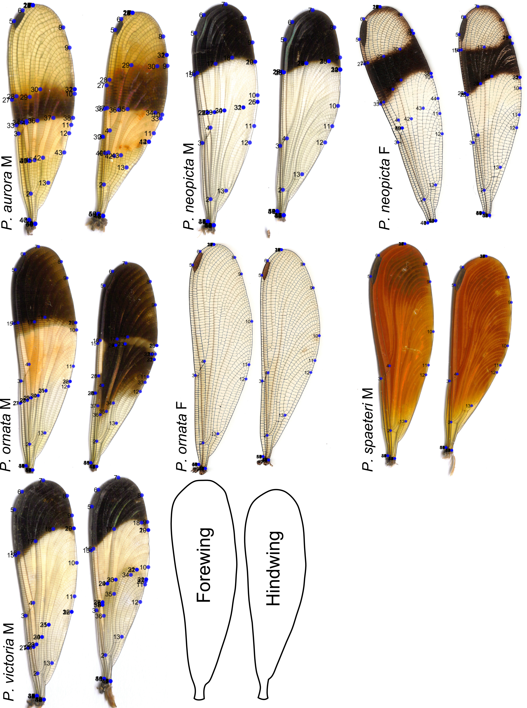
Figure B
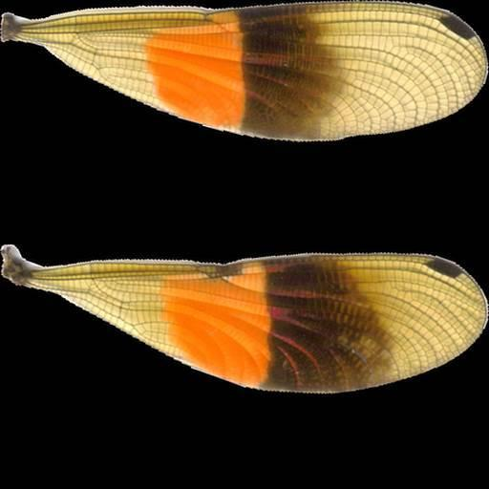
Figure C
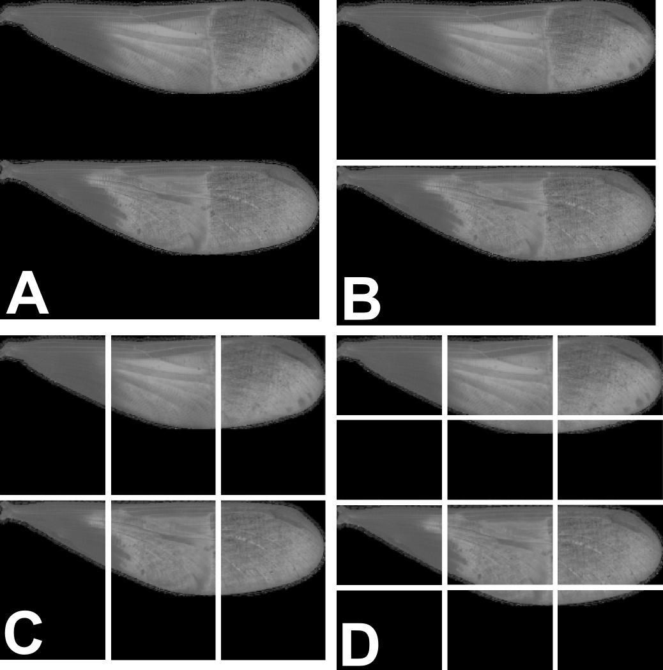

Figure D
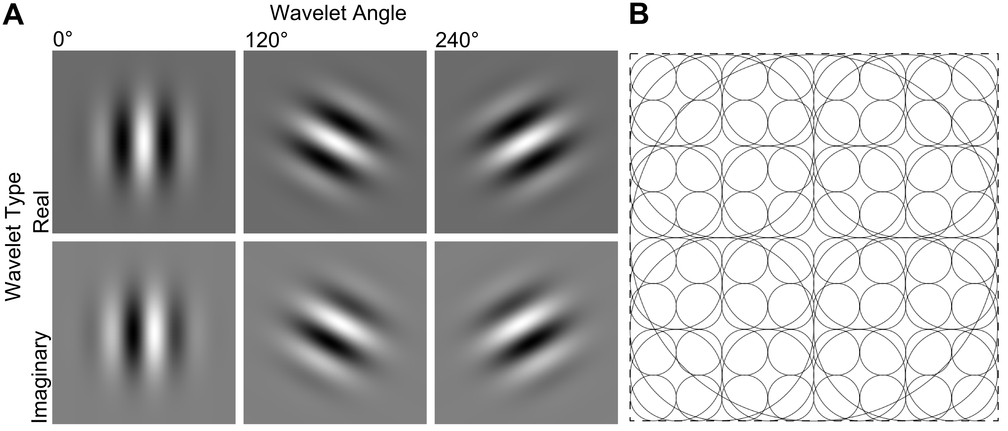
Figure E
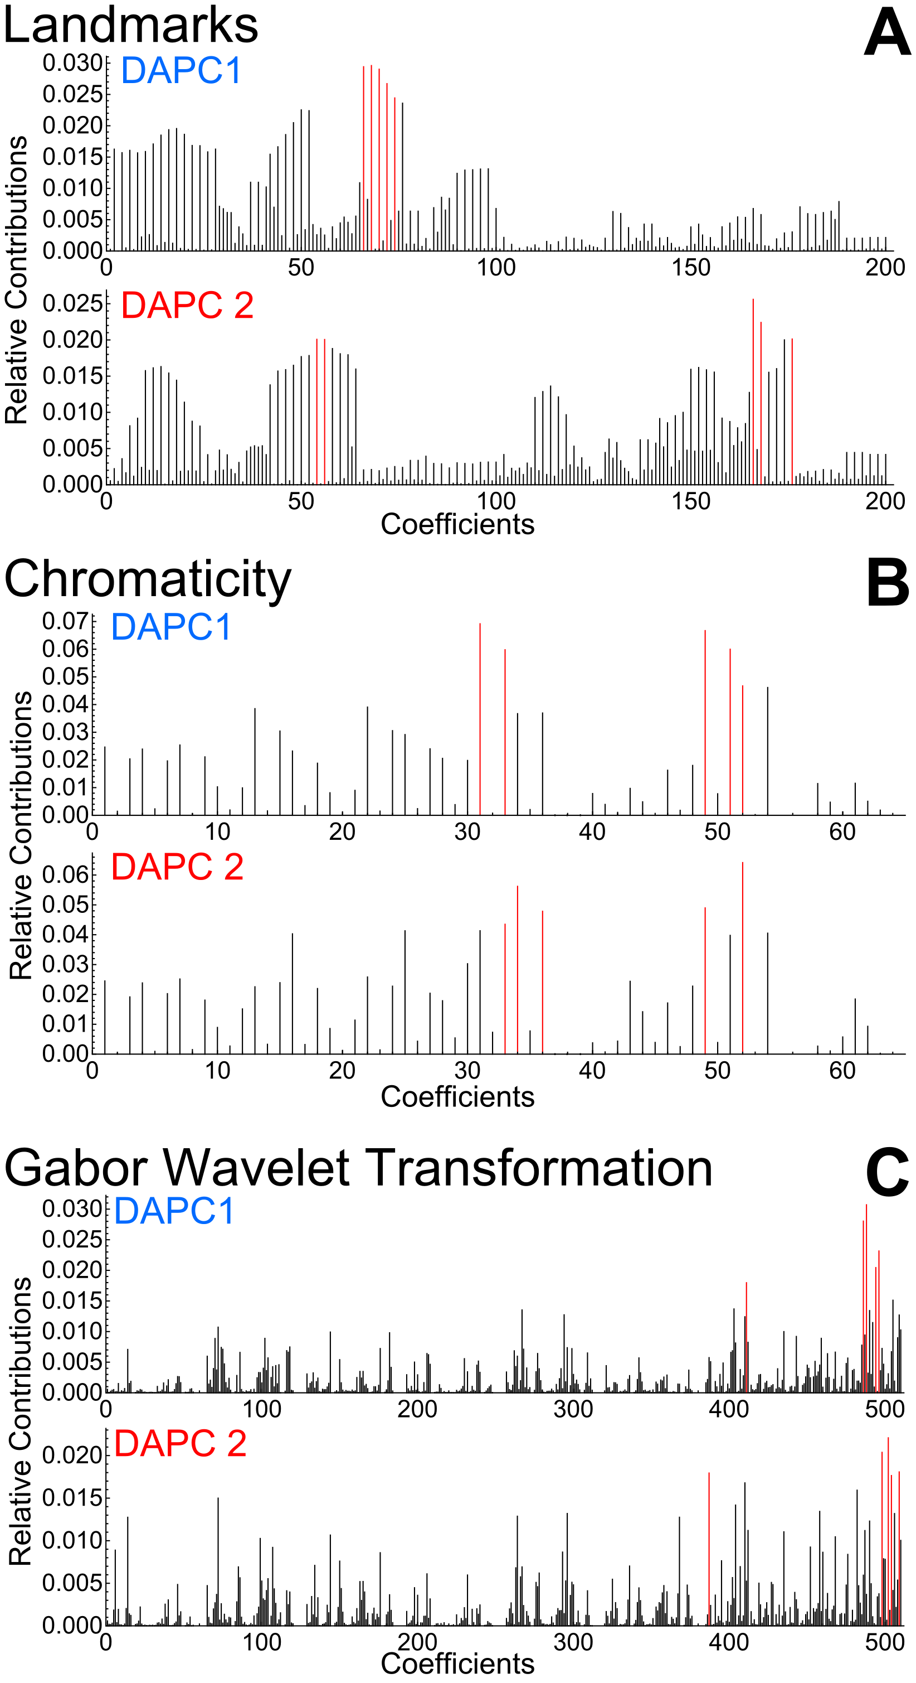
Figure F
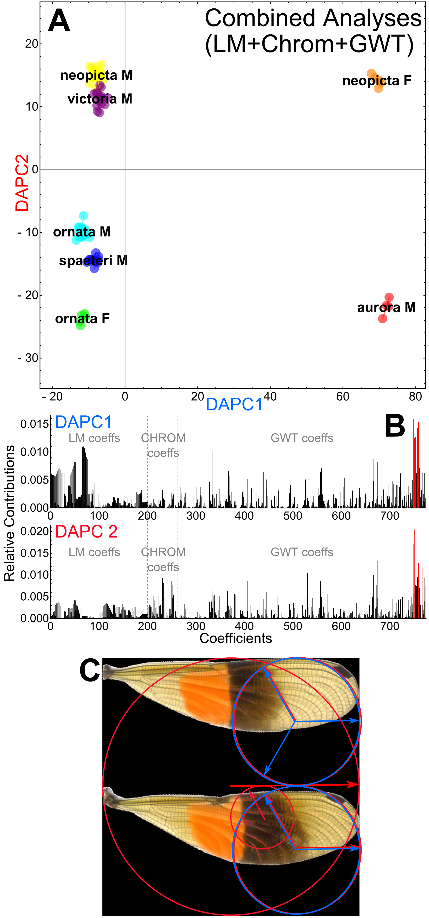
Figure G
