S1 Appendix – Sample scenarios

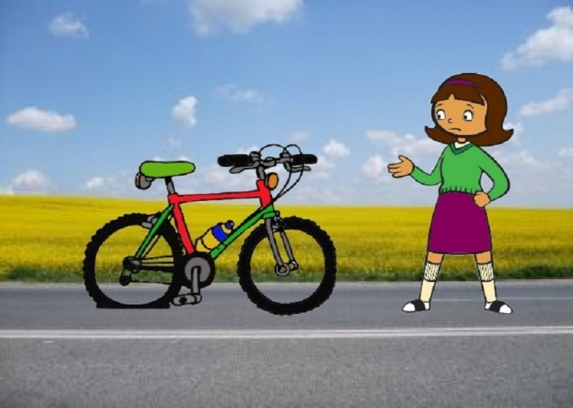 | 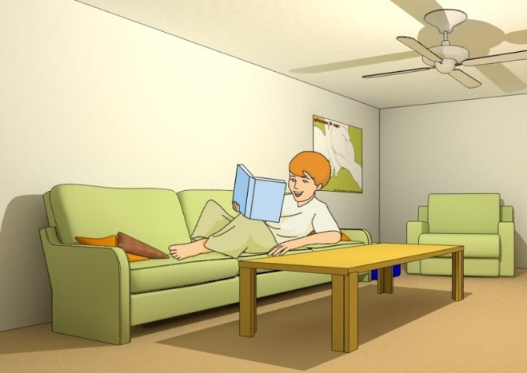
(a)  You are on your way to a friend to bike to school together, but you get a flat tire.  You explain to her what has happened.  You ask her if she can maybe wait for you. | (b)  You’re at home tonight and are bored.  You ask a friend what he’s doing.  You ask whether he maybe wants to meet tonight to play computer games.

