Sample | Selective Agar Plate | Distinct 2mm colonies | Color
Bait + candidate prey | DDO/X | Yes | Blue
 | QDO/X/A | Yes | Blue
Empty pGBKT7 + candidate prey | DDO/X | Yes | White
 | QDO/X/A | No | N/A
A
With Bait (H5N1 NP) and candidate prey (chicken lung cDNA library)

B
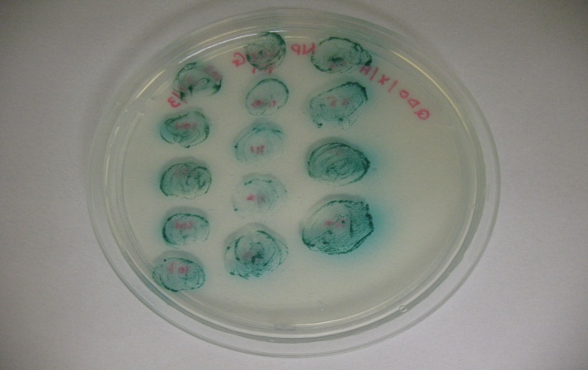
D
C
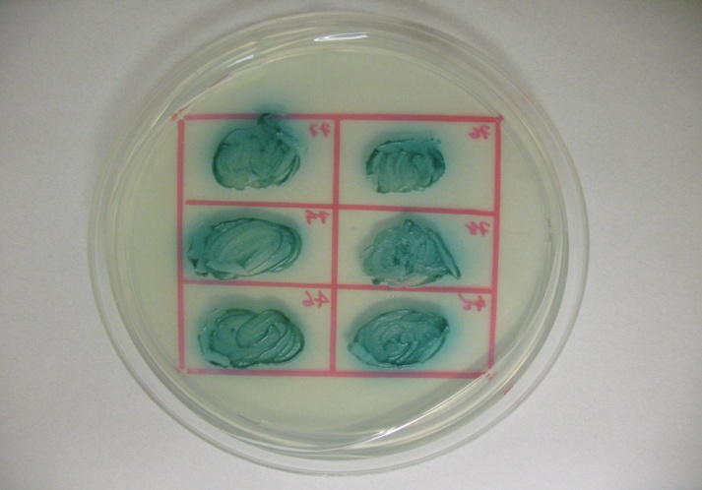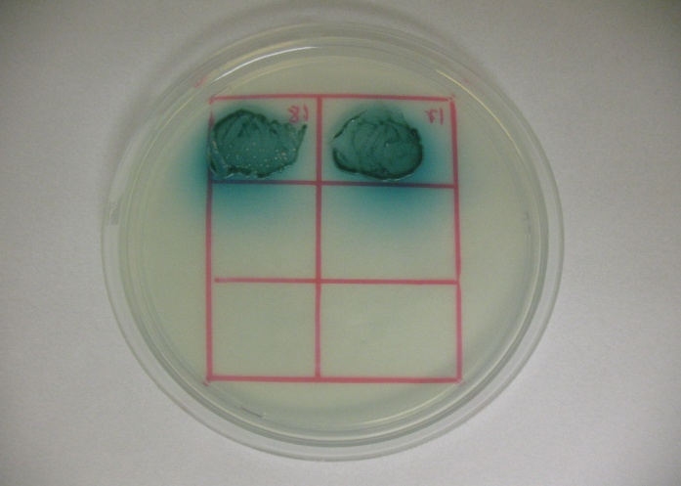
C

