Methods
The phenotype used in the discovery set was longitudinal total serum bilirubin adjusted for clinic, sex and age using a Bayesian hierarchical model. These measurements are modeled using a lognormal distribution with mean, μ and variance, τ. The mean, μ was adjusted using the following formula:
μ = β_{0,clinic}+β_{clinic,age}(age-mean(age)) + β_{clinic,sex}(sex-mean(sex)) + β_{patient}

The mean of distribution was modeled such that each clinic has a separate slope and age and gender effect. The patient ,age and gender random effect and intercept were modeled using a normal prior.
β_{patient}~dnorm(0,τ_{patient})
β_{0,clinic}~dnorm(alpha.0,τ₀)
β_{age}~dnorm(alpha.age,τ_{age})
β_{sex}~dnorm(alpha.sex,τ_{sex})

The mean of the random effects was modeled with a normal distribution and the variance a gamma prior:
alpha.0~ dnorm(200,0.0001)
alpha.age~dnorm(0,0.0001)
alpha.sex~dnorm(0,0.0001)
τ_{patient}~dgamma(1,1)
τ₀~dgamma(1,1)
τ_{age}~dgamma(1,1)
τ_{sex}~dgamma(1,1)

Supplementary Figure 1
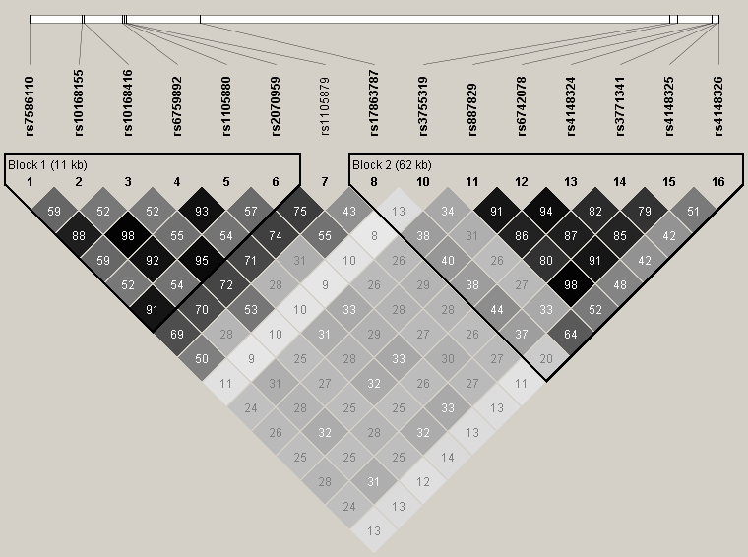
Figure 1 LD Structure in CSSCD Cohort. LD plots for regions in genes UGT1A1, UGT1A3, UGT1A4, UGT1A5, UGT1A6, UGT1A7, UGT1A8, UGT1A9 and UGT1A10 on chromosome 2 in the CSSCD subjects. The LD plot was generated using Haploview 4.2. Each diamond represents the r² value between two SNPs. The LD color scheme is: white r²=0, 0<r²<1 grey (the darker the shade of grey, the higher the r² value), black r²=1.

Adjusted Analysis

In order to determine if these associations were part of one or multiple signals we performed a SNP set association analysis adjusting for age, sex and our top SNP rs887829. The results can be seen in Supplementary Table 1. After adjusting for our top SNP, none of the SNPs show a significant association with serum bilirubin thus providing evidence that the associations shown in these 16 SNPs are part of one signal.

Supplementary Table 1

SNP | Chr | BP | Coded Allele | NonCoded Allele | pvalue
rs7586110 | 2 | 234255266 | C | A | 0.5148
rs10168155 | 2 | 234261575 | A | G | 0.9454
rs10168416 | 2 | 234261826 | G | C | 0.3274
rs6759892 | 2 | 234266408 | C | A | 0.9348
rs1105880 | 2 | 234266704 | G | A | 0.8925
rs2070959 | 2 | 234266930 | G | A | 0.2368
rs1105879 | 2 | 234266941 | C | A | 0.05988
rs17863787 | 2 | 234275833 | C | A | 0.2617
rs3755319 | 2 | 234332321 | A | C | 0.1526
rs6742078 | 2 | 234337378 | A | C | 0.8188
rs4148324 | 2 | 234337461 | C | A | 0.1547
rs3771341 | 2 | 234337978 | A | G | 0.9155
rs4148325 | 2 | 234338048 | A | G | 0.5338
rs4148326 | 2 | 234338201 | A | G | 0.6086

