Figure S1
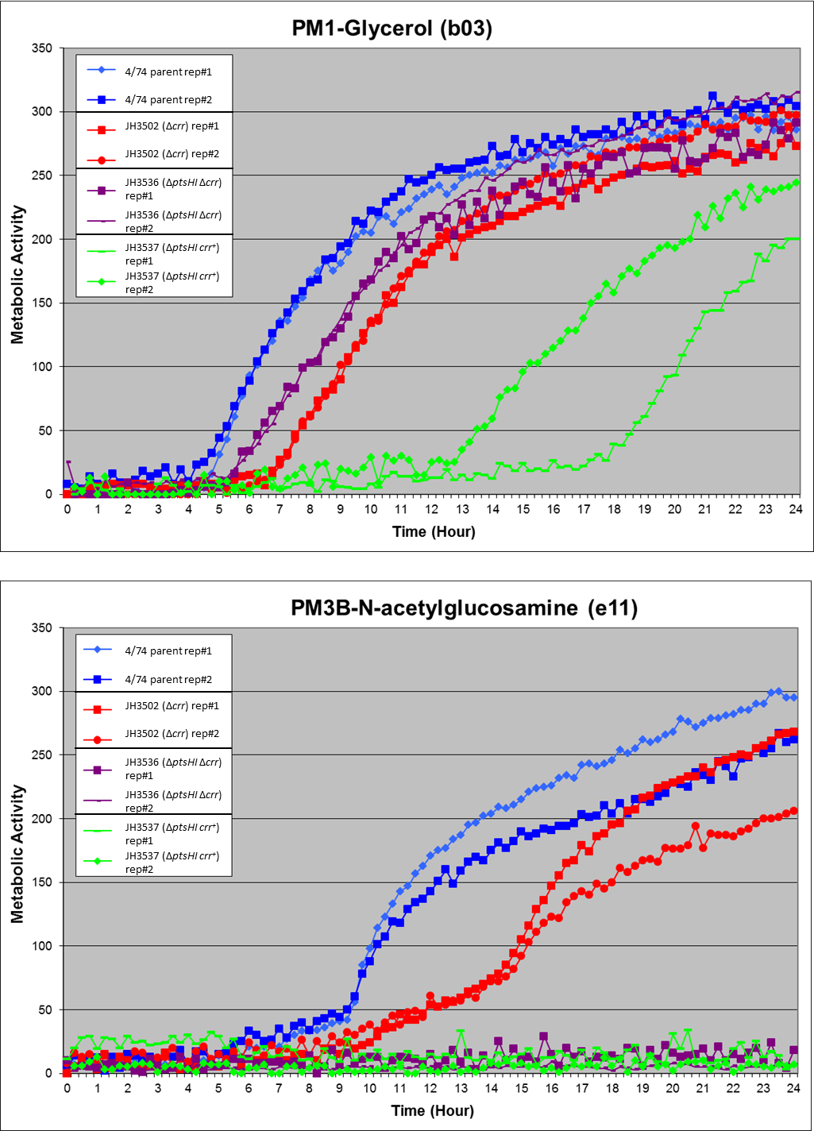
B
A
C
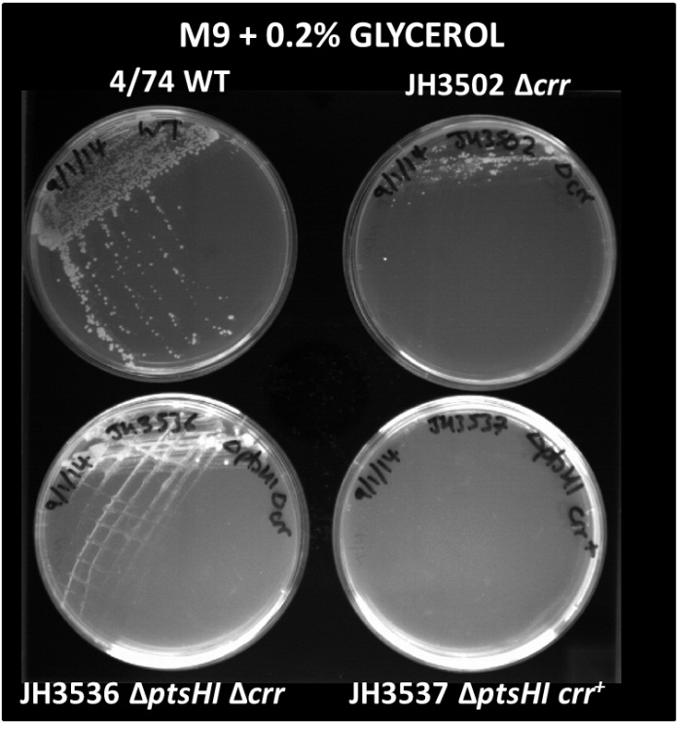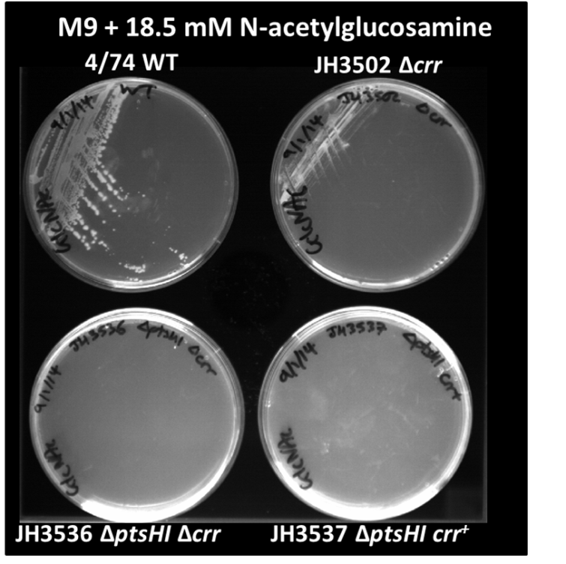
Growth phenotypes of 4/74 parental strain and ΔptsHI crr⁺, ΔptsHIΔcrr and Δcrr strains in media supplemented with either glycerol or NAG as sole carbon sources. Results from duplicate phenotype arrays (BiOLOG) showing growth characteristics of 4/74 parental strain (blue) and ΔptsHI crr⁺(green), ΔptsHIΔcrr (purple) and Δcrr strains (red) in media containing either (A) glycerol or (B) NAG as sole carbon sources. The ΔptsHIΔcrr and Δcrr show similar growth characteristics to the parent strain (4/74) in media containing glycerol whereas the ΔptsHI crr⁺ strain (green) shows considerably retarded growth. The latter phenotype is likely due to the inhibition of glycerol uptake by unphosphorylated EIIA^{Glc}, as described in [48], which can eventually be partially compensated by phosphorylated EII^{Nag}. Neither the ΔptsHI crr⁺ or ΔptsHIΔcrr strains grew in media containing NAG, whereas the Δcrr strain (red) did grow on NAG as sole carbon source. This is most likely due to deletion of the ptsHI genes resulting in the inability to phosphorylate EII^{Nag} and therefore import NAG into the cell [26]. (C) Confirmation of the growth phenotypes of the 4/74, ΔptsHI crr⁺, ΔptsHIΔcrr and Δcrr strains on M9 minimal media plates containing either glycerol or NAG as sole carbon sources.

