SOUTH AFRICA

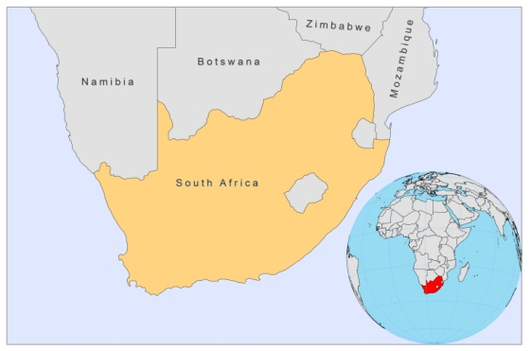

BASIC COUNTRY DATA

Total Population: 49,991,300
Population 0-14 years: 30%
Rural population: 38%
Population living under USD 1.25 a day: 17.4%
Population living under the national poverty line: 23%
Income status: Upper middle income economy
Ranking: Medium human development (ranking 123)
Per capita total expenditure on health at average exchange rate (US dollar): 485
Life expectancy at birth (years): 52
Healthy life expectancy at birth (years): 44

BACKGROUND

A number of CL cases were identified in former South-West Africa (now Namibia) in the 1970s [1]. As environmental conditions are very similar in the neighboring Northern Cape province of South Africa, it is thought that CL is likely to be present there as well.

PARASITOLOGICAL INFORMATION
Leishmania species | Clinical form | Vector species | Reservoirs
Unknown | CL | Unknown | Unknown

MAPS & TRENDS, CONTROL, DIAGNOSIS & TREATMENT, ACCESS TO CARE and ACCESS TO DRUGS

No information available.

SOURCES OF INFORMATION

1. Rutherfoord GS, Uys CJ (1978). Cutaneous Leishmaniasis in Southern Africa. A Case Report. South African Medical Journal. 6 May, 716-18.

