S2 Fig. Pathways most strongly associated with the significantly altered genes in the cold plasma-treated cells.
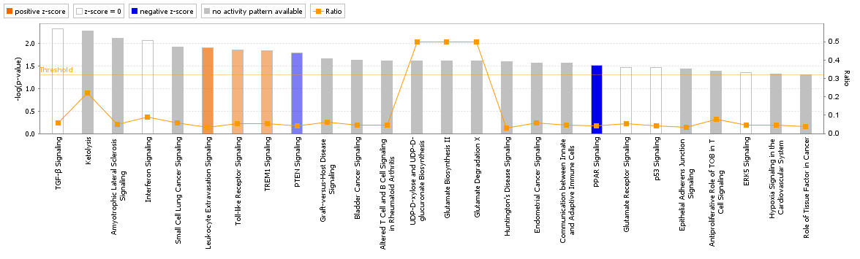
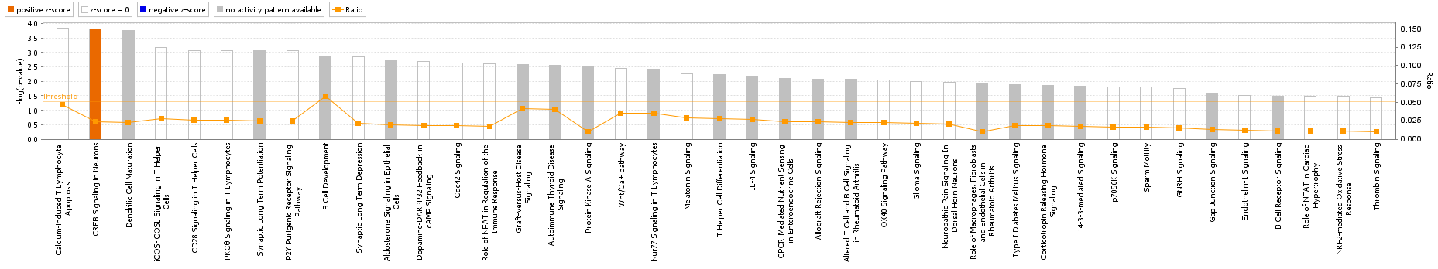
A
B

