Reticulated Origin of Domesticated Emmer Wheat Supports a Dynamic Model for the Emergence of Agriculture in the Fertile Crescent

Peter Civáň, Zuzana Ivaničová, Terence A. Brown

SUPPORTING INFORMATION

Table A List of wheat accessions used for retrotransposon typing

Table B Primer sequences

Table C List of wheat accessions reanalyzed from data of Haudry et al.

Table D Data obtained by inspection of sequence data for 21 loci in wild and domesticated emmer

Fig. A Geographical locations of wild accessions for which Jeli–5.8S sequence data were obtained

Fig. B The most parsimonious tree constructed from the 21-gene concatenated data matrix.

Fig. C MJ Network constructed from 64 rapidly evolving Pm3 gene sequences from tetraploid wheats

Fig. D Model of the pace of genetic identity disruption after intermixing distinct populations

References
Table A. List of wheat accessions
Species | Reclassificationª | Accession ID | Code | Country | Source^{b} | Latitude; Longitude
T.tu. subsp. dicoccoides | - | IG 116188 | M001 | TUR | ICARDA | 36.867222; 36.95
T.tu. subsp. dicoccoides | - | IG 116185 | M002 | TUR | ICARDA | 36.780833; 37.283333
T.tu. subsp. dicoccoides | - | IG 116184 | M003 | TUR | ICARDA | 36.778333; 37.131944
T.tu. subsp. dicoccoides | - | IG 46448 | M004 | SYR | ICARDA | 32.769444; 36.783333
T.tu. subsp. dicoccoides | - | IG 46445 | M005 | SYR | ICARDA | 32.716667; 36.666667
T.tu. subsp. dicoccoides | - | IG 46444 | M006 | SYR | ICARDA | 32.665; 36.837778
T.tu. subsp. dicoccoides | - | IG 46442 | M007 | SYR | ICARDA | 32.509444; 36.808333
T.tu. subsp. dicoccoides | - | IG 46439 | M008 | SYR | ICARDA | 32.490556; 36.616944
T.tu. subsp. dicoccoides | - | IG 46391 | M009 | JOR | ICARDA | 32.166667; 35.916667
T.tu. subsp. dicoccoides | - | IG 46384 | M010 | JOR | ICARDA | 32.3; 35.916667
T.tu. subsp. dicoccoides | - | IG 110815 | M011 | LBN | ICARDA | 33.566667; 35.716667
T.tu. subsp. dicoccoides | - | IG 110732 | M012 | SYR | ICARDA | 34.973056; 36.751667
T.tu. subsp. dicoccoides | - | IG 109085 | M013 | IRQ | ICARDA | 36.383333; 41.783333
T.tu. subsp. dicoccoides | - | IG 46527 | M014 | LBN | ICARDA | 33.433333; 35.766667
T.tu. subsp. dicoccoides | - | IG 46528 | M015 | LBN | ICARDA | 34.016667; 36.083333
T.tu. subsp. dicoccoides | - | IG 46525 | M016 | LBN | ICARDA | 33.516667; 35.766667
T.tu. subsp. dicoccoides | - | IG 46483 | M017 | JOR | ICARDA | 32.066667; 35.75
T.tu. subsp. dicoccoides | - | IG 46390 | M018 | JOR | ICARDA | 32.183333; 35.85
T.tu. subsp. dicoccoides | - | IG 46472 | M019 | SYR | ICARDA | 33.644444; 35.958333
T.tu. subsp. dicoccoides | - | IG 46354 | M020 | JOR | ICARDA | 32.066667; 35.75
T.tu. subsp. dicoccoides | - | IG 46458 | M021 | SYR | ICARDA | 32.533333; 36.711111
T.tu. subsp. dicoccoides | - | IG 117894 | M022 | SYR | ICARDA | 36.370833; 36.855
T.tu. subsp. dicoccoides | - | IG 117890 | M023 | SYR | ICARDA | 36.351944; 36.85
T.tu. subsp. dicoccoides | - | IG 46369 | M024 | TUR | ICARDA | 38.216667; 39.816667
T.tu. subsp. dicoccoides | - | IG 113301 | M025 | IRN | ICARDA | 33.616667; 46.45
T.tu. subsp. dicoccoides | - | IG 113302 | M026 | IRN | ICARDA | 33.616667; 46.45
T.tu. subsp. dicoccoides | - | IG 115800 | M027 | JOR | ICARDA | 32.416667; 35.916667
T.tu. subsp. dicoccoides | - | IG 115808 | M028 | JOR | ICARDA | 30.666667; 35.616667
T.tu. subsp. dicoccoides | - | IG 109088 | M029 | IRQ | ICARDA | 36.35; 41.85
T.tu. subsp. dicoccoides | T.ti. subsp. armeniacum | IG 46246 | M030 | TUR | ICARDA | 37.916667; 41.533333
T.tu. subsp. dicoccoides | - | IG 46148 | M031 | TUR | ICARDA | 37.666667; 39.55
T.tu. subsp. dicoccoides | - | IG 46248 | M032 | TUR | ICARDA | 37.933333; 40.516667
T.tu. subsp. dicoccoides | T.ti. subsp. armeniacum | IG 46434 | M033 | TUR | ICARDA | 38.1; 38.516667
T.tu. subsp. dicoccoides | - | IG 46244 | M034 | TUR | ICARDA | 37.716667; 39.45
T.tu. subsp. dicoccoides | - | PI 428063 | M035 | TUR | NSGC | 37.8; 39.766667
T.tu. subsp. dicoccoides | - | PI 428069 | M036 | TUR | NSGC | 37.866667; 39.883333
T.tu. subsp. dicoccoides | - | PI 428086 | M037 | TUR | NSGC | 37.716667; 39.5
T.tu. subsp. dicoccoides | - | PI 428145 | M038 | TUR | NSGC | 37.283333; 41.6
T.tu. subsp. dicoccoides | - | PI 538660 | M039 | TUR | NSGC | 37.783333; 39.766667
T.tu. subsp. dicoccoides | T.ti. subsp. armeniacum | PI 560872 | M040 | TUR | NSGC | 37.933333; 42.266667
T.tu. subsp. dicoccoides | T.ti. subsp. armeniacum | PI 560877 | M041 | TUR | NSGC | 38.216667; 41.433333
T.tu. subsp. dicoccoides | - | PI 428053 | M042 | TUR | NSGC | 37.833333; 39.816667
T.tu. subsp. dicoccoides | T.ti. subsp. armeniacum | PI 560874 | M043 | TUR | NSGC | 37.733333; 42.25
T.tu. subsp. dicoccoides | T.ti. subsp. armeniacum | PI 560873 | M044 | TUR | NSGC | 37.783333; 42.05
T.tu. subsp. dicoccoides | T.ti. subsp. armeniacum | PI 560697 | M045 | TUR | NSGC | 37.583333; 42.383333
T.tu. subsp. dicoccoides | - | PI 554583 | M046 | TUR | NSGC | 37.783333; 39.783333
T.tu. subsp. dicoccoides | - | - | M047 | LBN | TB | 33.884722; 35.551389
T.tu. subsp. dicoccoides | - | - | M048 | ISR | TB | 32.716667; 35.0
T.tu. subsp. dicoccoides | - | - | M049 | LBN | TB | 33.884722; 35.551389
T.tu. subsp. dicoccoides | - | - | M050 | LBN | TB | 33.884722; 35.551389
T.tu. subsp. dicoccoides | - | TRI16627 | M051 | ISR | IPK | unavailable
T.tu. subsp. dicoccoides | - | TRI16625 | M052 | ISR | IPK | 33.23348; 35.78769^{c}
T.tu. subsp. dicoccoides | - | TRI11502 | M053 | TUR | IPK | unavailable
T.tu. subsp. dicoccoides | - | TRI11505 | M054 | LBN | IPK | unavailable
T.tu. subsp. dicoccoides | - | TRI11504 | M055 | LBN | IPK | unavailable
T.tu. subsp. dicoccoides | - | TRI16626 | M056 | ISR | IPK | 33.26772; 35.77318^{c}
T.tu. subsp. dicoccoides | - | TRI16629 | M057 | ISR | IPK | 32.9374; 35.45037^{c}
T.tu. subsp. dicoccoides | - | TRI16630 | M058 | ISR | IPK | unavailable
T.tu. subsp. dicoccoides | T.ti. subsp. armeniacum | TRI9865 | M059 | former SUN | IPK | unavailable
T.tu. subsp. dicoccoides | - | TRI17214 | M060 | ISR | IPK | unavailable
T.tu. subsp. dicoccoides | - | IG 46519 | M061 | SYR | ICARDA | 32.833611; 36.175
T.tu. subsp. dicoccoides | - | TRI16633 | M062 | ISR | IPK | 33.19173; 35.61909^{c}
T.tu. subsp. dicoccum | - | IG 45401 | M063 | GEO | ICARDA | 42.016667; 44.933333
T.tu. subsp. dicoccum | - | IG 45243 | M064 | ITA | ICARDA | 40.833333; 15.483333
T.tu. subsp. dicoccum | - | IG 45247 | M065 | ITA | ICARDA | 40.65; 15.583333
T.tu. subsp. dicoccum | - | IG 45338 | M066 | RUS | ICARDA | unavailable
T.tu. subsp. dicoccum | - | IG 45327 | M067 | RUS | ICARDA | unavailable
T.tu. subsp. dicoccum | - | IG 45359 | M068 | IRN | ICARDA | unavailable
T.tu. subsp. dicoccum | - | IG 45345 | M069 | IRN | ICARDA | unavailable
T.tu. subsp. dicoccum | - | IG 45308 | M070 | IND | ICARDA | unavailable
T.tu. subsp. dicoccum | - | IG 45334 | M071 | ARM | ICARDA | unavailable
T.tu. subsp. dicoccum | - | IG 45426 | M072 | HUN | ICARDA | 47.483333; 19.066667
T.tu. subsp. dicoccum | - | IG 45408 | M073 | UKR | ICARDA | 49.85; 35.6
T.tu. subsp. dicoccum | - | IG 45399 | M074 | ROM | ICARDA | unavailable
T.tu. subsp. dicoccum | - | IG 45364 | M075 | CHE | ICARDA | unavailable
T.tu. subsp. dicoccum | - | IG 45363 | M076 | PSE | ICARDA | unavailable
T.tu. subsp. dicoccum | - | IG 45410 | M077 | BLR | ICARDA | 52.78; 29.45
T.tu. subsp. dicoccoides | - | IG 46386 | M078 | JOR | ICARDA | 31.85; 35.8
T. zhukovskyi | T.tu. subsp. dicoccum | IG 45441 | M079 | SYR | ICARDA | unavailable
T.tu. subsp. dicoccum | - | IG 45406 | M080 | MNE | ICARDA | 42.766667; 18.816667
T.tu. subsp. dicoccum | - | IG 45384 | M081 | SRB | ICARDA | 44.8; 20.466667
T.tu. subsp. dicoccum | - | IG 45087 | M082 | TUR | ICARDA | 40.766667; 43.283333
T.tu. subsp. dicoccum | - | IG 45391 | M083 | TUR | ICARDA | 40.766667; 43.283333
T.tu. subsp. dicoccum | - | IG 45414 | M084 | DEU | ICARDA | unavailable
T.tu. subsp. dicoccum | - | IG 45350 | M085 | DEU | ICARDA | unavailable
T.tu. subsp. dicoccum | - | IG 45398 | M086 | ESP | ICARDA | 42.75; -1.666667
T.tu. subsp. dicoccum | - | IG 45096 | M087 | ESP | ICARDA | 42.866667; -1.75
T.tu. subsp. dicoccum | - | IG 45411 | M088 | MAR | ICARDA | unavailable
T.tu. subsp. dicoccum | - | IG 45393 | M089 | ERI | ICARDA | 15; 39
T.tu. subsp. dicoccum | - | IG 45321 | M090 | ETH | ICARDA | 8.6; 39.116667
T.tu. subsp. dicoccum | - | TRI11283 | M091 | SVK | IPK | unavailable
T.tu. subsp. dicoccum | - | TRI11293 | M092 | SVK | IPK | unavailable
T.tu. subsp. dicoccum | - | TRI3424 | M093 | ISR | IPK | unavailable
T.ti. subsp. timopheevii | - | IG 46247 | M094 | TUR | ICARDA | 38.183333; 41.516667
T.tu. subsp. turgidum | - | - | M095 | GBR | TB | unavailable
T.tu. subsp. dicoccoides | - | IG 131234 | M096 | IRN | ICARDA | 34.783333; 46.933333
T.tu. subsp. dicoccoides | - | IG 116173 | M097 | TUR | ICARDA | 36.705556; 37.230278
T.tu. subsp. dicoccoides | - | IG 46475 | M098 | SYR | ICARDA | 33.812778; 36.163889
T.tu. subsp. dicoccoides | - | IG 46521 | M099 | SYR | ICARDA | 33.013889; 36.041667
T.tu. subsp. dicoccoides | - | IG 46477 | M100 | SYR | ICARDA | 33.790278; 36.094444
T.tu. subsp. dicoccoides | - | IG 46506 | M101 | SYR | ICARDA | 36.475; 36.991667
T.tu. subsp. dicoccoides | - | IG 116181 | M102 | TUR | ICARDA | 37.322778; 37.467222
T.tu. subsp. dicoccoides | T.ti. subsp. armeniacum | IG 116176 | M103 | TUR | ICARDA | 37.270833; 37.540278
T.tu. subsp. dicoccoides | - | IG 116179 | M104 | TUR | ICARDA | 37.253056; 37.333056
T.tu. subsp. dicoccum | - | IG 45444 | M105 | PSE | ICARDA | unavailable
T.tu. subsp. dicoccum | - | IG 45352 | M108 | CHN (?) | ICARDA | 45.733333; 126.6
T.tu. subsp. dicoccum | - | IG 4318 | M109 | AFG | ICARDA | unavailable
T.tu. subsp. dicoccum | - | IG 45073 | M110 | OMN | ICARDA | 22.166667; 59.166667
T.tu. subsp. dicoccum | - | IG 45070 | M111 | OMN | ICARDA | 23.416111; 57.133333
T.tu. subsp. dicoccum | - | IG 45305 | M112 | IND | ICARDA | 17.33; 77.9
T.tu. subsp. dicoccum | - | IG 45254 | M113 | JOR | ICARDA | 32.066667; 35.75
T.tu. subsp. dicoccum | - | IG 45392 | M114 | TUR | ICARDA | 40.766667; 43.283333
T.tu. subsp. dicoccum | - | IG 45336 | M115 | TUR | ICARDA | 40.766667; 43.283333
T.tu. subsp. dicoccum | - | IG 45335 | M116 | TUR | ICARDA | 40.766667; 43.283333
T.tu. subsp. dicoccum | - | IG 45089 | M117 | TUR | ICARDA | 40.766667; 43.283333
T.tu. subsp. dicoccum | - | IG 45088 | M118 | TUR | ICARDA | 40.766667; 43.283333
T.tu. subsp. dicoccum | - | IG 45087 | M119 | TUR | ICARDA | 40.766667; 43.283333
T.tu. subsp. dicoccum | - | IG 45391 | M120 | TUR | ICARDA | 40.766667; 43.283333
T.tu. subsp. dicoccum | - | IG 45412 | M121 | IRN | ICARDA | unavailable
T.tu. subsp. dicoccum | - | IG 45400 | M122 | IRN | ICARDA | unavailable
T.tu. subsp. dicoccum | - | IG 45330 | M123 | IRN | ICARDA | unavailable
T.tu. subsp. dicoccum | - | IG 45331 | M124 | IRN | ICARDA | unavailable
T.tu. subsp. dicoccum | - | IG 45341 | M125 | IRN | ICARDA | unavailable
T.tu. subsp. dicoccum | - | IG 45342 | M126 | IRN | ICARDA | unavailable
T.tu. subsp. dicoccum | - | IG 45343 | M127 | IRN | ICARDA | unavailable
T.tu. subsp. dicoccum | - | IG 45344 | M128 | IRN | ICARDA | unavailable
T.tu. subsp. dicoccum | - | IG 45346 | M129 | IRN | ICARDA | unavailable
T.tu. subsp. dicoccum | - | IG 45347 | M130 | IRN | ICARDA | unavailable
T.tu. subsp. dicoccum | - | IG 45351 | M131 | IRN | ICARDA | unavailable
T.tu. subsp. dicoccum | - | IG 45381 | M132 | IRN | ICARDA | unavailable
T.tu. subsp. dicoccum | - | IG 45382 | M133 | IRN | ICARDA | unavailable
T.tu. subsp. dicoccum | - | IG 45396 | M134 | IRN | ICARDA | unavailable
T.tu. subsp. dicoccum | - | IG 45340 | M135 | IRN | ICARDA | unavailable
T.tu. subsp. dicoccum | - | TRI584 | M136 | TUR | IPK | unavailable
T.tu. subsp. dicoccum | - | TRI17040 | M137 | TUR | IPK | unavailable
T.tu. subsp. dicoccum | - | TRI17031 | M138 | TUR | IPK | 40.75; 43.416667
T.tu. subsp. dicoccum | - | TRI17029 | M139 | TUR | IPK | 41.35; 33.85
T.tu. subsp. dicoccum | - | TRI6158 | M140 | IRN | IPK | 32.55; 50.85
T.tu. subsp. dicoccum | - | TRI6141 | M141 | IRN | IPK | 32.55; 50.85
T.tu. subsp. dicoccum | - | TRI6142 | M142 | IRN | IPK | 32.55; 50.85
T.tu. subsp. dicoccum | - | TRI3432 | M143 | KWT | IPK | unavailable
T.ti. subsp. armeniacum | - | CItr17678 | S001 | ARM | NSGC | unavailable
T.ti. subsp. armeniacum | - | PI 355452 | S002 | AZE | NSGC | 40.5; 45
T.ti. subsp. armeniacum | - | AZESVK-47 | S003 | AZE | RIPP | unavailable
T.ti. subsp. armeniacum | - | PI 427366 | S004 | IRN | NSGC | 34.3; 46.183333
T.ti. subsp. armeniacum | - | PI 427347 | S005 | IRQ | NSGC | 36.916667; 43.033333
T.ti. subsp. armeniacum | - | CItr17677 | S006 | TUR | NSGC | 38.983333; 39.5
T.ti. subsp. armeniacum | T.tu. subsp. dicoccoides | PI 427998 | S007 | LEB | NSGC | 33.516667; 35.866667
T.ti. subsp. timopheevii | - | PI 352506 | S008 | GEO | NSGC | unavailable
T.ti. subsp. timopheevii | - | PI 352508 | S009 | GEO | NSGC | unavailable
T.ti. subsp. timopheevii | T.tu. subsp. dicoccum | PI 251017 | S010 | RUS | NSGC | unavailable
T.ti. subsp. timopheevii | T.tu. subsp. dicoccum | PI 251018 | S011 | UZB | NSGC | 41.333333; 69.3
T.ti. subsp. timopheevii | - | PI 119442 | S012 | TUR | NSGC | 41.242222; 33.328333
T.ti. subsp. timopheevii | - | CItr15205 | S013 | GRC | NSGC | unavailable
T.ti. subsp. timopheevii | - | PI 221421 | S014 | SRB | NSGC | unavailable
T.tu. subsp. dicoccoides | - | PI 352322 | S015 | LBN | NSGC | 33.416667; 35.866667
T.tu. subsp. dicoccoides | - | IG 131233 | S016 | IRQ | ICARDA | 37.1; 43.633333
T.tu. subsp. dicoccoides | - | IG 131232 | S017 | IRQ | ICARDA | 36.6; 44.486389
T.tu. subsp. dicoccoides | T.ti. subsp. armeniacum | IG 131231 | S018 | IRQ | ICARDA | 35.4; 45.5
T.tu. subsp. dicoccoides | - | PI 554580 | S019 | TUR | NSGC | 37.783333; 39.766667
T.tu. subsp. dicoccoides | - | PI 428016 | S020 | IRN | NSGC | 34.366667; 46.1
T.tu. subsp. dicoccoides | - | 01C0201521 | S021 | ISR | RICP | unavailable
T. ispahanicum | - | PI 352492 | S022 | IRN | NSGC | unavailable
T. ispahanicum | - | PI 352493 | S023 | IRN | NSGC | unavailable
T. ispahanicum | - | PI 572904 | S024 | IRN | NSGC | unavailable
T. ispahanicum | - | PI 294477 | S025 | IRN | NSGC | unavailable
T. ispahanicum | - | PI 294478 | S026 | IRN | NSGC | unavailable
T. ispahanicum | - | PI 330548 | S027 | IRN | NSGC | unavailable
T. ispahanicum | - | PI 346782 | S028 | HUN (?) | NSGC | 47.416667; 19.333333
T. ispahanicum | - | 01C0201721 | S029 | IRN | RICP | unavailable
T. ispahanicum | - | AZESVK2009-92 | S030 | ARM (?) | RIPP | unavailable
T.tu. subsp. carthlicum | - | PI 61102 | S031 | GEO | NSGC | unavailable
T.tu. subsp. carthlicum | - | PI 283887 | S032 | IRN | NSGC | unavailable
T.tu. subsp. carthlicum | - | PI 283888 | S033 | IRN | NSGC | unavailable
T.tu. subsp. carthlicum | - | PI 283889 | S034 | IRN | NSGC | unavailable
T.tu. subsp. carthlicum | - | PI 387696 | S035 | ETH | NSGC | unavailable
T.tu. subsp. carthlicum | - | PI 573179 | S036 | TUR | NSGC | 40.783333; 43.016667
T.tu. subsp. carthlicum | - | PI 573182 | S037 | TUR | NSGC | 40.95; 43.283333
T.tu. subsp. polonicum | - | PI 167622 | S038 | TUR | NSGC | 39.913611; 28.157778
T.tu. subsp. polonicum | - | PI 208911 | S039 | IRQ | NSGC | unavailable
T.tu. subsp. polonicum | - | PI 223171 | S040 | JOR | NSGC | unavailable
T.tu. subsp. polonicum | - | PI 225335 | S041 | IRN | NSGC | unavailable
T.tu. subsp. polonicum | - | PI 245663 | S042 | AFG | NSGC | unavailable
T.tu. subsp. polonicum | - | PI 254215 | S043 | IRQ | NSGC | unavailable
T.tu. subsp. polonicum | - | 01C0201287 | S044 | TUR | RICP | unavailable
T.tu. subsp. durum | - | PI 182717 | S045 | SYR | NSGC | 36.5; 41
T.tu. subsp. turanicum | - | PI 481582 | S046 | IRQ | NSGC | unavailable
T.tu. subsp. turanicum | - | PI 560896 | S047 | TUR | NSGC | 38.266667; 41.4
T.tu. subsp. turanicum | - | PI 624207 | S048 | IRN | NSGC | 34.316667; 47.066667
T.tu. subsp. turanicum | - | PI 625214 | S049 | IRN | NSGC | 36.666667; 48.5
T.tu. subsp. turanicum | - | BVAL-212017 | S050 | unavailable | AGES | unavailable
T.tu. subsp. turanicum | - | KAMUT® | S051 | EGY | RIPP | unavailable
T.tu. subsp. durum | - | PI 61114 | S052 | IRN | NSGC | unavailable
T.tu. subsp. durum | - | 39-317 | S053 | ISR | IGB | unavailable
T.tu. subsp. durum | - | 39-321 | S054 | ISR | IGB | unavailable
T.tu. subsp. durum | - | 56-634 | S055 | ISR | IGB | unavailable
T.tu. subsp. durum | - | AZESVK2009-92 | S056 | AZE (?) | RIPP | unavailable
T.tu. subsp. durum | - | 01C0200668 | S057 | USA | RICP | unavailable
T.tu. subsp. durum | - | 01C0202874 | S058 | ITA | RICP | unavailable
T.tu. subsp. turgidum | - | PI 66058 | S059 | EGY | NSGC | 30.033333; 31.216667
T.tu. subsp. turgidum | - | PI 223173 | S060 | JOR | NSGC | unavailable
T.tu. subsp. turgidum | - | PI 341482 | S061 | TUR | NSGC | 38.079444; 31.366389
T.tu. subsp. turgidum | - | NGB 4795 | S062 | DNK | NGB | unavailable
T.tu. subsp. turgidum | - | NGB 9012 | S063 | DNK | NGB | unavailable
T.tu. subsp. turgidum | - | NGB 9050 | S064 | DNK | NGB | unavailable
T.tu. subsp. turgidum | - | 22490 | S065 | PRT | IHAR | unavailable
T.tu. subsp. dicoccum | - | TRI17023 | S068 | TUR | IPK | 41.683333; 33.716667
T.tu. subsp. dicoccum | - | PI 319869 | S069 | TUR | NSGC | unavailable
T.tu. subsp. dicoccum | - | PI 606325 | S070 | TUR | NSGC | 41.415833; 35.054444
T.tu. subsp. dicoccum | - | K-23035 | S071 | former YUG | VIR | unavailable
T.tu. subsp. dicoccum | - | K-35099 | S072 | RUS | VIR | unavailable
T.tu. subsp. dicoccum | - | PI 168676 | S073 | ETH | NSGC | unavailable
T.tu. subsp. dicoccum | - | CItr14868 | S074 | ETH | NSGC | 10.35; 37.733333
T.tu. subsp. dicoccum | - | PI 191387 | S075 | ETH | NSGC | 9.5; 41.5
T.tu. subsp. dicoccum | - | K-5154 | S076 | ETH | VIR | unavailable
T.tu. subsp. dicoccum | - | K-5202 | S077 | ETH | VIR | unavailable
T.tu. subsp. dicoccum | - | K-15840 | S078 | MAR | VIR | unavailable
T.tu. subsp. dicoccum | - | K-22246 | S079 | MAR | VIR | unavailable
T.tu. subsp. dicoccum | - | PI 182743 | S080 | TUR | NSGC | 37.363333; 40.271111
T.tu. subsp. dicoccum | - | 01C0204035 | S081 | PSE | RICP | unavailable
T.tu. subsp. dicoccum | - | CGN8354 | S082 | ISR | CGN | unavailable
T.tu. subsp. dicoccum | - | PI 355495 | S083 | PSE | NSGC | unavailable
T.tu. subsp. dicoccum | - | PI 355464 | S084 | unavailable | NSGC | unavailable
T.tu. subsp. dicoccum | - | NGB16080 | S085 | DNK/SWE | NGB | unavailable
T.tu. subsp. dicoccum | - | TRI 17700 | S086 | ESP | IPK | unavailable
T.tu. subsp. dicoccum | - | CGN11488 | S087 | DEU | CGN | unavailable
T.tu. subsp. paleocolchicum | - | PI 330553 | S088 | unavailable | NSGC | unavailable

ª Fourteen accessions were reclassified prior to the work described in this paper. Ten of these were accessions labelled as T. turgidum subsp. dicoccoides which we reclassified as T. timopheevii subsp. armeniacum, one was subsp. armeniacum reclassified as subsp. dicoccoides, and two T. timopheevii subsp. timopheevii reclassified as T. turgidum subsp. dicoccum. Difficulties in distinguishing BA^{u} and GA^{u} wheats have previously been documented [1.2]. The ten dicoccoides accessions (wild BA^{u}) reclassified as armeniacum (wild GA^{u}) were all from the natural armeniacum range (Mori et al. 2009) including areas in which dicoccoides has never been recorded, as far as we are aware. The single armeniacum to dicoccoides reclassification was an accession from Lebanon, where no armeniacum populations are known. The two timopheevii (domesticated GA^{u}) to dicoccum (domesticated BA^{u}) reclassifications were accessions from Russia and Uzbekistan, outside of the range for domesticated timopheevii wheat, which is limited to Georgia [2]. Additionally, an accession labelled T. zhukovskyi (domesticated GA^{u}A^{u} hexaploid) by ICARDA, from whom we obtained seed, but described by NSGC as T. dicoccon (syn. T. turgidum subsp. dicoccum), was considered more likely to be the latter. All but two of these reclassifications were supported by sequence data for the SBEIIa-intron9, 11B gene and psi-LPX-A1 pseudogene (Civáň P and Ivaničová Z, unpublished data). The two accessions not tested in this way are IG 116176 and IG 131231. Neither of these two accessions is critical to any of the conclusions drawn in this paper.

^{b} Abbreviations: AGES, Österreichische Agentur für Gesundheit und Ernährungssicherheit, Linz, Austria; CGN, Centre for Genetic Resources, Wageningen, Netherlands; ICARDA, International Center for Agricultural Research in Dry Areas, Aleppo, Syria; IGB, The Israeli Gene Bank for Agricultural Crops, Bet Dagan, Israel; NGB, Nordic Genetic Resource Center, Alnarp, Sweden; NSGC, National Small Grains Collection, Aberdeen, Idaho; RICP, Research Institute of Crop Production, Prague, Czech Republic; RIPP, Research Institute of Plant Production, Piešťany, Slovakia; TB, collection of T.A.Brown; VIR, N.I.Vavilov Research Institute of Plant Industry, Petersburg, Russia.

^{c} Estimated according to given geographic description.
Table B. Primer sequences
Target sequence | Primer | 5'→3' sequence
5S rDNA  5.8S rDNA | 5S_Idª | 6FAM-AAGTCCTCGTGTTGCATTCC
 | 5S_Iiª | 6FAM-GGAATGCAACACGAGGACTT
 | 5S_IIdª | 6FAM-TCATACCAGCACTAAAGCACC
 | 5S_IIiª | 6FAM-GGTGCTTTAGTGCTGGTATGA
 | 5.8S_i^{c} | CAACTTGCGTTCAAAGACTCG
LTRs | Fatima-LTR | GTTTTACCTCCATCAAGAGGGC
 | Laura-LTR | TGAGGCCGCAAAGTGATATG
 | Sabrina-LTR | AGAGAAGCCACTAGTGAAACCT
 | Wham-LTR | AACGGACTCTAGACGAGCC
 | Erika-LTR | GAAACTTGACAGGCGGTCTAC
 | Daniela-LTR | GGAGTAGGGTTTTACGCATCC
 | BARE1/Wis/Angela-LTR^{b} | ATTGCCTCTAGGGCATATTTCC
 | Jeli-LTR^{b} | CTGTCAGACTTAGAACCACGAC
 | Angela-LTR^{b} | GCCTCTAGGGCATATTTCCTT

^{a,b} Combining primers "a" (primers P2, P3, P4 and P5 in Figure 1) with primers "b" (primer P1 in Figure 1) results in size polymorphic PCR products; primer combinations utilised to screen the whole sample set were: 5S_Id–Jeli, 5S_Ii–Jeli, 5S_IId–Jeli, 5S_IIi–Jeli, 5S_Ii–Angela, 5S_IIi–Angela.

^{c} PCRs with primer 5.8S_i and Jeli-LTR were in a volume of 50 µl with 1.6 mM MgCl₂ and an annealing temperature of 59°C to increase specificity and facilitate direct sequencing of the amplicon.
Table C. List of wheat accessions reanalyzed from data of Haudry et al. [3]
Individual | Codeª | Species | Accession Id. | Source^{b} | Geographic Region
DC10 |  | T.tu. subsp. dicoccum | 45383 | Icarda | Bulgaria
DC11 |  | T.tu. subsp. dicoccum | 45351 | Icarda | Iran
DC12 |  | T.tu. subsp. dicoccum | 45239 | Icarda | Italy
DC13 |  | T.tu. subsp. dicoccum | 45354 | Icarda | Russia
DC14 |  | T.tu. subsp. dicoccum | 45280 | Icarda | Slovakia
DC15 |  | T.tu. subsp. dicoccum | 45309 | Icarda | Slovakia
DC16 |  | T.tu. subsp. dicoccum | PI 352365 | UsDA | Germany
DC17 |  | T.tu. subsp. dicoccum | PI 355484 | UsDA | Spain
DC18 |  | T.tu. subsp. dicoccum | PI 94635 | UsDA | Iran
DC19 |  | T.tu. subsp. dicoccum | PI 415152 | UsDA | Israel
DC20 |  | T.tu. subsp. dicoccum | PI 94648 | UsDA | Italy
DC70 |  | T.tu. subsp. dicoccum | erge 4098 | CRB Clermont | India
DD21 | SE1 | T.tu. subsp. dicoccoides | 113302 | Icarda | Iran Ilam
DD22 | SW1 | T.tu. subsp. dicoccoides | 45963 | Icarda | Jordan, Amman
DD23 | SW2 | T.tu. subsp. dicoccoides | 46391 | Icarda | Jordan, Zarqa
DD25 | SW3 | T.tu. subsp. dicoccoides | 46470 | Icarda | Syria, As Suwayda
DD26 | NE1 | T.tu. subsp. dicoccoides | 46253 | Icarda | Turkey, Diyarbakir (Karaca Dağ vicinity)
DD27 | NW1 | T.tu. subsp. dicoccoides | 116172 | Icarda | Turkey, Gaziantep
DD28 | SW4 | T.tu. subsp. dicoccoides | PI 467014 | UsDA | Israel
DD29 | SW5 | T.tu. subsp. dicoccoides | PI 428133 | UsDA | Lebanon
DD30 | SW6 | T.tu. subsp. dicoccoides | 46516 | Icarda | Syria, As Suwayda
DD31 | SW7 | T.tu. subsp. dicoccoides | PI 487255 | UsDA | Syria
DD48 | SW8 | T.tu. subsp. dicoccoides | 46499 | Icarda | Jordan, As Salt
DD51 | SW9 | T.tu. subsp. dicoccoides | 111002 | Icarda | Jordan, Irbid
DD53 | SW10 | T.tu. subsp. dicoccoides | 115811 | Icarda | Jordan, Tafila
DD56 | SW11 | T.tu. subsp. dicoccoides | 46056 | Icarda | Jordan, Tafila
DD61 | SW12 | T.tu. subsp. dicoccoides | 46294 | Icarda | Palestinian Territories
DD63 | SW13 | T.tu. subsp. dicoccoides | 46310 | Icarda | Palestinian Territories
DD64 | SW14 | T.tu. subsp. dicoccoides | 46518 | Icarda | Syria, Dar'a
DD65 | SW15 | T.tu. subsp. dicoccoides | 46520 | Icarda | Syria, Dar'a
DD70 | SW16 | T.tu. subsp. dicoccoides | 46501 | Icarda | Syria, As Suwayda
DD74 | NW2 | T.tu. subsp. dicoccoides | 116175 | Icarda | Turkey, Gaziantep
DD75 | NW3 | T.tu. subsp. dicoccoides | 116179 | Icarda | Turkey, Gaziantep
DD76 | NW4 | T.tu. subsp. dicoccoides | 116184 | Icarda | Turkey, Gaziantep
DD77 | NE2 | T.tu. subsp. dicoccoides | 46191 | Icarda | Turkey, Urfa (Karaca Dağ vicinity)
DD78 | NE3 | T.tu. subsp. dicoccoides | 46244 | Icarda | Turkey, Urfa (Karaca Dağ vicinity)
DD81 | N/A | T.tu. subsp. dicoccoides | 68263 | rennes | Unknown
DD82 | SW17 | T.tu. subsp. dicoccoides | PI 428105 | UsDA | Israel
DD95 | NW5 | T.tu. subsp. dicoccoides | 117894 | Icarda | Syria, Aleppo
DD101 | NE4 | T.tu. subsp. dicoccoides | PI 538657 | UsDA | Turkey, Diyarbakir (Karaca Dağ vicinity)
DR36 |  | T.tu. subsp. durum | senatoreCappelli(21) | Montpellier | Italy
DR47 |  | T.tu. subsp. durum | LRB6R5546/49/4 |  | Bulgaria
DR49 |  | T.tu. subsp. durum | kubanka | Montpellier | Russia
DR50 |  | T.tu. subsp. durum | 84866 | Icarda | Syria
DR51 |  | T.tu. subsp. durum | 95920 | Icarda | Syria
DR52 |  | T.tu. subsp. durum | 82697 | Icarda | Turkey
DR53 |  | T.tu. subsp. durum | 82726 | Icarda | Turkey
DR54 |  | T.tu. subsp. durum | 82715 | Icarda | Turkey
DR55 |  | T.tu. subsp. durum | BRUMAIRE | GEVEs | France
DR56 |  | T.tu. subsp. durum | PRIMADUR | GEVEs | France
DR57 |  | T.tu. subsp. durum | NEODUR91 | GEVEs | France
DR58 |  | T.tu. subsp. durum | IXOs9442 | GEVEs | France
DR59 |  | T.tu. subsp. durum | VILLEMUR | GEVEs | France
DR60 |  | T.tu. subsp. durum | ARMET910 | GEVEs | France
DR61 |  | T.tu. subsp. durum | DURENTAL | GEVEs | France
DR62 |  | T.tu. subsp. durum | LLOYD945 | GEVEs | France
DR63 |  | T.tu. subsp. durum | B6Rtchir |  | Bulgaria
DR75 |  | T.tu. subsp. durum | erge 3173 | CRB Clermont | Italy
DR77 |  | T.tu. subsp. durum | erge 7657 | CRB Clermont | Spain
DR78 |  | T.tu. subsp. durum | erge 3509 | CRB Clermont | Turkey
TI103 |  | T. timopheevii | PI 560872 | UsDA | Turkey
TI104 |  | T. timopheevii | PI 560873 | UsDA | Turkey
TI105 |  | T. timopheevii | PI 560874 | UsDA | Turkey
TI106 |  | T. timopheevii | PI 560877 | UsDA | Turkey
TI32 |  | T. timopheevii | PI 560697 | UsDA | Turkey

ª Geographical coding used in Figure 4.

^{b} As described but not defined by Haudry et al. [3].

^{c} The geographical origin that we give for this accession corresponds to the data given by the germplasm collection, but is different to that stated by Haudry et al. [3].

Table D. Data obtained by reanalysis of sequence data for 21 loci in wild and domesticated emmer
Gene | π×10⁻³ | #DD | #DC | A^{DC} | A^{DC∩DD}
11B | 3.28 | 10 | 12 | 2 | 1
91A | 2.18 | 10 | 12 | 2 | 1
AapA | 0.6 | 9 | 10 | 1 | 1
AlperA | 2.28 | 23 | 12 | 3 | 3
Bp2A | 1.67 | 27 | 12 | 3 | 2
Bp3B | 1.04 | 10 | 8 | 2 | 1
Bp5A | 0.83 | 26 | 12 | 1 | 1
ChsA | 11.27 | 6 | 6 | 2 | 2
GdhA | 2.4 | 26 | 12 | 3 | 3
Gsp1A | 4.2 | 25 | 11 | 4 | 2
Gsp1B | 2.23 | 28 | 12 | 5 | 2
HgA | 11.63 | 15 | 6 | 3 | 1
HiplA | 1.8 | 26 | 12 | 2 | 1
Mdh4B | 1.72 | 8 | 12 | 3 | 2
MdhA | 1.16 | 27 | 11 | 1 | 1
Mp7A | 0.97 | 24 | 12 | 3 | 2
MybA | 0.61 | 10 | 12 | 2 | 2
MybB | 1.37 | 10 | 11 | 6 | 2
NrpA | 2.58 | 18 | 9 | 3 | 2
PsyA | 1.84 | 28 | 12 | 3 | 2
ZdsB | 0.82 | 28 | 12 | 3 | 2

NOTE—π×10⁻³, average number of nucleotide differences per site between allele pairs [3]; #DD, number of sequences available for wild emmer; #DC number of sequences available for domesticated emmer; A^{DC}, number of alleles detected in domesticated emmer; A^{DC∩DD}, number of alleles shared by domesticated emmer and wild accessions. The difference between A^{DC} and A^{DC∩DD} may be due to post-domestication divergence or poor sampling of wild emmer.
Fig. A. Geographical locations of wild accessions for which Jeli–5.8S sequence data were obtained. (A) Wild emmers with alleles from clusters I and II in the MJ network (Figure 2). (B) Wild emmers from clusters III and IV. (C) Accessions with early-diverging or basal alleles. Color coding corresponds with the outer circles of the nodes in Figure 2. The locations of Bingöl (B) and Kapadokya (K) are indicated (see Discussion). In (C) the early-diverging and basal types of T. turgidum subsp. dicoccoides are confined largely to the western Fertile Crescent and the wild GA^{u} species Triticum timopheevii subsp. armeniacum to the eastern arm. These distributions are consistent with the presumed origin of BA^{u} tetraploids in the vicinity of Mount Hermon [4] and the reported distribution of wild timopheevii wheat [5].

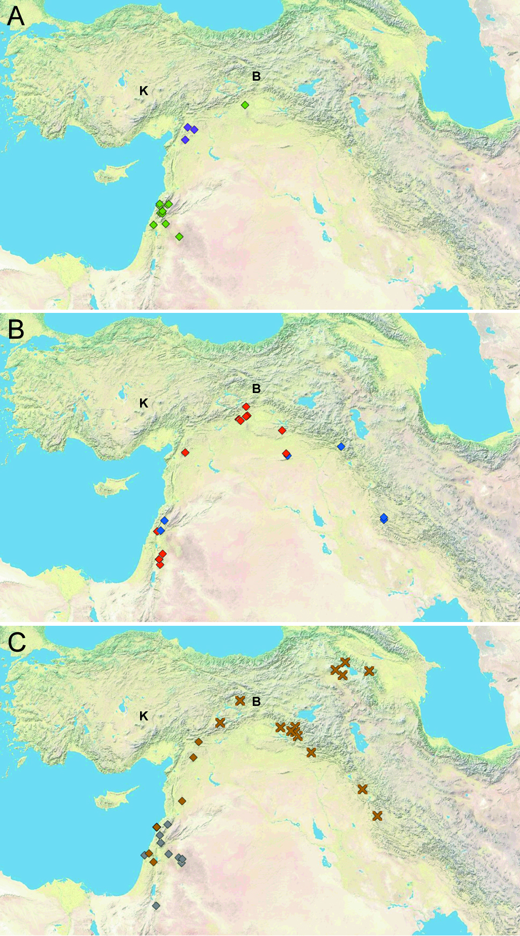
Fig. B. The most parsimonious tree constructed from the 21-gene concatenated data matrix. Color coding of the leafs corresponds to that used in Figure 5. Clades that obtained >50% support in the bootstrap analysis are indicated. With regards to the origin of domesticated emmer, the most frequent grouping in the bootstrap analysis involves all the dicoccum and durum accessions together with the wild samples SE1 and SW17, this group appearing in 16.8% of the resampled trees. Alternative frequent groupings exclude the domesticated sample DC19 from the set above (9.8% of the resampled trees), or add the samples NE4 (5.6%), NE4+NW2+NW3±SW10 (5.6%), NE4+SW10 (3.7%), or NE4+SW10+NE2+NE3 (3.1%).

Fig. C. MJ Network constructed from 64 rapidly evolving Pm3 gene sequences from tetraploid wheats [6], plus additional sequences from Genbank (excluding three that appear to display intragenic recombination). Node sizes are proportional to the number of accessions displaying that allele, and the edge lengths are proportional to the number of substitutions between pairs of allele sequences. Southwest populations originate from Israel, Lebanon and southwest Syria, northeast populations from the vicinity of Karaca Dağ Mountain, and the southeast population (a single accession) is from the Iranian Zagros Mountains. A presumed ortholog sequence from T. monococcum is included as outgroup. Accessions from the northeast and southeast are located in two peripheral regions of the network. The genetic distance between these two peripheral groups, and the presence of closely-related Levantine accessions at positions basal to both groups, suggest that one or both of the northeast and southeast allele groups migrated from the southern Levant relatively recently.

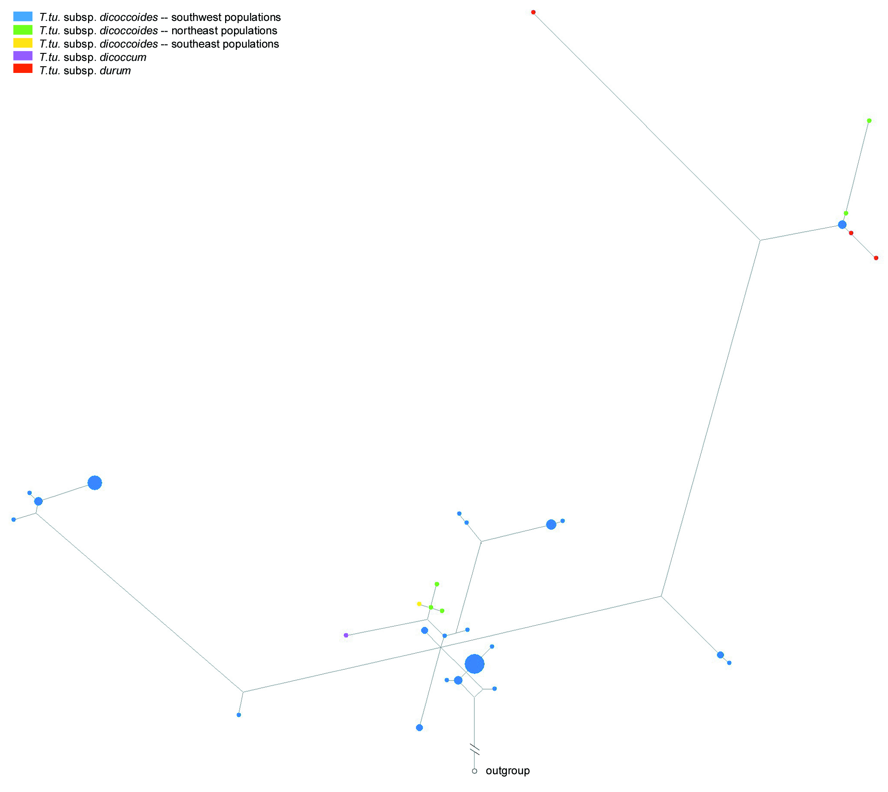

Fig. D. Model of the pace of genetic identity disruption after intermixing distinct populations in equal proportions (absence of selection assumed). n, number of generations since the populations are mixed; f(h), frequency of individuals with at least one outcrossing event in their genealogy since n = 0; 2P, two populations intermixed; 3P, three populations intermixed; f(o), frequency of cross-pollination. For two populations, the frequency of hybrids one generation after intermixing equals (half of the cross-pollinating events result in pairing different genotypes). The subsequent rise of f(h) is calculated with the formulae and for 2P and 3P, respectively.

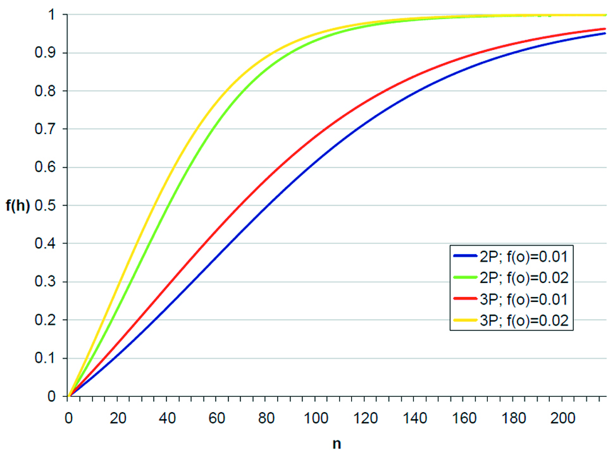
References

1. Özkan H, Brandolini A, Schäfer-Pregl R, Salamini F. (2002) AFLP analysis of a collection of tetraploid wheats indicates the origin of emmer and hard wheat domestication in southeast Turkey. Mol Biol Evol 19: 1797–1801.
3. Haudry A, Cenci A, Ravel C, Bataillion T, Brunel D, et al. (2007) Grinding up wheat: a massive loss of nucleotide diversity since domestication. Mol Biol Evol 24: 1506–1517.
4. Feldman M, Kislev ME. (2007) Domestication of emmer wheat and evolution of free-threshing tetraploid wheat. Isr J Plant Sci 55: 207–221.
5. Mori N, Kondo Y, Ishii T, Kawahara T, Valkoun J, Nakamura C. (2009) Genetic diversity and origin of timopheevi wheat inferred by chloroplast DNA fingerprinting. Breed Sci 59: 571–578.
5. Zohary D, Hopf M, Weiss E. (2012) Domestication of plants in the Old World, 4th ed. Oxford: Oxford University Press.
6. Yahiaoui N, Kaur N, Keller B. (2009) Independent evolution of functional Pm3 resistance genes in wild tetraploid wheat and domesticated bread wheat. Plant J 57: 846–856.

